

CAPSTONE PROJECT REPORT
Report 3 – Software Requirement Specification

– Hanoi, Aug 2026 –
Table of Contents
Change Log 5
Definition and Acronyms 6
I. Overall Requirements 6
1. Context Diagram 6
2. Main Business Flow 7
2.1 Consumer Purchase Flow (BF-01) 7
2.2 Farmer product upload flow (BF-02) 8
3. Conceptual Data Model 8
3.1 Entity Relationship Diagram 8
3.2 Entity Descriptions 9
3.3 Data Business Rules 15
4. User Requirements 15
4.1 Actors 15
4.2 Use Cases (UC) 16
4.3 Use Case Diagrams 22
4.4 Permission Matrix 26
5. System Functionalities 29
5.1 Screen Inventory 29
5.2 External API Inventory 31
5.3 Background Job Inventory 32
II. Use Case Specifications 33
1. Authentication 33
1.1 UC-AUTH-01 - Register Consumer or Farmer Account 33
1.2 UC-AUTH-03 - Manage Profile 35
1.3 UC-CON-04 - Track Retail Order 38
1.4 UC-AUTH-04 Sign In Screen 40
1.5 UC-AUTH-06 Change Password 43
1.6 UC-AUTH-07 - Reset Password 45
2. Marketplace 47
2.1 UC-MKT-01 Browse Marketplace 47
2.2 UC-MKT-02 View Product Detail 49
3. Farmer Sales 51
3.1 UC-FAR-06 - Process Order 51
4. Administration 53
4.1 Product Listing Moderation Screen 53
4.2 UC-ADM-03 - Manage User Account Status 56
4.3 UC-ADM-05 - Manage Product Categories 59
5. Product Management 62
5.1 UC-FAR-03 - Manage Product Listing 62
6.Consumer Ordering 64
6.1.2 UC-CON-02 - Checkout and Place Retail Order 64
III. Functional Requirements 67
1. User Authentication 67
1.1 User Register 67
1.2 Sign In Screen 69
1.3 Change Password 70
1.4 Reset Password 71
1.4 Logout 72
2. MarketPlace 73
2.1 Browse Marketplace 73
2.2 View Product Detail 74
3. Farmer Sales 77
3.1 Process Order 77
3.2 Information Farmer 79
4. Administration 81
4.1 User Management 81
4.2 Product Management 84
5.Product Management 89
5.1 Manage Product Listing 89
6.Consumer Ordering 91
6.1Checkout and Place Retail Order 91
6.2 Information Consumer 92
6.3Track Retail Order 94
6.4 Shopping Cart 97
7. Background Job Inventory 99
7.1 Expire Password Reset Tokens (JOB-01) 99
7.2 Auto-Cancel Unpaid Retail Orders (JOB-02) 99
7.3 Reconcile Payment Status (JOB-03) 99
7.4 Pre-Order Campaign Status Update (JOB-04) 100
7.5 Contract Milestone Reminder (JOB-05) 101
7.6 Clean Up Old Notifications and Activity Logs (JOB-06) 101
7.7 Certificate Expiry Monitoring (JOB-07) 102
7.8 Pending KYC Review Reminder (JOB-08) 102
7.9 Notification Delivery Retry (JOB-09) 103
7.10 Archive Old Audit and Activity Logs (JOB-10) 103
8. External API Inventory 103
8.1 PayOS / VietQR Webhook (API-01) 103
8.2 Gmail Notification Service API (API-02) 104
IV. Non-Functional Requirements 104
1. External Interfaces 104
2. Quality Attributes 105
2.1 Usability 105
2.2 Performance 106
2.3 Security 106
V. Requirement Appendix 107
1. Business Rules 107
2. System Messages 111
3. Other Requirements 116

Change Log
Date | A*  M, D | In charge | Change Description
*A - Added M - Modified D - Deleted

Definition and Acronyms

Acronym | Definition
COS | AgriSustain - Digital Platform for Sustainable Agriculture
SEP490 | Software Engineering Graduation Capstone Project
B2B | Business-to-Business
B2C | Business-to-Consumer
CRUD | Create, Read, Update, Delete

I. Overall Requirements

1. Context Diagram
AgriSustain is a digital e-commerce platform for agricultural products that directly connects farmers and cooperatives with consumers and B2B buyers. The system supports product search and trading, crop and shipment management, QR-based traceability, production pre-ordering, B2B off-take contracts, online payments, dispute resolution, and operational reporting.
Key actors include Guests, Consumers, B2B Buyers, Farmers, and Administrators. The system also interfaces with the VietQR/PayOS payment gateway to generate payment codes and receive transaction results. The Context Diagram below illustrates the system boundaries and the primary data flows between AgriSustain and external actors.
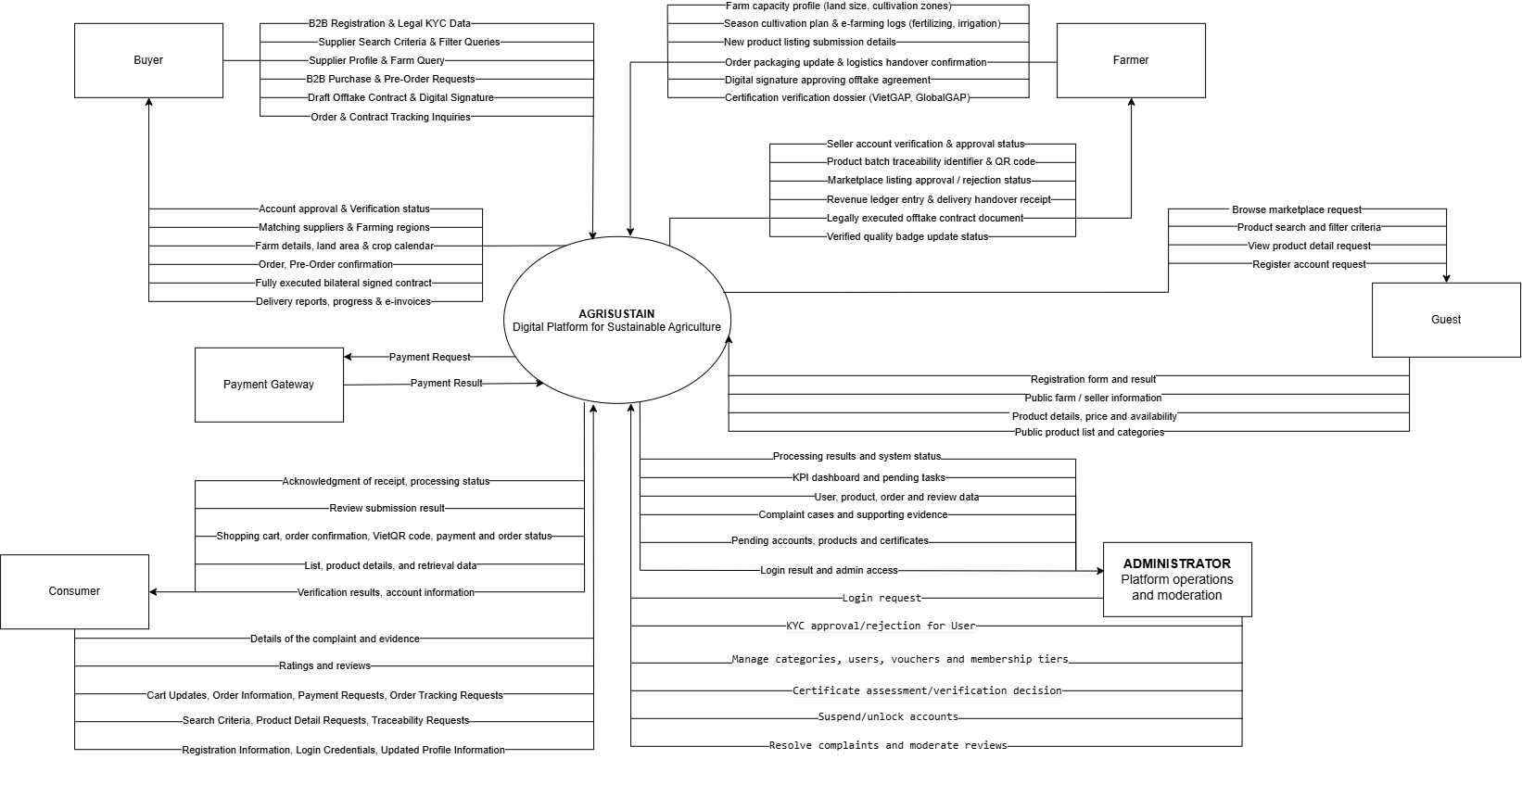

2. Main Business Flow

2.1 Consumer Purchase Flow (BF-01)
Trigger: Candidate creates an account.
End condition: Candidate has seen the final outcome of all applications.
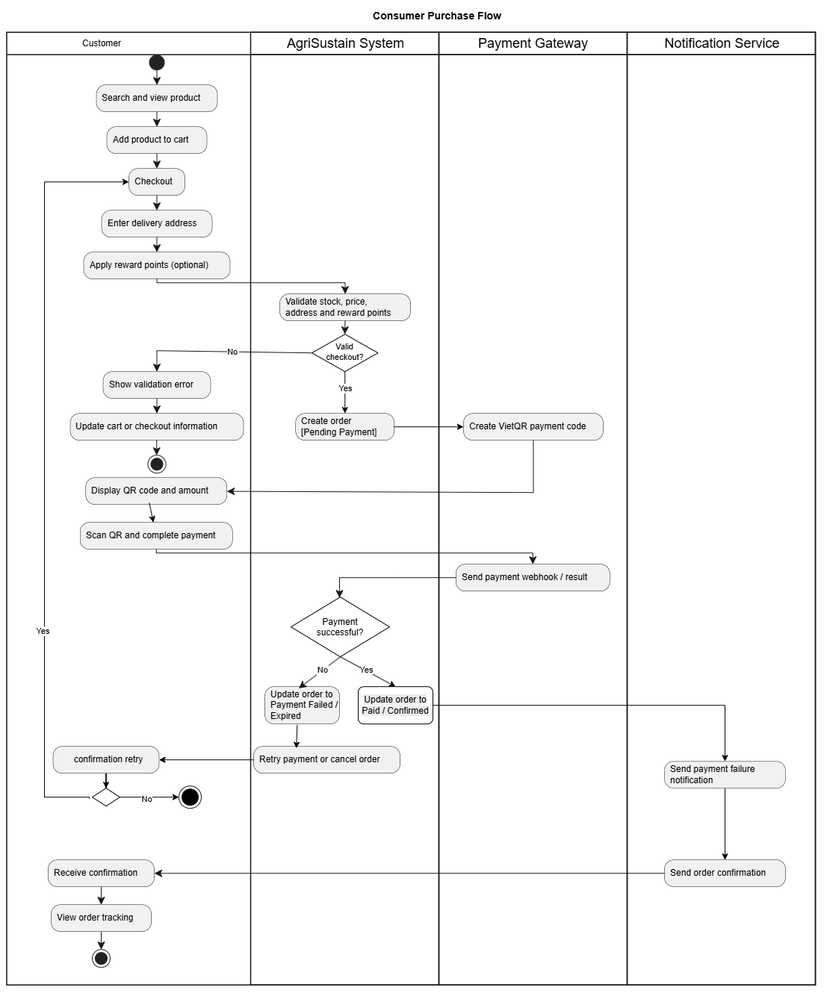

2.2 Farmer product upload flow (BF-02)
Trigger: HR Manager decides to open a new position and creates a job posting.
End condition: Candidate status reaches HIRED or REJECTED (both terminal).

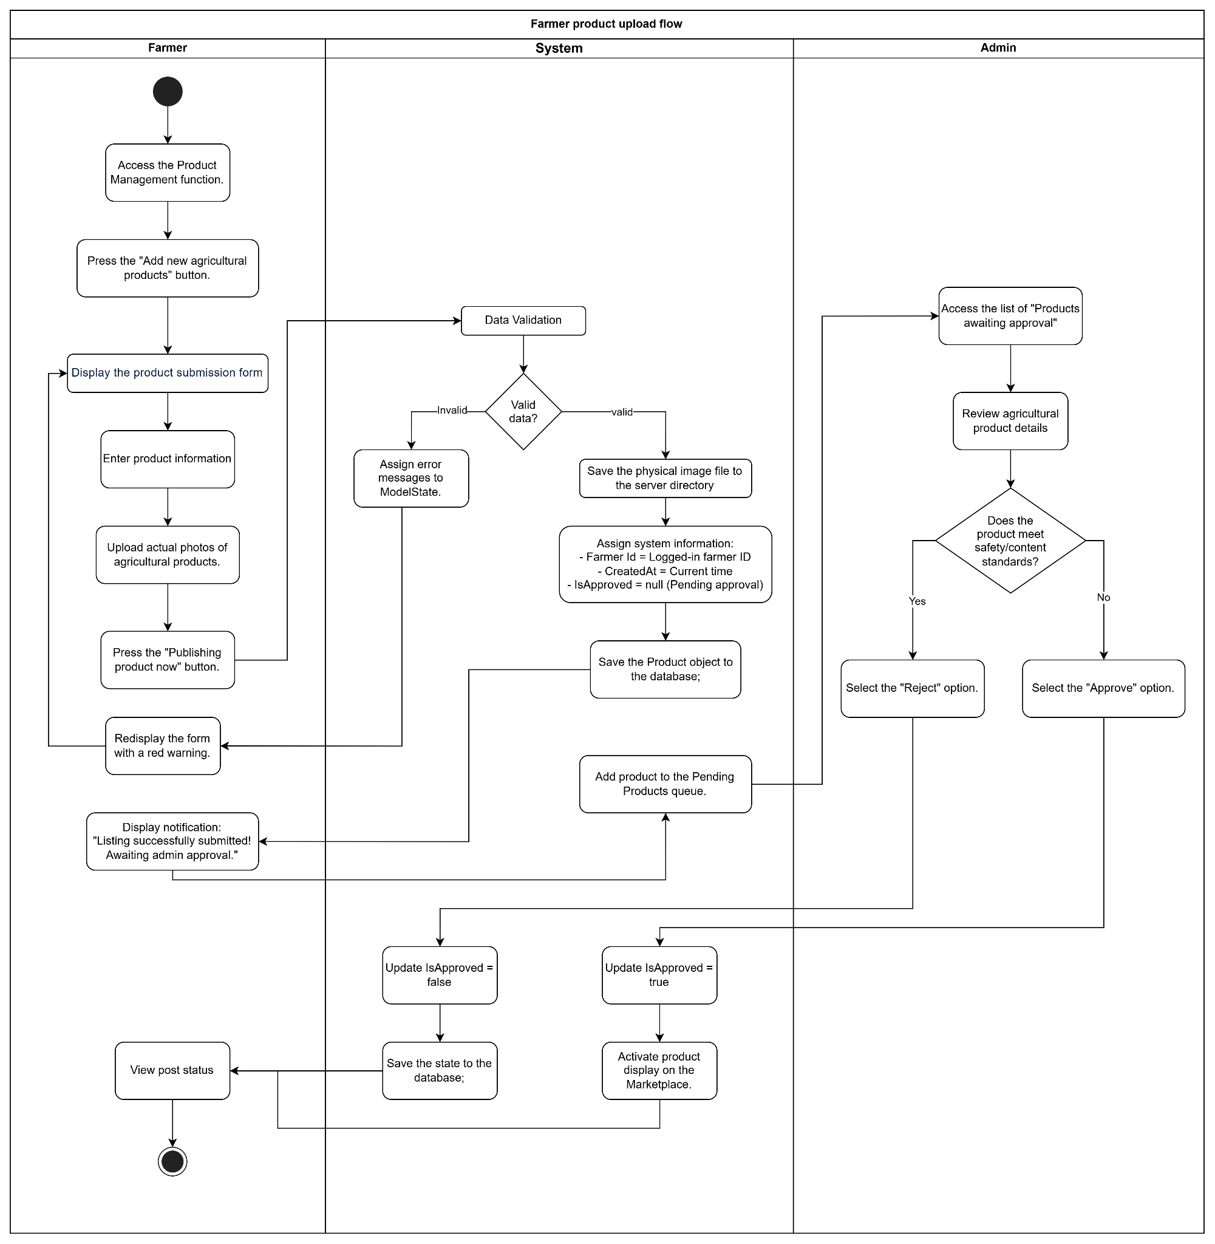

3. Conceptual Data Model

3.1 Entity Relationship Diagram

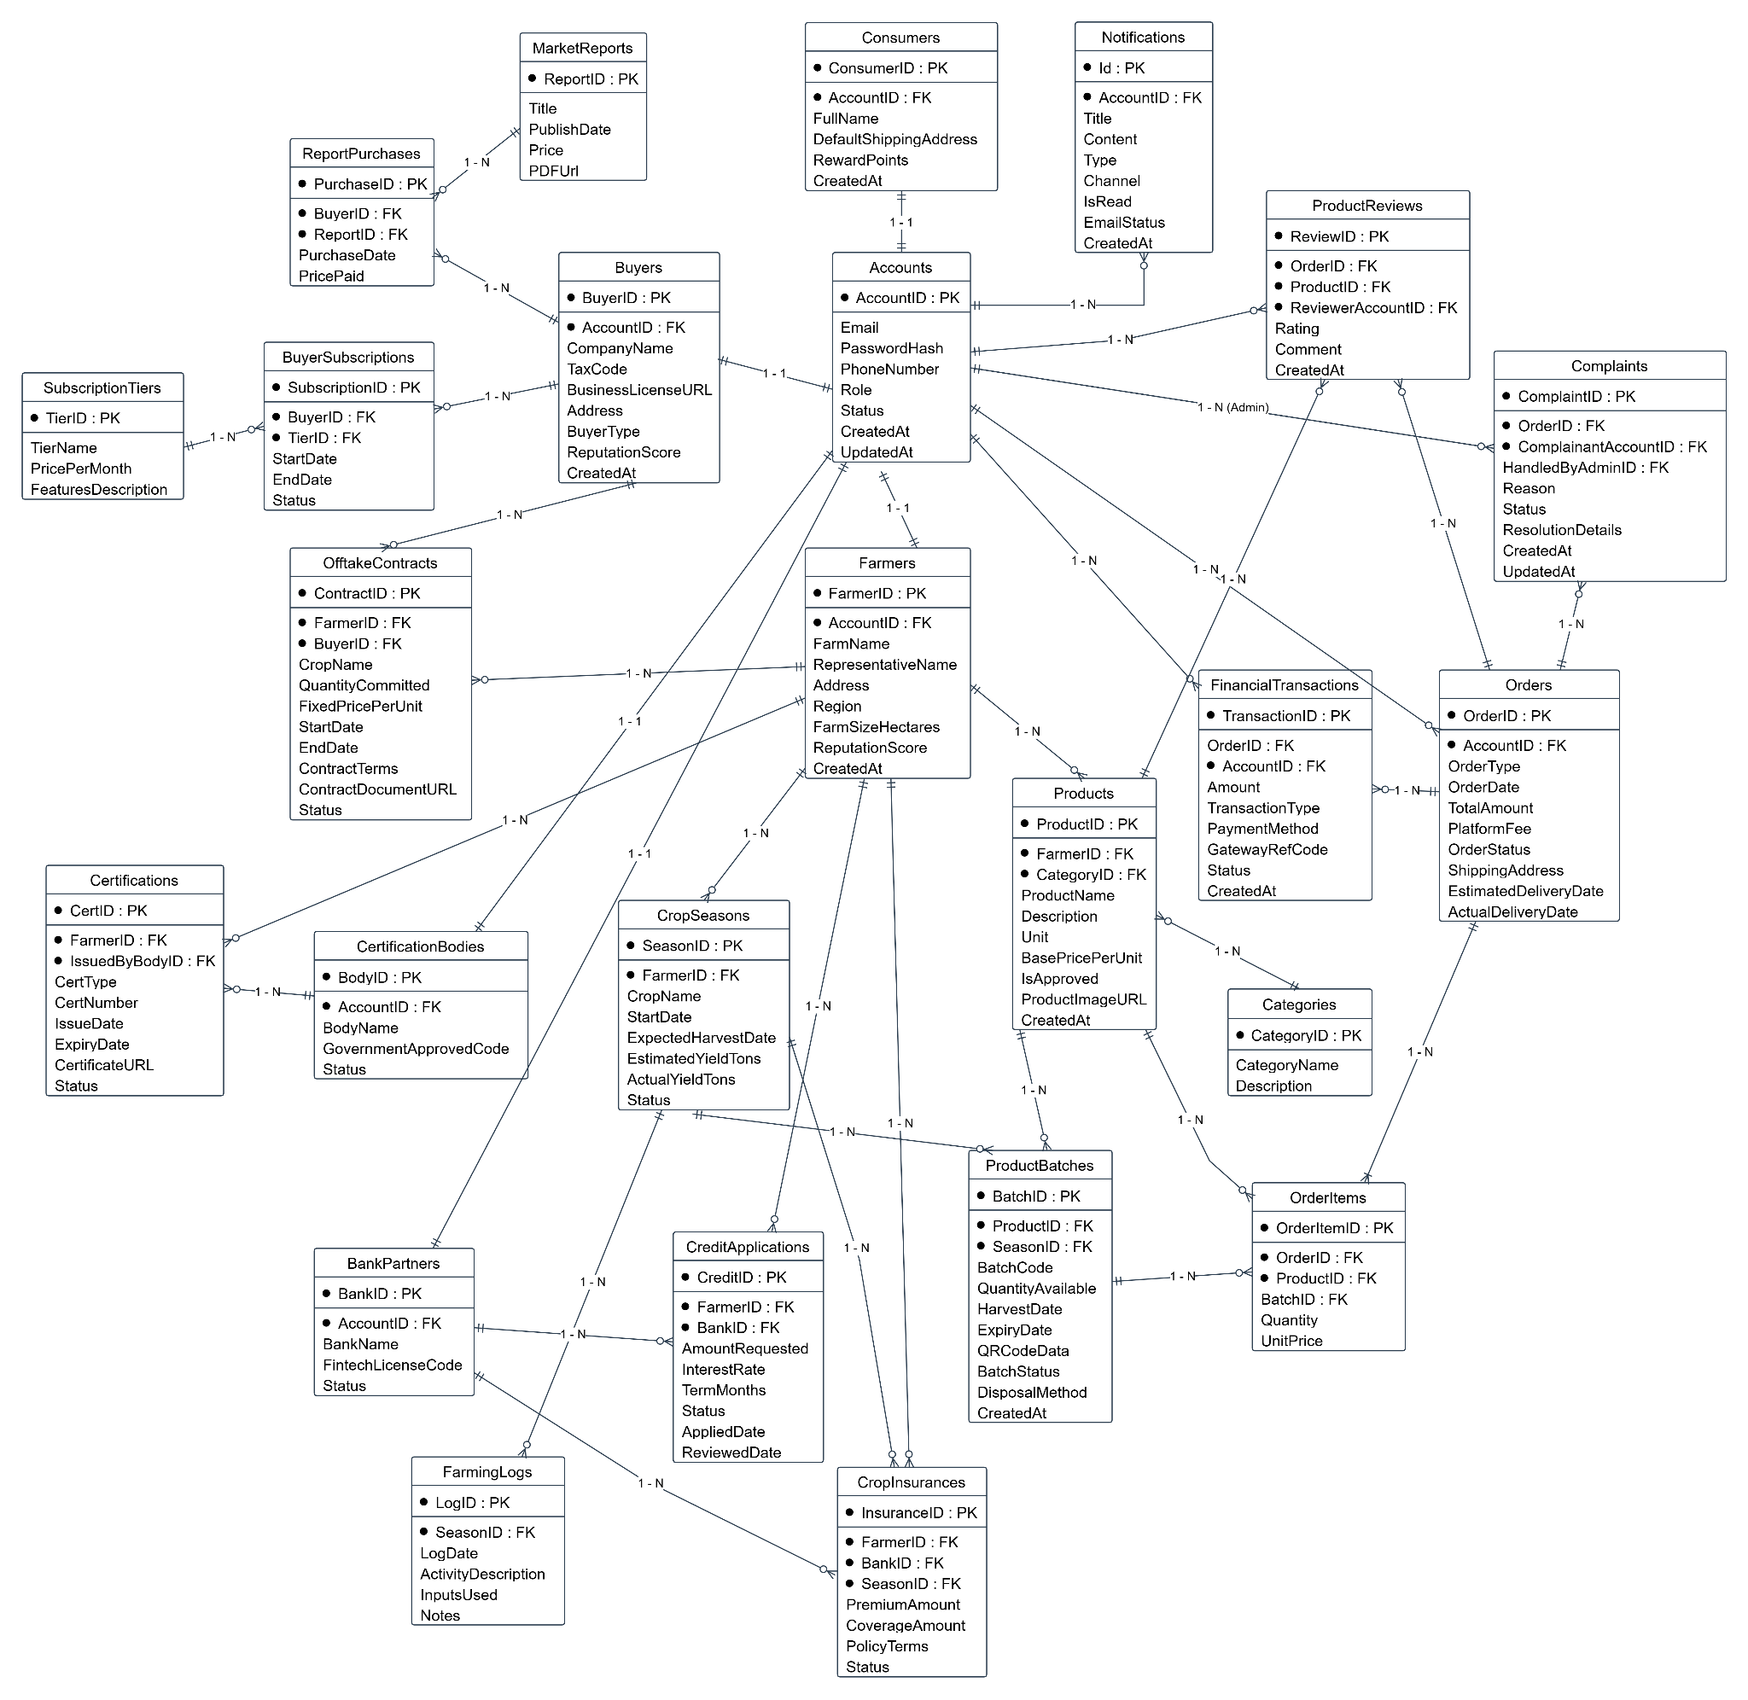

3.2 Entity Descriptions

Entity: Accounts
Field | Value
Purpose | Central identity record for all individuals and organizations accessing the platform, handling authentication and high-level role authorization.
Key business attributes | Email, PasswordHash, PhoneNumber, Role (Admin, Farmer, Buyer, Consumer, Bank, Certifier), Status (Pending, Approved, Rejected, Suspended), CreatedAt, UpdatedAt
Business identity | Email is globally unique across the system (UNIQUE). PhoneNumber is globally unique across the system (UNIQUE).
Status / lifecycle | Pending (default upon registration) → Approved (verified and granted platform access by Admin) · Rejected (application refused) · Suspended (deactivated due to policy violation)

Entity: Farmers
Field | Value
Purpose | Profile entity storing operational and legal details of agricultural producers, cooperatives, or individual farmers.
Key business attributes | FarmName, RepresentativeName, Address, Region, FarmSizeHectares, ReputationScore (baseline default: 5.00), CreatedAt
Business identity | Exactly one profile per account (AccountID carries a UNIQUE foreign key constraint referencing Accounts).
Status / lifecycle | Instantiated with account approval (cascades on account deletion via ON DELETE CASCADE). ReputationScore dynamically adjusts based on customer ratings and contract compliance.

Entity: Buyers
Field | Value
Purpose | Profile entity for commercial enterprise buyers, supermarket chains, food processing facilities, and bulk off-takers.
Key business attributes | CompanyName, TaxCode, BusinessLicenseURL, Address, BuyerType (Supermarket, ProcessingPlant, Exporter, Restaurant), ReputationScore (baseline default: 5.00), CreatedAt
Business identity | Exactly one buyer profile per account (AccountID UNIQUE). TaxCode is globally unique across the platform (UNIQUE).
Status / lifecycle | Created upon Account approval. TaxCode verified during KYC onboarding.

Entity: Consumers
Field | Value
Purpose | Profile entity for individual retail buyers purchasing fresh produce directly from farmers.
Key business attributes | FullName, DeliveryAddress, RewardPointsBalance (default: 0), CreatedAt
Business identity | Exactly one consumer profile per account (AccountID UNIQUE).
Status / lifecycle | Active upon self-service registration. Reward points increment on successful orders.

Entity: BankPartners
Field | Value
Purpose | Profile entity for financial institutions evaluating credit applications and providing agricultural loans.
Key business attributes | BankName, LicenseNumber, ContactPerson, MaxCreditLimit, InterestRateMin, CreatedAt
Business identity | Exactly one bank profile per account (AccountID UNIQUE). LicenseNumber UNIQUE.
Status / lifecycle | Onboarded by Admin approval.

Entity: CertificationBodies
Field | Value
Purpose | Third-party accredited certification organizations verifying agricultural standards (VietGAP, GlobalGAP, Organic).
Key business attributes | OrganizationName, AccreditationCode, Website, ContactEmail, CreatedAt
Business identity | Exactly one profile per account (AccountID UNIQUE). AccreditationCode UNIQUE.
Status / lifecycle | Authorized by platform Admin.

Entity: Certifications
Field | Value
Purpose | Quality and safety certification documents submitted by farmers or verified by certification bodies.
Key business attributes | FarmerID, CertificationBodyID, CertificateType (VietGAP, GlobalGAP, Organic, OCOP), CertificateNumber, IssuedDate, ExpiryDate, DocumentURL, VerificationStatus (Pending, Verified, Rejected, Expired)
Business identity | CertificateNumber is UNIQUE.
Status / lifecycle | Pending → Verified / Rejected · Automatically transitions to Expired past ExpiryDate.

Entity: CropSeasons
Field | Value
Purpose | Represents a specific cultivation cycle managed by a farmer, including area, crop type, and expected yield.
Key business attributes | FarmerID, SeasonName, CropType, AreaHectares, PlantingDate, ExpectedHarvestDate, ExpectedYieldTons, Status (Planned, InProgress, Harvested, Completed, Cancelled)
Business identity | Identified by CropSeasonID. Foreign key to Farmers.
Status / lifecycle | Planned → InProgress → Harvested → Completed.

Entity: FarmingLogs
Field | Value
Purpose | Electronic farming log (E-Farming Log) recording daily agricultural activities for traceability.
Key business attributes | CropSeasonID, ActivityType (Sowing, Fertilizing, PesticideApp, Irrigation, Harvest), LogDate, InputsUsed, QuantityUsed, ImageURL, PerformedBy
Business identity | Identified by FarmingLogID. Foreign key referencing CropSeasons.
Status / lifecycle | Append-only audit trail during active crop season.

Entity: Categories
Field | Value
Purpose | Hierarchical product classification taxonomy for catalog organization.
Key business attributes | CategoryName, ParentCategoryID, Description, IconURL, IsActive
Business identity | CategoryName UNIQUE under the same ParentCategoryID.
Status / lifecycle | Managed by Admin.
Entity: Products
Field | Value
Purpose | Master catalog listing for agricultural produce offered by farmers.
Key business attributes | FarmerID, CategoryID, ProductName, Description, Unit (kg, ton, box), RetailPrice, B2BPrice, IsApproved (null, true, false), CreatedAt
Business identity | Identified by ProductID.
Status / lifecycle | Submitted by Farmer → Pending Admin Approval (IsApproved = null) → Approved (true) / Rejected (false).

Entity: ProductBatches
Field | Value
Purpose | Specific physical inventory lot harvested from a crop season, linked with QR traceability code.
Key business attributes | ProductID, CropSeasonID, BatchCode, HarvestDate, QuantityAvailable, ExpiryDate, QRCodeURL
Business identity | BatchCode UNIQUE across platform.
Status / lifecycle | Active stock depletes upon order placement.

Entity: OfftakeContracts
Field | Value
Purpose | Long-term binding bilateral agreement between Farmer and B2B Buyer for guaranteed forward harvest purchase.
Key business attributes | BuyerID, FarmerID, CropSeasonID, ContractCode, AgreedQuantityTons, AgreedPricePerTon, TotalValue, DepositAmount, Status (Draft, PendingSign, Active, Fulfilled, Defaulted, Terminated), SignedDate
Business identity | ContractCode UNIQUE.
Status / lifecycle | Draft → PendingSign → Active → Fulfilled / Defaulted / Terminated.

Entity: Orders
Field | Value
Purpose | Transactional header record for spot purchases, pre-orders, or wholesale purchases.
Key business attributes | AccountID (Consumer or Buyer), OrderCode, OrderType (Retail, PreOrder, B2BWholesale), TotalAmount, DiscountAmount, FinalAmount, PaymentMethod (VietQR, PayOS, Escrow), OrderStatus (PendingPayment, Paid, Processing, Shipping, Completed, Cancelled), CreatedAt
Business identity | OrderCode UNIQUE.
Status / lifecycle | PendingPayment → Paid → Processing → Shipping → Completed / Cancelled.

Entity: OrderItems
Field | Value
Purpose | Line-item detail for products and specific batch assignments within an order.
Key business attributes | OrderID, ProductID, ProductBatchID, Quantity, UnitPrice, Subtotal
Business identity | Identified by OrderItemID. Foreign key to Orders.
Status / lifecycle | Immutable once order is confirmed.

Entity: FinancialTransactions
Field | Value
Purpose | Ledger record for electronic payments, webhook payouts, and escrow releases.
Key business attributes | OrderID, OfftakeContractID, GatewayTransactionRef, GatewayName (VietQR, PayOS, SePay), Amount, Currency, TransactionType (OrderPayment, Deposit, EscrowRelease, Refund), Status (Pending, Success, Failed), TransactionTime
Business identity | GatewayTransactionRef UNIQUE per gateway.
Status / lifecycle | Immutable once Success or Failed is recorded.

Entity: CreditApplications
Field | Value
Purpose | Financing requests submitted by farmers or B2B buyers to banking partners.
Key business attributes | ApplicantAccountID, BankPartnerID, RequestedAmount, LoanTermMonths, PurposeDescription, Status (Submitted, UnderReview, Approved, Disbursed, Rejected), ApplicationDate
Business identity | Identified by CreditApplicationID.
Status / lifecycle | Submitted → UnderReview → Approved / Rejected → Disbursed.

Entity: CropInsurances
Field | Value
Purpose | Agricultural insurance policy covering crop seasons against natural disasters or yield loss.
Key business attributes | CropSeasonID, PolicyNumber, InsurerName, CoverageAmount, PremiumAmount, StartDate, EndDate, Status (Active, Claimed, Expired, Cancelled)
Business identity | PolicyNumber UNIQUE.
Status / lifecycle | Active during crop season → Claimed / Expired.

Entity: SubscriptionTiers
Field | Value
Purpose | SaaS pricing levels for B2B Buyers granting premium features (advanced analytics, priority matching).
Key business attributes | TierName (Basic, Standard, Enterprise), MonthlyFee, FeaturesJSON, IsActive
Business identity | TierName UNIQUE.
Status / lifecycle | Configured by Admin.

Entity: BuyerSubscriptions
Field | Value
Purpose | Active subscription instance connecting a B2B Buyer to a SubscriptionTier.
Key business attributes | BuyerID, SubscriptionTierID, StartDate, EndDate, AutoRenew, Status (Active, Cancelled, Expired)
Business identity | Identified by SubscriptionID.
Status / lifecycle | Active → Expired / Cancelled.

Entity: MarketReports
Field | Value
Purpose | Analytical market intelligence reports on crop prices, supply-demand trends, and regional forecasts.
Key business attributes | Title, Region, CropCategory, PriceAmount, PublishedDate, FileURL, IsFreeForSubscribers
Business identity | Identified by ReportID.
Status / lifecycle | Published by Platform Analysts/Admins.

Entity: ReportPurchases
Field | Value
Purpose | Access grant record when a buyer purchases an individual MarketReport.
Key business attributes | BuyerID, MarketReportID, PricePaid, PurchasedAt
Business identity | Identified by PurchaseID.
Status / lifecycle | Permanent download entitlement once purchased.

Entity: ProductReviews
Field | Value
Purpose | Ratings and feedback submitted by consumers or buyers following completed orders.
Key business attributes | OrderID, ProductID, AccountID, RatingStars (1-5), CommentText, IsHiddenByAdmin, CreatedAt
Business identity | One review per Product per Order (UNIQUE constraint on OrderID + ProductID).
Status / lifecycle | Submitted → Visible · May be moderated/hidden by Admin.

Entity: Complaints
Field | Value
Purpose | Dispute records submitted by buyers regarding damaged, missing, or poor-quality goods.
Key business attributes | OrderID, ComplainantAccountID, ReasonCategory (Defective, Crushed, WrongItem, Expired), DescriptionText, EvidenceImageURL, ResolutionStatus (Submitted, UnderReview, Refunded, Rejected, Closed), AdminNote
Business identity | Identified by ComplaintID.
Status / lifecycle | Submitted → UnderReview → Refunded / Rejected → Closed.

Entity: Notifications
Field | Value
Purpose | System, order, and contract alert messages dispatched to users.
Key business attributes | TargetAccountID, Title, MessageBody, NotificationType (Order, Contract, System, Credit), IsRead, SentAt
Business identity | Identified by NotificationID.
Status / lifecycle | Unread (IsRead = false) → Read (IsRead = true).

3.3 Data Business Rules

Rule | Description | Enforced On
Unique email | No two user accounts may share the same email address across the AgriSustain platform. | Account creation and profile update
Unique phone number | PhoneNumber is mandatory and must be globally unique across all accounts. | Account registration
Unique TaxCode for Buyers | Every commercial Buyer must provide a TaxCode that is globally unique across the system. | B2B Buyer onboarding / KYC submission
Product approval required | A Product listing must have IsApproved = true before appearing on the public Marketplace. | Product search and catalog display
Active stock validation | An Order cannot be placed if the requested quantity exceeds ProductBatch QuantityAvailable. | Checkout and order placement
One review per order item | A buyer may submit only one ProductReview per product per completed Order. | Review submission
Bilateral signature for contracts | An OfftakeContract becomes Active only after digital signature approval by both Farmer and Buyer. | Contract execution
Certificate expiration auto-check | Certifications automatically transition to Expired status past ExpiryDate and remove verified quality badges from associated products. | Daily scheduled job / system status check
Financial transaction immutability | FinancialTransactions once recorded with status Success or Failed cannot be edited or deleted by any user. | Payment processing and ledger updates

4. User Requirements

4.1 Actors

# | Actor | Description
1 | Administrator | A platform administrator responsible for platform operations and moderation, including managing users, categories, vouchers and membership tiers, reviewing KYC and certificates, managing accounts, and resolving complaints and reviews.
2 | Guest | An unregistered visitor who can access the public AgriSustain website, browse public farm/seller information, search and view products, and request account registration.
3 | Buyer | A registered user who searches for suppliers, views farm information, creates B2B orders or pre-orders, manages and signs offtake contracts, and tracks order and delivery progress.
4 | Farmer | A registered agricultural producer who manages farm information, provides cultivation and seasonal information, submits agricultural products, updates order and logistics information, and provides certification information for verification.
5 | Consumer | A registered end user who searches for agricultural products, views product details and traceability information, manages the shopping cart, places orders, makes payments, tracks orders, submits ratings and reviews, and sends complaints.
6 | Payment Gateway | An external payment service that processes payment requests from AgriSustain and returns payment results to the system.

4.2 Use Cases (UC)
ID | Use Case | Feature | Use Case Description
UC-AUTH-01 | Register Consumer or Farmer Account | Authentication and Profile Management | Primary actor: Guest. Creates a Consumer or Farmer account using a phone number and password, then stores the account with its initial status.
UC-AUTH-02 | Register Buyer B2B Account | Authentication and Profile Management | Primary actor: Guest. Creates a Buyer B2B account and submits company information, tax code, and legal documents for KYC review.
UC-AUTH-03 | Manage Profile | Authentication and Profile Management | Primary actor: Consumer, Farmer, Buyer B2B. Completes or updates role-specific profile information, including delivery addresses, farm details, or business information.
UC-AUTH-04 | Log In | Authentication and Profile Management | Primary actor: Consumer, Farmer, Buyer B2B, Administrator. Authenticates credentials, checks account status, and opens the appropriate role workspace.
UC-AUTH-05 | Log Out | Authentication and Profile Management | Primary actor: Authenticated User. Ends the active session and invalidates the active token or session.
UC-AUTH-06 | Change Password | Authentication and Profile Management | Primary actor: Authenticated User. Changes the password after validating the current password and password policy.
UC-AUTH-07 | Reset Password | Authentication and Profile Management | Primary actor: Guest or User. Starts and completes the verified password-reset process for a forgotten password.
UC-MKT-01 | Browse Marketplace | Marketplace | Primary actor: Guest, Consumer, Buyer B2B. Browses public products and optionally searches or filters them by name, category, supplier, region, season, or certification.
UC-MKT-02 | View Product Detail | Marketplace | Primary actor: Guest, Consumer, Buyer B2B. Views a product's description, price, available stock or batches, farm information, certificates, and eligible reviews.
UC-TRC-01 | View Product Traceability | Traceability | Primary actor: Consumer. Enters a batch code or scans a QR code to view the farm, crop season, farming logs, harvest date, and quality certificates.
UC-CON-01 | Manage Shopping Cart | Consumer Ordering | Primary actor: Consumer. Adds products to a cart, changes quantities, or removes products before ordering.
UC-CON-02 | Place Retail Order | Consumer Ordering | Primary actor: Consumer. Selects a delivery address, applies eligible reward points, validates stock and price, and creates an order with Pending Payment status.
UC-CON-03 | Pay Retail Order | Consumer Payment | Primary actor: Consumer; secondary actor: VietQR/PayOS Payment Gateway. Requests a dynamic QR payment and records payment success only after a valid gateway webhook is received.
UC-CON-04 | Track Retail Order | Consumer Ordering | Primary actor: Consumer. Views order history and order details.
UC-CON-05 | Submit Product Review | Consumer Engagement | Primary actor: Consumer. Submits a star rating and comment for a product after the related order is completed.
UC-CON-06 | Submit Order Complaint | Consumer Engagement | Primary actor: Consumer. Creates an order complaint with a reason and supporting evidence within the allowed policy period.
UC-B2B-01 | Search Suppliers | B2B Procurement | Primary actor: Buyer B2B. Searches Farmers and production regions by location, supply capacity, crop season, and certification.
UC-B2B-02 | View Supplier Capacity Profile | B2B Procurement | Primary actor: Buyer B2B. Views a selected supplier's cultivated area, production capacity, crop calendar, available products, certificates, and reputation information.
UC-B2B-03 | Create Wholesale Order | B2B Procurement | Primary actor: Buyer B2B. Creates a bulk order with quantity, packaging requirements, and a requested delivery schedule.
UC-B2B-04 | Create Pre-Order Commitment | B2B Procurement | Primary actor: Buyer B2B. Reserves output from an upcoming crop season under agreed quantity, price, and commitment or deposit terms.
UC-B2B-05 | Create Offtake Contract Proposal | B2B Contract Management | Primary actor: Buyer B2B. Drafts a long-term offtake proposal containing quantity, price framework, delivery terms, and validity period.
UC-B2B-06 | Sign Offtake Contract | B2B Contract Management | Primary actor: Buyer B2B and Farmer. Electronically signs or confirms an offtake contract after both parties agree to its terms.
UC-B2B-07 | Track B2B Fulfillment | B2B Contract Management | Primary actor: Buyer B2B. Tracks contract fulfillment, wholesale delivery milestones, invoices, and related records.
UC-B2B-08 | Manage Buyer Subscription | B2B Membership | Primary actor: Buyer B2B. Views, selects, renews, or cancels an eligible subscription tier.
UC-FAR-01 | Manage Crop Seasons | Farm Management | Primary actor: Farmer. Creates and updates crop-season plans, expected harvest dates, estimated and actual yields, and season status.
UC-FAR-02 | Record E-Farming Logs | Farm Management | Primary actor: Farmer. Records cultivation activities such as irrigation, fertilisation, pest management, and supporting evidence.
UC-FAR-03 | Manage Product Listing | Product Management | Primary actor: Farmer. Creates, updates, archives, and submits product listings with product name, category, unit, price, images, and publishing information.
UC-FAR-04 | Manage Traceability Batches | Product Traceability | Primary actor: Farmer. Creates product batches linked to crop seasons, maintains harvest/expiry/stock data, and requests QR traceability identifier generation.
UC-FAR-05 | Manage Pre-Order Campaign | Farmer Sales Management | Primary actor: Farmer. Opens, updates, or closes a pre-order campaign for an upcoming crop season using target quantity and campaign dates.
UC-FAR-06 | Process Order | Farmer Sales Management | Primary actor: Farmer. Confirms or rejects an order, packs it, and records handover or delivery status with a reason when required.
UC-FAR-07 | Submit Certificate Dossier | Certification | Primary actor: Farmer. Uploads VietGAP, GlobalGAP, Organic, or other approved certificate evidence for verification.
UC-FAR-08 | Manage Offtake Contract | B2B Contract Management | Primary actor: Farmer. Reviews, accepts, signs, or requests termination of an offtake contract.
UC-FAR-09 | View Revenue Dashboard | Farmer Analytics | Primary actor: Farmer. Views retail and B2B sales, revenue, and cash-flow information by crop season or payment stage.
UC-ADM-01 | Monitor Platform Operations | Administration | Primary actor: Administrator. Monitors KPIs, GMV or revenue, user growth, orders requiring coordination, and pending work queues.
UC-ADM-02 | Review KYC Application | Administration | Primary actor: Administrator. Reviews a Farmer or Buyer B2B KYC application and approves or rejects it with a recorded reason.
UC-ADM-03 | Manage User Account Status | Administration | Primary actor: Administrator. Searches user accounts and activates, suspends, unlocks, or deactivates them according to policy.
UC-ADM-04 | Moderate Product Listing | Administration | Primary actor: Administrator. Reviews product images, descriptions, origin information, and publication status before or after listing.
UC-ADM-05 | Manage Product Categories | Administration | Primary actor: Administrator. Creates, updates, reorders, activates, or deactivates the product-category hierarchy.
UC-ADM-06 | Resolve Complaint | Administration | Primary actor: Administrator. Reviews evidence, records a resolution, and updates the complaint and related order status.
UC-ADM-07 | Manage Promotions | Administration | Primary actor: Administrator. Configures voucher codes, discount rules, minimum order value, usage limits, validity periods, and activation status.
UC-ADM-08 | Moderate Product Review | Administration | Primary actor: Administrator. Reviews reported or policy-violating product reviews and decides whether to retain or remove them.
UC-ADM-09 | Manage Subscription Tiers | Administration | Primary actor: Administrator. Configures tier price, feature entitlement, transaction limits, and availability status.

4.3 Use Case Diagrams

4.3.1 UCs for Guest
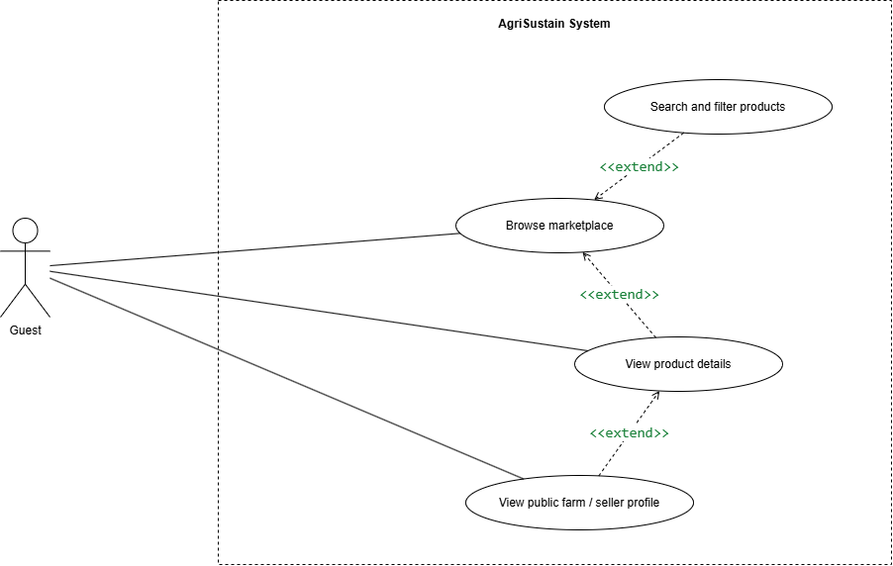

4.3.2 UCs for Consumer
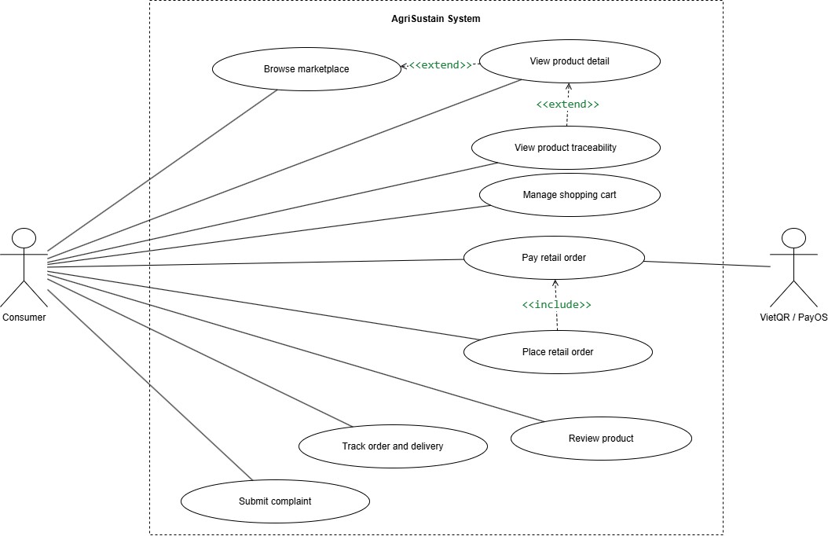

4.3.3 UCs for farmer

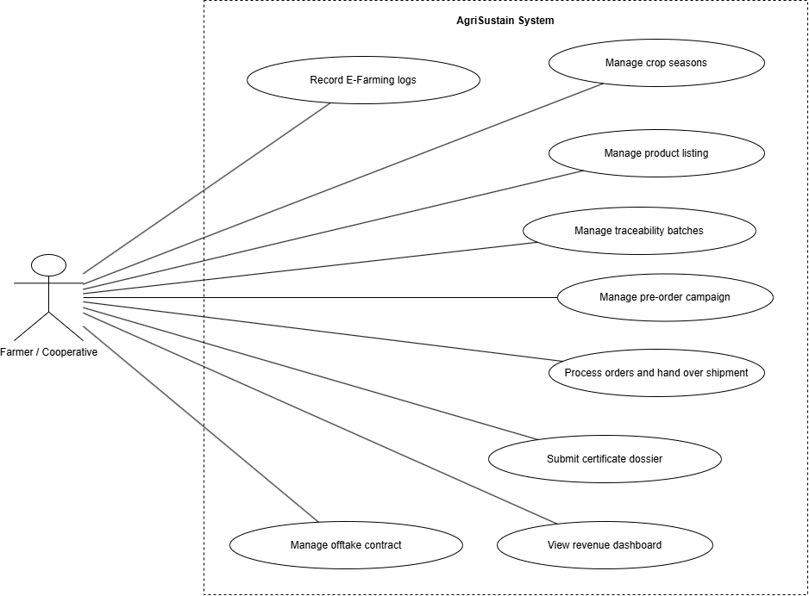

4.3.4 UCs for B2B
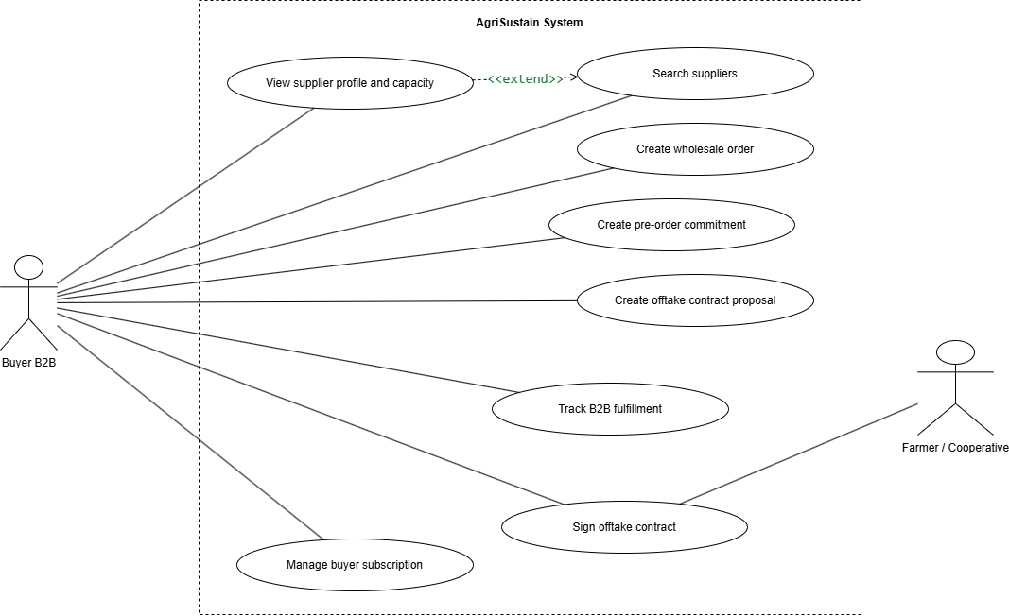

4.3.5 UCs for Admin
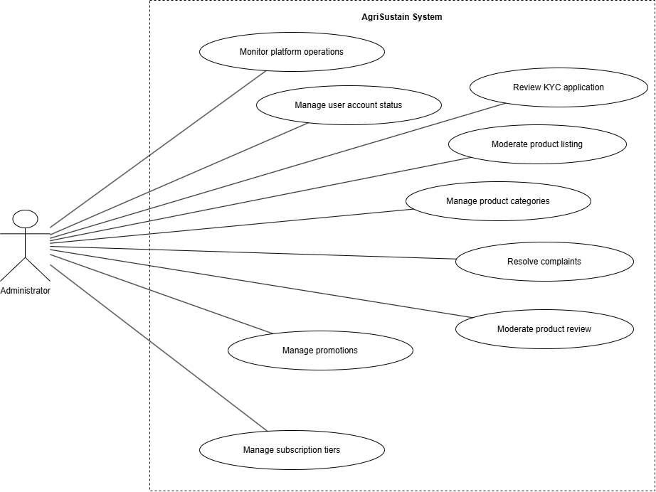

4.3.5 UCs for Authentication
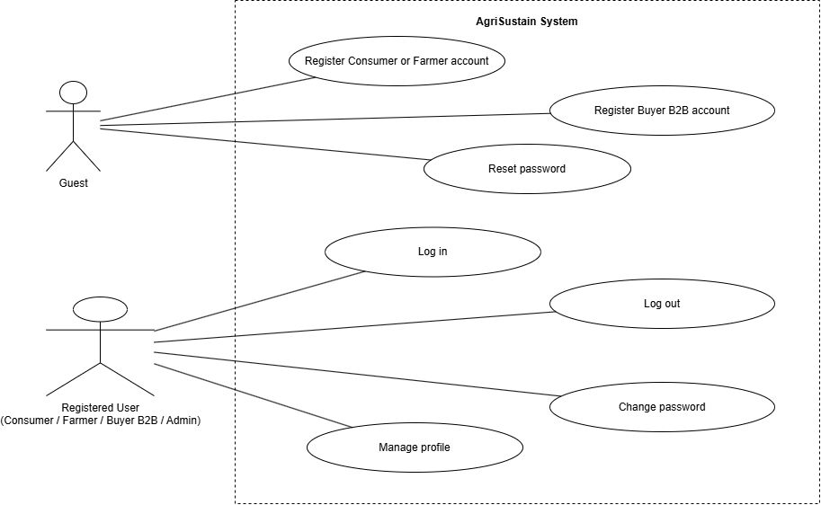

4.4 Permission Matrix
Full = unrestricted · Restricted = conditions apply (see footnotes) · No = denied

Entity | Action | Admin | Farmer / Cooperative | Buyer B2B | Consumer | Guest
Account | Register account | No | Full | Full | Full | Full
Account | Log in / log out / reset password | Full | Full | Full | Full | Restricted ¹
Account | View/update own profile | Full | Full | Full | Full | No
Account | Submit KYC dossier | No | Full | Full | No | No
Account | Approve/reject KYC dossier | Full | No | No | No | No
Account | Search/view user directory | Full | No | No | No | No
Account | Suspend/unlock/activate account | Full | No | No | No | No
Marketplace | Browse/search public products | Full | Full | Full | Full | Full
Marketplace | View product details | Full | Full | Full | Full | Full
Farm / supplier profile | View public profile | Full | Full | Full | Full | Full
Traceability | View QR traceability data | Full | Full ² | Full | Full | Restricted ³
Farm and crop season | Create/update own farm and crop seasons | No | Full | No | No | No
Farming log | Create/update own e-farming logs | No | Full | No | No | No
Certificate dossier | Submit/view own certificate dossier | Restricted ⁴ | Full | No | No | No
Product listing | Create/update/archive own listing | No | Full | No | No | No
Product listing | Approve/reject/moderate listing | Full | No | No | No | No
Product batch | Create/update own batch, stock and QR traceability | No | Full | No | No | No
Pre-order campaign | Create/update/close own campaign | No | Full | No | No | No
Shopping cart | Add/update/remove cart items | No | No | No | Full | No
Retail order | Checkout and place retail order | No | No | No | Full | No
Payment | Initiate QR payment for own retail order | No | No | Restricted ⁵ | Full | No
Order | View own purchase/order history | Restricted ⁶ | Full ⁷ | Full | Full | No
Order | Confirm/reject/pack/hand over assigned order | No | Full | No | No | No
B2B procurement | Search suppliers and production regions | No | Restricted ⁸ | Full | No | No
B2B order | Create wholesale order | No | No | Full | No | No
Pre-order commitment | Create commitment/reservation | No | No | Full | No | No
Offtake contract | Create contract proposal | No | No | Full | No | No
Offtake contract | Review/sign/manage own contract | Restricted ⁹ | Full | Full | No | No
B2B subscription | View/manage own subscription | No | No | Full | No | No
Subscription tier | Create/update/activate tier | Full | No | No | No | No
Product review | Submit review | No | No | No | Full | No
Product review | Moderate/remove violating review | Full | No | No | No | No
Complaint | Submit complaint | No | No | No | Full | No
Complaint | View/resolve complaint | Full | No | No | No | No
Voucher / promotion | Create/update/activate voucher | Full | No | No | No | No
Voucher / reward points | Apply eligible voucher/reward points | No | No | No | Full ¹² | No
Product category | Create/update/activate category hierarchy | Full | No | No | No | No
Dashboard | View platform KPI and pending work | Full | No | No | No | No
Dashboard | View own revenue/cash-flow dashboard | No | Full | No | No | No
Notification | View own notifications | Full | Full | Full | Full | No

5. System Functionalities

5.1 Screen Inventory

a. Screen Flow
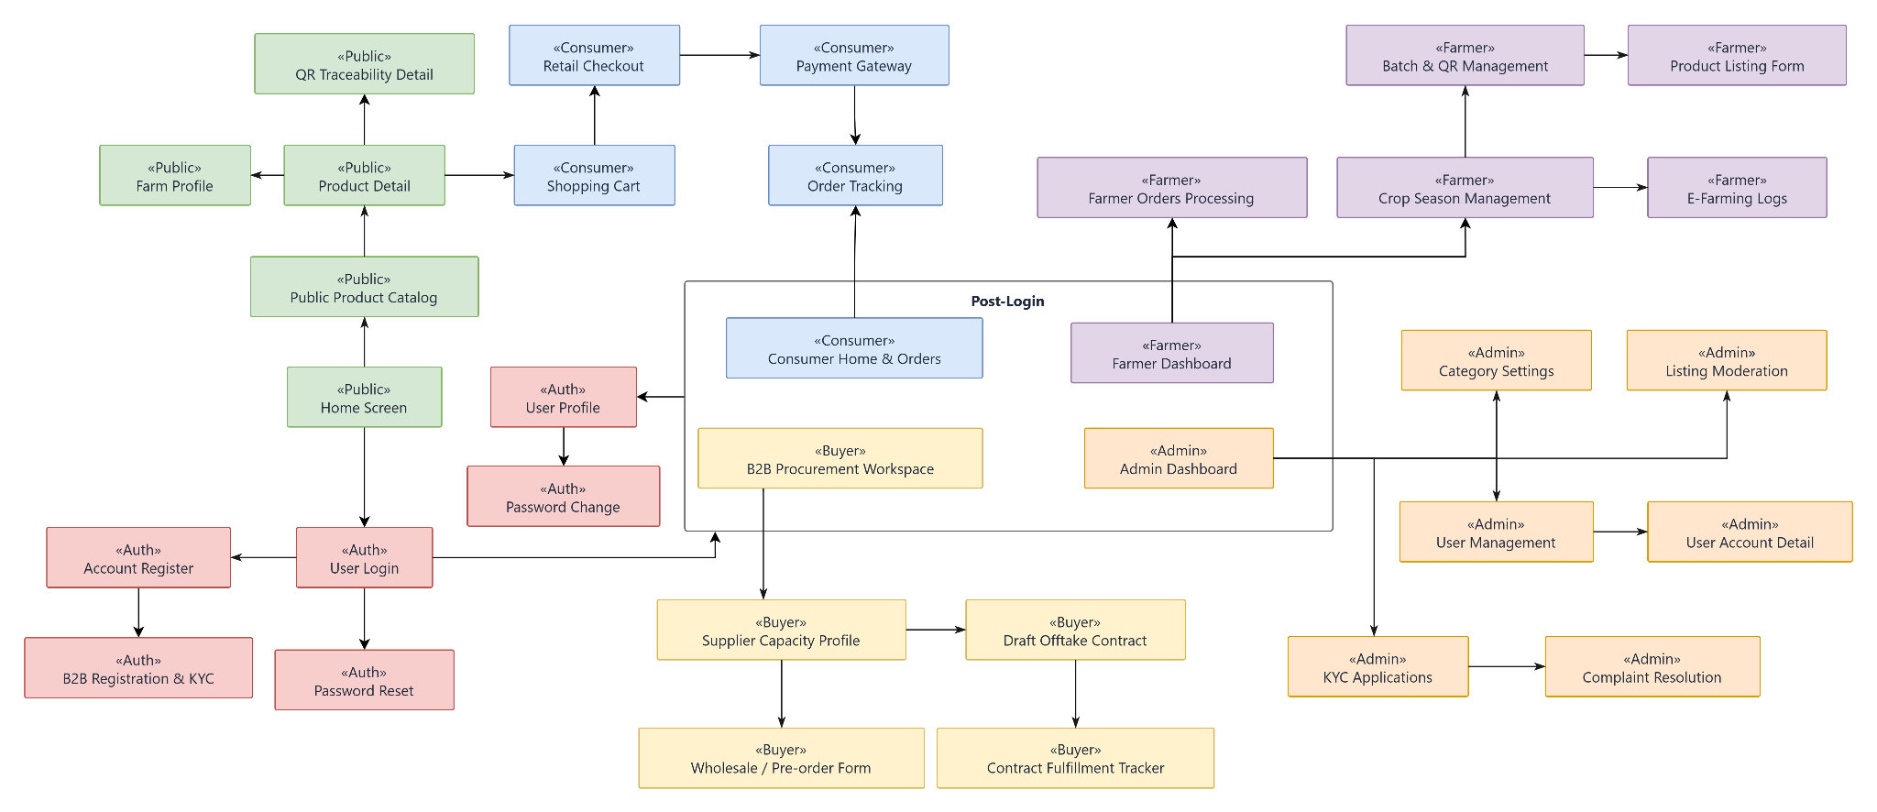

b. Screen List
# | Screen Name | Feature | Description
1 | Home Screen | Marketplace | Landing page displaying featured agricultural products, key platform highlights, and entry points for search and role-based login.
2 | Public Product Catalog | Marketplace | Allows guests and buyers to browse, search, and filter public agricultural products by name, category, region, season, or certification.
3 | Product Detail | Marketplace | Displays full product information including pricing, stock, descriptions, farm background, certifications, and eligible customer ratings.
4 | Farm Profile | Marketplace / Capacity | Displays public farm information, verified certifications, production capabilities, crop seasons, and listed agricultural items.
5 | QR Traceability Detail | Traceability | Displays origin batch logs, harvest dates, farming practices, and verified certification dossiers retrieved via batch code or QR scanning.
6 | User Login | Authentication | Allows registered users (Consumer, Farmer, Buyer B2B, Administrator) to authenticate and navigate to their role-specific workspaces.
7 | Account Register | Authentication | Enables new individual users to create either a Consumer or Farmer account using their phone number and initial security credentials.
8 | B2B Registration & KYC | Authentication | Allows corporate B2B buyers to submit enterprise profiles, tax codes, representative info, and legal dossiers for KYC verification.
9 | Password Reset | Authentication | Enables users to securely recover their forgotten account passwords via verification code confirmation.
10 | Password Change | Authentication | Allows logged-in users to update their account credentials after validating their current password against system policies.
11 | User Profile | Authentication & Profile | Enables users across roles to view and edit role-specific details, contact information, farm properties, or delivery addresses.
12 | Consumer Home & Orders | Consumer Ordering | Serves as the landing hub for consumers to access order records, track active shipments, and manage loyalty points or vouchers.
13 | Shopping Cart | Consumer Ordering | Allows consumers to view selected products, update package quantities, and review subtotal amounts before checkout.
14 | Retail Checkout | Consumer Ordering | Enables consumers to configure shipping addresses, apply reward points or discount vouchers, and initialize pending retail orders.
15 | Payment Gateway | Consumer Payment | Facilitates dynamic payment processing via VietQR / PayOS integrations and awaits webhook execution results.
16 | Order Tracking | Consumer Ordering | Provides tracking of delivery milestones, parcel tracking codes, driver handoffs, and fulfillment status for retail purchases.
17 | B2B Procurement Workspace | B2B Procurement | Central hub for wholesale buyers to search for farming cooperatives, filter supply capacity, and track off-take contracts.
18 | Supplier Capacity Profile | B2B Procurement | Shows comprehensive supplier metrics including cultivation area, crop calendar, seasonal yields, and trust ratings for B2B procurement.
19 | Wholesale / Pre-order Form | B2B Procurement | Allows verified B2B buyers to construct bulk wholesale purchase requests or reserve yields from upcoming harvest seasons.
20 | Draft Offtake Contract | B2B Contract Management | Provides drafting tools for commercial offtake commitments, outlining supply schedules, terms, pricing formulas, and quality clauses.
21 | Contract Fulfillment Tracker | B2B Contract Management | Tracks contractual delivery milestones, scheduled consignments, invoices, and acceptance logs for active offtake deals.
22 | Farmer Dashboard | Farmer Analytics | Offers producers an operational overview of active season revenue, cash flow stages, inventory summaries, and order requests.
23 | Crop Season Management | Farm Management | Allows farmers to schedule production plans, estimate yield dates, allocate plots, and monitor crop growth phases.
24 | E-Farming Logs | Farm Management | Enables farmers to record cultivation tasks such as irrigation, fertilization, pest interventions, and supporting photo records.
25 | Batch & QR Management | Product Traceability | Enables farmers to pack harvested output into traceable batches and generate distinct QR codes linked to farming journals.
26 | Product Listing Form | Product Management | Allows farmers to create, adjust, price, and submit crop listings under defined categories for public cataloging.
27 | Farmer Orders Processing | Farmer Sales Management | Allows agricultural producers to accept incoming retail and wholesale orders, manage dispatch packaging, and log carrier handovers.
28 | Admin Dashboard | Administration | Displays operational metrics, GMV growth, system KPIs, incident reports, and pending administrative review items.
29 | User Management | Administration | Provides administrators with user search directories to monitor activity, unlock, suspend, or terminate user access permissions.
30 | User Account Detail | Administration | Detailed view of a selected user's account history, connected roles, activity trail, and compliance flags.
31 | KYC Applications | Administration | Allows platform administrators to review submitted legal certificates, verify tax documentation, and approve or reject B2B/Farmer accounts.
32 | Listing Moderation | Administration | Moderation portal to inspect product content, evaluate origin documentation, and approve or reject public agricultural listings.
33 | Category Settings | Administration | Interface for administrators to organize hierarchical product taxonomies, measurement units, and filtering classifications.
34 | Complaint Resolution | Administration | Allows administrators to examine evidence, review order timelines, mediate buyer-seller conflicts, and issue final resolutions.

5.2 External API Inventory
# | API Name | Calling Path | Description
1 | PayOS / VietQR Payment Webhook | PayOS Gateway → AgriSustain | Inbound webhook receiving Instant Payment Notifications (IPN) upon successful VietQR bank transfers to transition orders to Paid status and update transaction records.
2 | Google Gmail Notification API | AgriSustain $→$ Google Gmail API | Dispatches account verification OTP codes, order confirmations, password reset links, and bilateral offtake signing alerts via Google Gmail.

5.3 Background Job Inventory
# | Job Name | Group | Description
1 | Expire Password Reset Tokens | Scheduled | Runs every 15 minutes to invalidate expired password-reset OTPs/tokens.
2 | Auto-Cancel Unpaid Retail Orders | Scheduled | Runs every 30 minutes to cancel retail orders that remain unpaid beyond the configured payment time limit; restores reserved inventory when applicable.
3 | Reconcile Payment Status | Scheduled | Runs every 15 minutes to re-check pending VietQR/PayOS payment transactions when a payment webhook is delayed or unavailable.
4 | Pre-Order Campaign Status Update | Scheduled | Runs every hour to automatically activate, close, or mark pre-order campaigns as completed based on start time, end time, capacity, and campaign rules.
5 | Contract Milestone Reminder | Scheduled | Runs daily at 8:00 AM to notify Buyers and Farmers about upcoming or overdue B2B contract milestones.
6 | Subscription Expiry Reminder | Scheduled | Runs daily at 8:00 AM to notify B2B Buyers before their membership subscription expires and update expired subscription status.
7 | Certificate Expiry Monitoring | Scheduled | Runs daily at 8:00 AM to identify certificates nearing expiry or already expired and notify Farmers/Admins.
8 | Pending KYC Review Reminder | Scheduled | Runs daily at 8:00 AM to notify Administrators of Consumer, Farmer, or Buyer accounts pending KYC approval.
9 | Notification Delivery Retry | Scheduled | Runs every 15 minutes to resend failed in-app, email, or system notifications.
10 | Archive Old Audit and Activity Logs | Scheduled | Runs monthly at 2:00 AM to archive old activity logs according to the platform’s data-retention policy.

II. Use Case Specifications

1. Authentication

1.1 UC-AUTH-01 - Register Consumer or Farmer Account

UC ID and Name: | UC-AUTH-01 - Register Consumer or Farmer Account
Created By: | DuND | Date Created:
Primary Actor: | Guest | Secondary Actors: | Google Gmail Notification API (API-02)
Summary: | As a Guest, I want to register a Consumer or Farmer account using a phone number, email, and password so that I can access the AgriSustain platform and start using role-specific features
Preconditions: | - - The user is not currently logged in (Guest).  - - The user has a phone number and an email address that are not already registered on the platform (PhoneNumber and Email are each UNIQUE in the Accounts table).  - The Account Register screen is accessible from the public website.
Postconditions: | - - A new Account record is created with Role = Consumer or Farmer and Status = Pending.  - - For a Consumer registration, the corresponding Consumers profile is created immediately (self-service; RewardPointsBalance = 0).  - - For a Farmer registration, no Farmers profile is created yet; it is instantiated only after the Account is approved by an Admin (Status = Approved), with ReputationScore defaulting to 5.00.  - The password is hashed (bcrypt/Argon2); the plain-text password is never persisted.
Dependency: | Google Gmail Notification API (API-02) - used to dispatch the account verification OTP email.
Description of main sequence: | - Guest navigates to the Account Register screen and selects the account type: Consumer or Farmer.  - Guest enters the required information: Full Name, Phone Number, Email, Password, and Confirm Password.  - Guest accepts the Terms of Service / Privacy Policy.  - Guest clicks the Register / Sign Up button.  - System validates the input fields (required fields, phone format, password policy, uniqueness of PhoneNumber and Email).  - System sends an OTP verification code to the registered Email via the Google Gmail Notification API.  - Guest enters the OTP code and clicks Verify.  - System verifies the OTP, hashes the password, and creates the Account record with Status = Pending.  - System creates the corresponding Consumers profile (Consumer) or defers profile creation until Admin approval (Farmer), then redirects the Guest to the User Login screen.
Description of alternative sequences: | - AF1 - Invalid / Incomplete Input (at Step 5):  - System detects missing required fields, invalid phone/email format, a weak password, or a mismatched Confirm Password, displays inline validation errors, and lets the Guest correct the input and resubmit.  - AF2 - Phone Number or Email Already Registered (at Step 5):  - System finds an existing Account with the same PhoneNumber or Email and displays an error message; the Guest may go to the User Login screen or enter different information.  - AF3 - Choose Farmer Role (at Step 1):  - System may request additional basic farm information (Farm Name); the Account is still created with Status = Pending, and the Farmers profile is created only after Admin approval.  - AF4 - Resend OTP (at Step 7):  - If the Guest does not receive the OTP email within 60 seconds, the Guest may request Resend OTP; the system invalidates the old code, generates a new one, and resends it via the Google Gmail Notification API.  - AF5 - Cancel Registration:  Guest clicks Cancel; no Account record is created.
Exceptions: | - - E1 - System / Database Error (at Step 8):  - - If Account creation fails, the system rolls back the transaction, displays a generic error message, and logs the error.  - - E2 - OTP Delivery Failure (at Step 6):  - If the Google Gmail Notification API does not respond, the system logs the error and displays "Failed to send verification code. Please try again later."
Nonfunctional requirements: | - Registration form response time <= 3 seconds under normal network conditions.  - Password policy: minimum 8 characters, at least 1 letter and 1 digit.  - Password is stored only as a secure hash (bcrypt/Argon2); plain text is never stored.  - PhoneNumber and Email are each unique across the platform.  - Only HTTPS is used for transmission of credentials.
Outstanding questions: | Should Farmer registration require immediate KYC document submission at this step, or can it be deferred to a later profile-completion use case (UC-AUTH-03) before Admin approval?

1.2 UC-AUTH-03 - Manage Profile

UC ID and Name: | UC-AUTH-03 - Manage Profile
Created By: | DuND | Date Created:
Primary Actor: | Consumer, Farmer, Buyer B2B | Secondary Actors:
Summary: | As a registered Consumer, Farmer, or Buyer B2B, I want to view, complete, and update my role-specific profile information (delivery address, farm details, or business information) so that the platform can support ordering, selling, and B2B procurement correctly.
Preconditions: | - The user is logged in with a valid Account (see UC-AUTH-04).  - Account.Status = Approved. For Consumer, the account is Active immediately upon self-registration; for Farmer and Buyer B2B, the corresponding Farmers/Buyers profile only exists once the Account has been Approved by Admin (profiles are instantiated on approval, not at registration).  - The User Profile / Farm Management screen is accessible from the account navigation menu.
Postconditions: | - Account.UpdatedAt is refreshed.  - The corresponding Consumers, Farmers, or Buyers profile record is updated with the new values.  - If Email or PhoneNumber was changed, uniqueness has been re-validated per the platform's Unique-Email / Unique-Phone business rules before commit.  - If a KYC-verified field (TaxCode, business license, or critical farm/legal info) was changed, the profile is flagged for Admin re-KYC review (UC-ADM-02) instead of being applied silently.  - System displays a success confirmation and refreshes the profile view.
Dependency: | UC-AUTH-01 / UC-AUTH-02 (Account must already exist) and UC-AUTH-04 (user must be logged in)
Description of main sequence: | - User selects "Profile Settings" (or "Farm Management" for Farmer) from the account/navigation menu.  - System navigates to the User Profile screen and retrieves current data from Accounts plus the role-specific table (Consumers / Farmers / Buyers) based on Role.  - System displays the form fields:  - Common: Email, PhoneNumber, Avatar.  - Consumer: FullName, DeliveryAddress, RewardPointsBalance (read-only).  - Farmer: FarmName, RepresentativeName, Address, Region, FarmSizeHectares, ReputationScore (read-only).  - Buyer B2B: CompanyName, TaxCode (read-only after KYC approval), BusinessLicenseURL, Address, BuyerType.  - User edits the desired fields and/or uploads a new avatar/farm photo.  - User clicks Save Changes.  - System validates input (required fields, address format, FarmSizeHectares > 0, and re-checks Email/PhoneNumber uniqueness if either was changed).  - System updates the Accounts record and the corresponding Consumers/Farmers/Buyers record in a single transaction, setting Account.UpdatedAt.  - If a KYC-locked field was changed, system flags the profile for re-KYC review instead of applying the change immediately.  - System displays "Profile updated successfully!" and refreshes the screen with the latest data.
Description of alternative sequences: | AF1 – Invalid / Incomplete Input (at Step 6): System shows inline validation errors; user corrects and resubmits.  AF2 – Farmer Updates Farm Size (at Step 4): Farmer updates FarmSizeHectares; system validates it is a positive number (> 0) and continues to Step 5.  AF3 – Buyer B2B Updates Business Documents (at Step 4): Buyer uploads a replacement BusinessLicenseURL; if TaxCode or the license is changed, the update routes into the re-KYC flow (Step 8) instead of applying directly.  AF4 – Cancel / Discard Changes (at Step 4): User cancels; if there are unsaved changes, system asks for confirmation before discarding them and restores the original values.
Exceptions: | - E1 – Unauthorized Access (at Step 1): If the session is invalid or the user is not the profile owner, system denies access and redirects to Login.  - E2 – System / Database Error (at Step 7): System rolls back the transaction, logs the error, and displays a generic error message.  - E3 – Concurrent Update Conflict (at Step 7): If the record was modified elsewhere since it was loaded, system notifies the user and reloads the latest data before allowing a retry.
Nonfunctional requirements: | - Load/save response time ≤ 3 seconds under normal network conditions.  - TaxCode and other KYC-verified legal fields cannot be edited directly once Approved; changes must route through re-KYC (UC-ADM-02).  - Only the account owner (matching AccountID) may write to this profile data (per Permission Matrix, Admin has Full access as well, likely via a separate admin function).  - Sensitive data is transmitted only over HTTPS.  - If avatar/farm-photo upload is implemented: file formats limited to PNG/JPG/JPEG, ≤ 5 MB.
Outstanding questions: | - Should avatar/farm-photo upload and GPS coordinates for Farmers be added as new ERD attributes and a new external Cloud File Storage dependency, since neither exists in the current Entity Descriptions or External API Inventory?  - Per Data Business Rule "Unique email... enforced on profile update," should Email be confirmed as editable (not read-only), and if so, does changing it require re-verification (OTP) similar to registration?  - Should multiple saved delivery addresses for Consumer be supported, or does the current single DeliveryAddress field remain the scope for this release?  - Does changing FarmSizeHectares/Region or Buyer TaxCode/BusinessLicenseURL require mandatory re-KYC before the new value takes effect, or can it apply immediately with a background admin-review flag?  - The Permission Matrix also grants Admin "Full" access to "View/update own profile" — should Admin's own profile be managed by this same UC, or by a separate Admin-only UC?

1.3 UC-CON-04 - Track Retail Order
UC ID and Name: | UC-CON-04 - Track Retail Order
Created By: | DuND | Date Created:
Primary Actor: | Consumer | Secondary Actors:
Summary: | As a Consumer, I want to view my order history and track the real-time progress of retail orders (payment status, packing, shipping, delivery) — including item details, supplying farmer info, and financial breakdown — so that I know when my agricultural products will arrive and can take follow-up actions (pay, review, or complain) at the right time.
Preconditions: | - The Consumer is logged in with a valid Account (Role = Consumer).  - The Consumer accesses the order management page from the account navigation menu, or is redirected there right after placing an order.
Postconditions: | - The order list or order detail is displayed accurately for the Consumer.  - No order data is modified (this is a read-only use case), except that the related Notification record's IsRead flag may be updated if the Consumer opened the screen from an order notification.  - The Consumer can navigate to related actions (Pay Now, Review, Complaint) if the current OrderStatus allows.
Dependency: | UC-CON-02 - Place Retail Order (at least one order must exist)
Description of main sequence: | - Consumer selects "My Orders" from the account navigation menu, or is redirected there after placing an order.  - System retrieves the list of Orders where AccountID matches the current Consumer, sorted by CreatedAt descending.  - System displays the order list as cards/rows: OrderCode, Order Date, FinalAmount, current OrderStatus (PendingPayment, Paid, Processing, Shipping, Completed, Cancelled), and quick-filter tabs by status.  - Consumer clicks "View Details" or taps a specific order.  - System navigates to the Order Tracking screen.  - System retrieves order detail by joining Orders, OrderItems, Products, ProductBatches, and Farmers.  - System displays the full order detail:  - Timeline stepper: Order Placed (PendingPayment) → Paid → Processing (Farmer packing) → Shipping → Completed.  - Delivery info: recipient name, phone, shipping address, estimated/actual delivery date (if available).  - Item list: product name, image, BatchCode, unit price, quantity, subtotal per item.  - Financial summary: subtotal, shipping fee, DiscountAmount (reward points applied), FinalAmount, PaymentMethod.  - Context-aware action buttons based on OrderStatus (e.g., "Review Product" or "Complaint" when Completed).
Description of alternative sequences: | AF1 – Filter / Search Orders (at Step 3): Consumer filters by status tab (All, Pending Payment, Processing, Shipping, Completed, Cancelled) or searches by product name/OrderCode; system reloads the matching list.  AF2 – Empty Order History (at Step 2): If the Consumer has no orders yet, system shows an empty-state message ("You have no orders yet.") with a link to the Public Product Catalog.  AF3 – Continue Payment for Pending Order (at Step 7): If OrderStatus = PendingPayment and the payment window has not expired, system shows a "Pay Now" button; tapping it triggers UC-CON-03 (Pay Retail Order).  AF4 – Review Completed Order (at Step 7): If OrderStatus = Completed and the product has not yet been reviewed, system shows a "Review" button that opens UC-CON-05 (Submit Product Review).  AF5 – Submit Complaint (at Step 7): If the order is Completed but within the allowed complaint window and an issue occurred, system shows a "Return / Complaint" button that opens UC-CON-06 (Submit Order Complaint).  AF6 – Refresh Order Status (at Step 7): Consumer pulls to refresh (or the screen auto-refreshes); system re-queries the latest OrderStatus and updates the view.
Exceptions: | E1 – Order Not Found (at Step 2 or 5): If the OrderCode doesn't exist or the URL/reference is invalid, system displays "Order not found. Please verify the order reference code." with a link back to the order list.  E2 – Unauthorized Access to Another Consumer's Order (at Step 5): If the requested OrderID's AccountID does not match the current logged-in user (e.g., via a manipulated URL), system denies access, displays "You do not have permission to view this order.", and logs a security event.  E3 – System / Database Error: System displays a generic error message and logs the issue.
Nonfunctional requirements: | - Order list and detail load time ≤ 3 seconds under normal conditions.  - Every order-detail query must verify data ownership (AccountID = current logged-in user) before returning results.  - Timeline milestones must be color-coded clearly (e.g., green for Completed, orange for Shipping, red for Cancelled).  - Only the owning Consumer (or an Administrator) may view the order; sensitive payment information is masked where appropriate.
Outstanding questions: | - Should the system send a push/in-app/SMS notification automatically whenever the Farmer updates the packing or carrier-handover step, or is pull-to-refresh sufficient for this release?  - Since there is no dedicated Shipment/Carrier entity in the current ERD, are the delivery milestones and any tracking code sourced purely from manual Farmer input, or does the platform plan to integrate a real third-party shipping/tracking API later?  - How long is full order history retained after completion, and should Cancelled/failed orders be hidden by default or only shown via filter?

1.4 UC-AUTH-04 Sign In Screen

UC ID and Name: | UC-AUTH-04 Sign In Screen
Created By: | TuTB | Date Created: | 27/09/2026
Primary Actor: | Consumer, Farmer, Buyer B2B, Administrator | Secondary Actors: | None
Summary: | As an authenticated user, I want to log out of the system so that my account session is securely terminated and unauthorized users cannot access my account.
Preconditions: | - The user has already registered an account in the system.  - The user's account is active and allowed to access the system.  - The user has access to the Login screen.
Postconditions: | - The user is successfully authenticated.  - The system creates an authenticated session for the user.  - The system identifies the user's role.  - The user can access functions authorized for their role.
Dependency: | None
Description of main sequence: | - The user accesses the Login page.  - The system displays the Login form.  - The user enters their login information:Email, Password  - The user clicks the Login button.  - The system validates that the required login information has been provided.  - The system searches for the account associated with the entered email.  - The system verifies the entered password against the stored password.  - The system checks whether the user's account is active and authorized to log in.  - The system authenticates the user successfully.  - The system identifies the user's role:  - Consumer  - Farmer  - Buyer B2B  - Administrator  - The system creates an authenticated session for the user.  - The system redirects the user to the appropriate page based on the user's role.
Description of alternative sequences: | AF1 – User accesses Login as Guest  At Step 1:  - A Guest accesses the Login page.  - The system displays the Login form.  - The Guest enters a registered account's email and password.  - Return to Step 4 of the Normal Flow.  - After successful authentication, the Guest becomes an authenticated user according to the account's assigned role.
Exceptions: | E1 – Email is empty (at Step 5)  The system detects that the Email field is empty.The system displays: "Email is required." The user must enter an email address before continuing.  E2 – Password is empty (at Step 5)  The system detects that the Password field is empty. The system displays: "Password is required." The user must enter a password before continuing.  E3 – Account does not exist (at Step 6)  The system cannot find an account associated with the entered email. The system displays: "Invalid email or password." The user remains on the Login page and can try again.  E4 – Incorrect password (at Step 7)  The system detects that the entered password does not match the stored password. The system displays: "Invalid email or password." The user remains on the Login page and can enter the credentials again.  E5 – Account is inactive or blocked (at Step 8)  The system detects that the user's account is inactive or blocked. The system displays: "Your account is inactive or blocked. Please contact the administrator." The system does not create an authenticated session.  E6 – Authentication failure (at Step 9)  The system encounters an unexpected authentication error. The system displays: "Unable to log in at this time. Please try again later." The user remains unauthenticated.  E7 – Database connection failure (at Step 6)  The system cannot access the database to verify the user's account. The system displays: "An error occurred while logging in. Please try again later." The system does not create an authenticated session.
Nonfunctional requirements: | - Login requests shall be transmitted using HTTPS.  - Passwords must never be stored in plain text.  - Passwords shall be stored using a secure salted hashing mechanism such as BCrypt or Argon2.  - The system shall not expose the user's password in API responses, logs, or error messages.  - The system shall enforce role-based access control after successful authentication.  - An authenticated user shall only access functions permitted for their assigned role.  - The system shall securely manage the user's authentication session.
Outstanding questions: | - Should the system lock an account after a specific number of consecutive failed login attempts?  - Should the system require email verification before the first login?  - Should the system provide a "Remember Me" option?  - Should Administrator have a separate login page from the other user roles?

1.5 UC-AUTH-06 Change Password

UC ID and Name: | UC-AUTH-06 Change Password
Created By: | ThuongNQ | Date Created: | 27/09/2026
Primary Actor: | Authenticated User (Consumer, Farmer, Buyer B2B, Administrator) | Secondary Actors: | None
Summary: | As an authenticated user, I want to change my current account password so that I can maintain account security and prevent unauthorized access.
Preconditions: | - The user is logged into the system with an active session (Status is Approved/Active).  - The user navigates to the Password Change screen (from User Profile / Account Settings).
Postconditions: | The new password hash is stored in the database (Accounts.PasswordHash), the old password is invalidated, and an activity log entry is recorded.
Dependency: | None
Description of main sequence: | - The user navigates to Account Settings and selects the Change Password option.  - The system displays the Password Change form with fields: Current Password, New Password, Confirm New Password, and policy requirements.  - The user inputs their Current Password, New Password, and Confirm New Password, then clicks Save / Update Password.  - The system validates the inputs:  - Current Password matches the user's stored password hash.  - New Password complies with password complexity policy (minimum 8 characters, includes uppercase, lowercase, numbers, and special characters).  - New Password is different from the Current Password.  - New Password matches Confirm New Password.  - The system hashes the new password securely and updates PasswordHash and UpdatedAt in the Accounts database table.  - The system revokes any concurrent active tokens/sessions except the current session.  - The system records the password change event into the Activity Log.  - The system displays a success toast notification: "Password updated successfully. Please use your new password for future sign-ins."
Description of alternative sequences: | AF1 – User cancels the change request (at Step 3):  - The user clicks Cancel or navigates away.  - The system discards input values without updating credentials.  - The system returns the user to the User Profile screen.
Exceptions: | E1 – Input fields are empty (at Step 4):  The system displays an inline validation error: "The field is required" under each blank field.  E2 – Current password is incorrect (at Step 4):  The system highlights the Current Password field and displays an error message: "The current password you entered is incorrect. Please try again." The system tracks the failed attempt.  E3 – New password does not meet security complexity (at Step 4):  The system displays a warning specifying missing criteria (e.g., "Password must be at least 8 characters long and contain both letters and numbers").  E4 – New password matches current password (at Step 4):  The system displays an error message: "New password cannot be the same as your current password."  E5 – New password and confirm password do not match (at Step 4):  The system displays an error under Confirm New Password: "Passwords do not match."  E6 – Database update failure (at Step 5):  The system encounters an unexpected failure, rolls back the transaction, displays an error message ("An error occurred while changing your password. Please try again later."), and writes an error log.
Nonfunctional requirements: | - Passwords must never be stored in plain text and must be encrypted using strong salted hashing (e.g., BCrypt / Argon2).  - The response time for form submission and password updating shall be under 2 seconds.  - Password change requests must be strictly submitted via secure HTTPS.
Outstanding questions: | - Should the system automatically log the user out of the current session upon successful password change and require re-login, or retain the active session?  - Should an SMS OTP or email confirmation code be required before submitting the password change?

1.6 UC-AUTH-07 - Reset Password

UC ID and Name: | UC-AUTH-07 - Reset Password
Created By: | HuyNV | Date Created: | 28/09/2026
Primary Actor: | Guest / Registered User | Secondary Actors: | Gmail Notification Service API
Summary: | User requests a password reset, verifies the code sent to the registered email, and sets a new password to regain account access.
Preconditions: | User is not logged in; Password Reset screen (#9) is accessible from Sign In; user can access the registered email address.
Postconditions: | Password is updated only after successful code and password validation; password is stored only as a secure hash; reset code/token is invalidated; system displays success and redirects to Sign In.
Dependency: | None
Description of main sequence: | 1. User selects Forgot Password on Sign In.  2. System displays the Password Reset screen.  3. User enters registered email and selects Send Verification Code.  4. System validates email format, creates a single-use reset code for an eligible account, and sends it by email.  5. User enters the verification code and selects Verify.  6. System validates the code and displays the reset-password step.  7. User enters New Password and Confirm New Password.  8. User selects Reset Password.  9. System validates password policy and matching confirmation.  10. System securely updates the password, invalidates the reset code, displays success, and redirects to Sign In.
Description of alternative sequences: | AF1 – Resend Code: User selects Resend Code; system invalidates the prior code and sends a replacement according to configured limits.  AF2 – Cancel: User selects Back to Sign In; system ends the reset flow without changing the password.  AF3 – Invalid Password: System displays validation errors and allows the user to retry.
Exceptions: | E1 – Invalid or expired code: System rejects verification and asks the user to request a new code.  E2 – Code delivery failure: System logs the failure and displays MSG26.  E3 – Password mismatch: System displays a field-level error and does not update the password.  E4 – System failure: System keeps the existing password unchanged, logs the error, and shows a generic error message.
Non-functional Requirements: | Reset-request and password-update acknowledgement shall complete within 2 seconds under normal load.  Passwords must be transmitted over HTTPS and stored only as hashes.  Passwords must satisfy the existing policy: at least 8 characters, including a letter and a digit.  The system must not expose technical errors or credentials.
Outstanding Questions: | What are the exact expiry period, resend delay, and maximum verification attempts for a reset code?  Should a successful reset revoke all active sessions immediately?  Should the system always show the same acknowledgement whether or not the submitted email is registered?

2. Marketplace

2.1 UC-MKT-01 Browse Marketplace

UC ID and Name: | UC-MKT-01 - Browse Marketplace
Created By: | ThuongNQ | Date Created: | 27/09/2026
Primary Actor: | Guest, Consumer, Buyer B2B | Secondary Actors: | None
Summary: | As a platform visitor or registered buyer, I want to browse, search, and filter public agricultural produce listings by criteria such as product category, farm origin, region, season, or standard certifications so that I can easily discover suitable agricultural items to purchase.
Preconditions: | - The user accesses the public AgriSustain web interface (Home Screen or Public Product Catalog).  - Only approved products (IsApproved = true) from active seller accounts are eligible for public display
Postconditions: | - The system retrieves and displays a paginated list of matching agricultural products matching the active filters.  - Filter and search states are reflected in the URL parameters for bookmarking/sharing.
Dependency: | None
Description of main sequence: | - The user navigates to the Public Product Catalog The user navigates to the Public Product Catalog / Marketplace screen.  - The system loads and displays the default product list (e.g., newest or featured items) along with the category navigation bar, search input, and filter facets (Category, Province/Region, Crop Season, Certification badges like VietGAP/GlobalGAP/Organic, Price range, Rating).  - Each product card displays: primary image, product name, retail price per unit, measurement unit, supplier farm name, region, and verified certification badges.  - The user enters keywords into the search box or selects specific filter parameters (e.g., category: "Vegetables", certification: "VietGAP", region: "Da Lat").  - The user selects a sort option (e.g., Price Low-to-High, Price High-to-Low, Top Rated, Newest Arrival).  - The system queries the database, applying: IsApproved = true, matching keyword in ProductName/Description, category criteria, and active certification badges.  - The system renders the filtered, sorted, and paginated product catalog results.  - The user clicks on a product card to view detailed specifications (transitions to UC-MKT-02: View Product Detail).
Description of alternative sequences: | AF1 – Reset/Clear Filters (at Step 4):  - The user clicks Clear All Filters.  - The system resets all query parameters and reloads the default catalog view.  AF2 – Change Page / Pagination (at Step 7):  - The user selects a specific page number or clicks Next Page.  - The system fetches and renders the next subset of records (e.g., 12 or 24 items per page).
Exceptions: | E1 – No products match the search or filter criteria (at Step 7):  The system displays an empty state message ("No products found matching your search criteria. Please try adjusting your filters." - MSG01) and suggests popular products or clearing filters.  E2 – Network or database timeout occurs (at Step 6):  The system displays a friendly service unavailability notice with a Retry button without breaking the UI layout.
Nonfunctional requirements: | - The catalog page and search filter queries shall load within 2 seconds under concurrent traffic of up to 100 simultaneous users.  - Public browsing must be completely accessible without requiring user authentication.  - Search queries must sanitize user inputs to prevent SQL Injection or XSS vulnerabilities.
Outstanding questions: | - Should Wholesale/B2B tiered pricing be visible on the public catalog, or should only standard retail prices be shown to Guests/Consumers?  - Will full-text search utilize database LIKE queries or an external search engine (e.g., Elasticsearch)?

2.2 UC-MKT-02 View Product Detail

UC ID and Name: | UC-MKT-02 - View Product Detail
Created By: | ThuongNQ | Date Created: | 27/09/2026
Primary Actor: | Guest, Consumer, Buyer B2B | Secondary Actors: | None
Summary: | As a customer or prospective buyer, I want to view comprehensive details of a specific agricultural product—including description, pricing, available stock/batch information, farm background, certifications, and customer reviews—so that I can evaluate its quality before purchasing.
Preconditions: | - The product exists in the system catalog and has been approved by the Administrator (IsApproved = true).  - The user selected a product card from the catalog, home page, or accessed the product via a direct link/QR scan.
Postconditions: | - The system presents full product specifications and enables purchase actions (e.g., Add to Cart, Buy Now, or Inquire B2B) depending on the actor's logged-in role.  - Product page view count is incremented for analytical metrics.
Dependency: | None
Description of main sequence: | - The user navigates to the Product Detail page by clicking on a product listing or opening a direct product URL.  - The system retrieves and presents full product information:  - Image gallery and media.  - Product name, unit, category, and comprehensive description.  - Pricing (Retail unit price; B2B price framework displayed if authenticated as Buyer B2B).  - Batch status and remaining available inventory quantity (QuantityAvailable across active ProductBatches).  - Farm profile summary: Farm name, location/region, and reputation score.  - Valid certification badges (VietGAP, GlobalGAP, Organic) with verification status and certificate numbers.  - Traceability summary and link to view full origin log (E-Farming log link).  - Average star rating and list of approved customer reviews and feedback comments (ProductReviews).  - The user inspects product specifications, certifications, and customer feedback.  - The user selects the desired quantity and clicks Add to Cart or Buy Now (for Consumer) or initiates a bulk quotation (for B2B Buyer).  - The system validates quantity availability against active batch stock and routes to UC-CON-01 (Manage Shopping Cart) or retail checkout.
Description of alternative sequences: | AF1 – View Farm Profile (at Step 3):  - The user clicks on the supplier's farm name.  - The system redirects the user to the Farm Profile screen displaying cultivation area, active seasons, and verified badges.  AF2 – View Traceability Data (at Step 3):  - The user clicks View Traceability / QR Log.  - The system executes UC-TRC-01 (View Product Traceability) displaying crop season details, sowing/harvest dates, and daily e-farming activity logs.  AF3 – Filter Product Reviews (at Step 3):  - The user filters customer reviews by star rating (e.g., 5 stars, with pictures).  - The system updates the review list section dynamically.
Exceptions: | E1 – Product has been unpublished, rejected, or deleted (at Step 1):  The system detects that the product is no longer active or approved (IsApproved != true or deleted), displays a "Product is no longer available" error notice, and provides a link back to the Marketplace catalog.  E2 – Product is out of stock (at Step 2/Step 4):  The system displays an "Out of Stock" status badge, disables the quantity selector, and deactivates the Add to Cart / Buy Now buttons.  E3 – User inputs quantity exceeding available stock (at Step 4):  The system displays an error prompt: "The requested quantity exceeds current available stock ({QuantityAvailable} {Unit} available)" and sets the quantity input to the maximum available.
Nonfunctional requirements: | - The Product Detail page shall load within 2 seconds under normal network conditions.  - Unauthenticated Guests must be able to view details, descriptions, ratings, and farm backgrounds.  - If a certification associated with the farmer has expired (via background job JOB-03), the verified quality badge must be suppressed automatically on the product detail page.
Outstanding questions: | - Should retail consumers be able to choose a specific harvest batch code (ProductBatch), or does the system auto-assign batches according to FIFO (First In, First Out)?  - Can unauthenticated guests add products to a local temporary cart before being prompted to log in or register?

3. Farmer Sales

3.1 UC-FAR-06 - Process Order
UC ID and Name: | UC-FAR-06 - Process Order
Created By: | Lof Mạnh Xum | Date Created: | 27/09/2026
Primary Actor: | Farmer | Secondary Actors: | None
Summary: | Allows Farmers to monitor incoming orders, verify stock levels against traceable batches, accept orders, confirm packaging completion, hand over goods to couriers, or reject orders with documented reasons.
Preconditions: | - Farmer has successfully logged in with the Farmer role.  - There are orders containing products owned by the Farmer in "Confirmed" status.  - All line items in the order are linked to traceable batch codes.
Postconditions: | - Order status is updated sequentially (Processing -> Awaiting Shipper -> In Transit or Cancelled).  - Available stock of the corresponding batch is deducted immediately upon order acceptance.  - The customer and shipping partner receive order status updates.
Dependency: | None
Description of main sequence: | - The Farmer selects "Manage Orders".  - The system retrieves all orders containing the farmer's products and renders the order list with status counter badges (Pending Confirmation, Processing, Awaiting Shipper, In Transit, Delivered) and total revenue.  - The Farmer selects an order in "Confirmed" status and clicks "Confirm Order".  - The system validates each item: Verifies linked batch codes and checks whether batch available stock suffices.  - The system deducts available stock from the corresponding batches, updates the order status to "Processing", and commits changes.  - Once items are prepared and packed, the Farmer clicks "Packaging Complete".  - The system updates order status to "Awaiting Shipper" and dispatches a ready-for-pickup alert to the carrier.  - When the courier arrives to pick up packages, the Farmer verifies and clicks "Handed Over to Shipper".  - The system updates order status to "In Transit" and updates delivery tracking for the buyer.
Description of alternative sequences: | AF1 – Filter orders by status tab (at Step 2):  - The Farmer selects a status tab (All, Confirmed, Processing, Awaiting Shipper, Shipping, Delivered).  - The system queries and filters order records matching the active tab.  - The system renders the filtered order list along with corresponding revenue metrics.  AF2 – Reject / Cancel order by Farmer (at Step 3):  - For an order in "Confirmed" status, if goods fail quality checks or due to adverse weather, the Farmer clicks "Reject Order".  - The system presents a modal requiring a rejection reason.  - The Farmer inputs a detailed reason and clicks "Confirm".  - The system validates that the reason is non-empty, updates order status to "Cancelled", records the cancellation reason, and triggers the buyer refund process.
Exceptions: | - E1 – Order item unassigned to a traceable batch (at Step 4):  If an item lacks an assigned batch, the system halts confirmation and alerts: "Product [{Product Name}] has not been assigned a traceable batch code."  - E2 – Insufficient available batch inventory (at Step 4):  If batch available stock is less than the requested quantity, the system halts acceptance and displays: "Approval failed! Batch [{Batch Code}] only has {Stock Qty} in stock, which is insufficient for the ordered quantity ({Order Qty})."  - E3 – Invalid order status workflow transition (at Step 6 or Step 8):  If the Farmer clicks "Handed Over to Shipper" while the order is still in "Processing" (unconfirmed packaging), the system blocks execution and alerts: "Invalid operation or order is not in ready-for-handover status."  - E4 – Empty rejection reason (at AF2, Step 3):  If the Farmer submits cancellation without a reason, the system prevents submission and alerts: "A rejection reason is required to notify the buyer."
Non-functional Requirements: | - Performance: Order status transitions and inventory balance calculations must respond within 2 seconds.  - Transaction Integrity (ACID): Inventory checks, batch stock deductions, and order status transitions must execute within a single atomic transaction to strictly prevent overselling during concurrent order placements.  - Audit Trail: All state transitions and order cancellation reasons must record immutable timestamps and user identifiers.
Outstanding Questions: | In multi-vendor shopping cart scenarios where an order contains items from multiple farmers: If one farmer rejects their portion, does the system cancel and refund the entire master order, or split it into independent sub-orders so other farmers can fulfill normally?

4. Administration

4.1 Product Listing Moderation Screen

UC ID and Name: | UC-ADM-04 Moderate Product Listing
Created By: | TuTB | Date Created: | 27/09/2026
Primary Actor: | Administrator | Secondary Actors: | None
Summary: | As an Administrator, I want to review and moderate product listings submitted by Sellers so that only products that meet the system requirements can be displayed on the Marketplace.
Preconditions: | - The Administrator has successfully logged into the system.  - The Administrator has permission to access product moderation functions.  - The Seller has submitted a product listing for approval.  - The product listing exists in the system.
Postconditions: | - The product listing is approved, rejected, or removed from the Marketplace.  - The system updates the product listing status accordingly.  - The Seller can view the result of the moderation process.  - An approved product can be displayed on the Marketplace according to the product visibility rules.
Dependency: | None
Description of main sequence: | - The Administrator navigates to the Administration section.  - The Administrator selects Product Listing Moderation.  - The system displays the Product Listing Moderation Screen.  - The system displays product listings that require moderation.  - The Administrator selects a product listing to review.  - The system displays the product information, including:  - Product name  - Product category  - Product description  - Product images  - Price  - Available quantity  - Seller information  - Farm information  - Traceability information  - Quality-related documents, if available  - The Administrator reviews the submitted product information.  - The Administrator checks whether the product information complies with the system's requirements.  - The Administrator chooses one of the available actions:  - Approve  - Reject  - Force Delist  - If the Administrator selects Approve, the system updates the product listing status to Approved.  - The system makes the product eligible to be displayed on the Marketplace according to its visibility and activation status.  - If the Administrator selects Reject, the system requests a rejection reason.  - The Administrator enters the rejection reason and confirms the rejection.  - The system updates the product listing status to Rejected and stores the rejection reason.  - The system notifies the Seller about the moderation result.  - The system returns the Administrator to the Product Listing Moderation Screen.
Description of alternative sequences: | AF1 – Administrator searches or filters product listings  At Step 4:  - The Administrator enters a search keyword or selects a filter.  - The system filters the product listings according to the selected criteria.  - The system displays the matching product listings.  - The Administrator selects a product listing.  - Return to Step 6 of the Main Sequence.  AF2 – Administrator rejects a product listing  At Step 9:  - The Administrator selects Reject.  - The system displays a field requiring the Administrator to provide a rejection reason.  - The Administrator enters the reason.  - The Administrator confirms the rejection.  - The system changes the product listing status to Rejected.  - The system stores the rejection reason.  - The system notifies the Seller.  - The system returns to the Product Listing Moderation Screen.  AF3 – Administrator force delists an approved product  At Step 9:  - The Administrator selects Force Delist for an existing product.  - The system displays a confirmation dialog.  - The Administrator provides the reason for delisting.  - The Administrator confirms the action.  - The system changes the product visibility to unavailable.  - The product is removed from the Marketplace.  - The system stores the delisting reason.  - The system notifies the Seller.
Exceptions: | E1 – Product listing information is incomplete(At Step 6)  The system detects that required product information is missing. The system displays the available information and indicates the missing fields. The Administrator may reject the listing and provide a rejection reason.  E2 – Product listing does not meet requirements(At Step 8)  The Administrator determines that the product does not satisfy the system's requirements .The Administrator selects Reject. The system requires a rejection reason before completing the action.  E3 – Product listing cannot be found(At Step 5)  The system cannot find the selected product listing. The system displays: "The product listing could not be found." The system returns the Administrator to the moderation list.  E4 – Database update failure(At Step 10 or Step 14)  The system encounters an error while updating the product listing status. The system does not complete the moderation operation and displays: "An error occurred while updating the product listing. Please try again later."
Nonfunctional requirements: | - Only users with the Administrator role shall be able to access the Product Listing Moderation Screen.  - Product listing information shall be displayed accurately and consistently.  - Product status updates shall be stored consistently in the database.  - The system shall prevent unauthorized users from approving, rejecting, or delisting products.  - The system shall validate the rejection or delisting reason before completing the corresponding action.  - The system shall prevent accidental deletion or delisting through a confirmation step.  - Product listing moderation operations should not result in partial or inconsistent database updates.
Outstanding questions: | - Should a rejected product be allowed to be edited and resubmitted by the Seller?  - Should the Administrator be required to enter a reason for every rejection and force delisting?  - Should an approved product be automatically visible on the Marketplace, or should the Seller still control its visibility?  - Should the system allow the Administrator to preview the product's traceability QR information before approval?

4.2 UC-ADM-03 - Manage User Account Status

UC ID and Name: | UC-ADM-03 - Manage User Account Status
Created By: | HuyNV | Date Created: | 28/09/2026
Primary Actor: | Administration | Secondary Actors: | None
Summary: | As an Administrator, I want to search, filter, inspect user accounts, and suspend, activate, or unlock eligible accounts so that platform access is managed securely and account actions are traceable.
Preconditions: | 1. Administrator is authenticated with an Active account and Role = Administrator.  2. Administrator is authorized to access User Management .  3. Target accounts exist in the system.
Postconditions: | 1. The selected account status or temporary lock state is updated only after a valid confirmation.  2. Every status change records Acting Administrator, Target Account, date/time, previous status, new status, and reason, in accordance with GBR-07.  3. The User Management list and User Account Detail view display the latest state.  4. No data is changed when the action is cancelled or validation fails.
Dependency: | None
Description of main sequence: | 1. Administrator opens User Management from the administration navigation.  2. System displays paginated user records, search, Role filter, and Account Status filter; default page size is 10 records.  3. Administrator optionally enters a keyword or selects filters, then selects Search.  4. System displays matching User/Entity Name, Email, Phone Number, Role, Account Status, KYC Status, Created Date, and available actions.  5. Administrator selects Suspend, Activate, or Unlock for an eligible account.  6. System displays a confirmation dialog. A reason is mandatory for Suspend or Activate.  7. Administrator enters the reason where required and selects Confirm.  8. System validates permissions, target-account eligibility, and GBR-05, GBR-06, and GBR-07.  9. System updates the account status or clears the temporary lock, writes the audit log, refreshes the list, and displays a success confirmation.
Description of alternative sequences: | AF1 - View Details: Administrator selects View Details; system opens User Account Detail (screen #30).  AF2 - No Results: System displays MSG01 - No search results. and preserves filters.  AF3 - Cancel Action: Administrator cancels the confirmation dialog; system makes no change and writes no audit log.  AF4 - Pagination: Administrator selects a page or Next/Previous; system displays the requested page.
Exceptions: | E1 - Unauthorized access: System denies the request; the web UI redirects to Sign In, while an API returns HTTP 403.  E2 - Self-management: System blocks Suspend, Activate, or Unlock on the acting Administrator’s own account and shows MSG33.  E3 - Missing reason: System blocks Suspend/Activate confirmation and shows a required-field message such as MSG02.  E4 - Concurrent update: System reloads the latest target-account state and requires confirmation again.  E5 - Database update failure: System rolls back the transaction, logs the error, and displays a generic error message without exposing technical details.
Non-functional Requirements: | 1. Search, filtering, and update acknowledgement shall complete within 2 seconds under normal load.  2. Only authorized Administrators may access account-management actions.  3. Every status change must be atomic and audit logged.  4. Dates use dd/MM/yyyy HH:mm; lists display 10 records per page by default.  5. KYC/legal information is visible only to authorized roles under GBR-08.
Outstanding Questions: | 1. Should User Account Detail expose KYC documents, or must those remain only in UC-ADM-02 - Review KYC Application?  2. Must a suspension immediately revoke active sessions/tokens, or only prevent subsequent sign-in?  3. Is a reason required for Unlock, or only for Suspend/Activate?

4.3 UC-ADM-05 - Manage Product Categories

UC ID and Name: | UC-ADM-05 - Manage Product Categories
Created By: | HuyNV | Date Created: | 28/09/2026
Primary Actor: | Administration | Secondary Actors: | None
Summary: | As an Administrator, I want to create, view, update, activate, deactivate, and delete product categories so that marketplace products are consistently classified and managed.
Preconditions: | 1. The Administrator is authenticated with an Active account and Role = Administrator.  2. The Administrator has permission to access Category Settings / Product Category Management (screen #33).  3. The system is available to retrieve existing categories or create a new root category.
Postconditions: | 1. A category is created, updated, activated, deactivated, or deleted only after successful validation.  2. Category names remain unique, case-insensitively, within the same parent category (GBR-09).  3. A category containing active products is not deleted (GBR-10).  4. The system records applicable category changes in the audit log (OR-07).  5. The Category List is refreshed with the latest data.  6. No data changes when the Administrator cancels or validation fails.
Dependency: | None
Description of main sequence: | 1. Administrator opens Category Settings from the administration navigation.  2. The system displays the Product Category List with search, Status filter, Parent Category filter, and pagination of 10 records per page.  3. Administrator optionally enters a category name keyword or selects Status and Parent Category filters.  4. The system displays matching categories with Category Image, Category ID, Category Name, Parent Category, Priority, Status, Product Count, Created Date, and actions.  5. Administrator selects New Category or Edit for a selected category.  6. The system displays Product Category Details.  7. Administrator enters or updates Category Name, optional Parent Category, optional Description, optional Category Image, Priority, and Status.  8. Administrator selects Save.  9. System validates required fields, name uniqueness within the selected parent category, image type/size, and Priority value.  10. The system creates or updates the category, records the change in the audit log, and displays a success message.  11. Administrators may select Activate or Deactivate for an existing category.  12. The system asks for confirmation, updates the category status after confirmation, and refreshes the list.
Description of alternative sequences: | AF1 - Cancel Create/Edit: Administrator selects Cancel; system returns to Product Category List without saving changes.  AF2 - Delete Category: Administrator selects Delete; system checks GBR-10 and, if deletion is allowed, asks for confirmation before deleting the category.  AF3 - Root Category: Administrator leaves Parent Category empty; system creates or updates the category as a root category.  AF4 - Pagination: Administrator selects a page or Next/Previous; system retrieves the selected page of category records.  AF5 - No Results: System displays MSG01 - No search results. and preserves current search/filter values.
Exceptions: | E1 - Duplicate Category Name: System rejects the save and displays a field-level validation message when the name already exists under the same parent category.  E2 - Active Products Exist: System blocks deletion when the category contains active products, in accordance with GBR-10.  E3 - Invalid Image Upload: System rejects files other than JPG, JPEG, or PNG, or files exceeding 2 MB; other valid entered data is retained.  E4 - Invalid Priority: System rejects a negative or non-numeric Priority value and displays a field-level validation message.  E5 - Unauthorized Access: System denies access to users without Administrator permission; the web UI redirects to Sign In and an API returns HTTP 403.  E6 - Concurrent Update or Database Failure: System preserves the current database state, logs the error, reloads the latest category data when applicable, and displays a generic user-friendly error message.
Non-functional Requirements: | 1. Category search, filtering, and save acknowledgement shall complete within 2 seconds under normal operating conditions.  2. Only authorized Administrators may access category-management functions.  3. Category images shall accept JPG, JPEG, and PNG formats only, with a maximum size of 2 MB (OR-10).  4. Delete, Activate, and Deactivate actions shall require a confirmation step (OR-14).  5. Category lists shall support search, filtering, and pagination, with 10 records per page by default (OR-12).  6. The system shall not expose technical exception details to end users (OR-09).
Outstanding Questions: | 1. May an Administrator change the Parent Category of a category that already has assigned products?  2. Must Priority be unique among sibling categories, or is any non-negative integer allowed?  3. When a category is deactivated, are assigned products hidden from Marketplace immediately or only prevented from being assigned to new products?  4. Can a category containing only inactive products be deleted?  5. Does the first version support drag-and-drop ordering, or only numeric Priority input?

5. Product Management

5.1 UC-FAR-03 - Manage Product Listing

UC ID and Name: | UC-FAR-03 - Manage Product Listing
Created By: | Lò Mạnh Xum | Date Created: | 27/09/2026
Primary Actor: | Farmer | Secondary Actors: | None
Summary: | Allows Farmers to view product lists, search, filter by approval status, create new agricultural product listings, update pricing/descriptions/images, and manage farm product lifecycles before publishing publicly on the Marketplace.
Preconditions: | - User has successfully logged into the system with the Farmer role.  - Farmer account is active and has a valid farm profile.  - Product categories have been activated on the system by the Administrator.
Postconditions: | - The new product is successfully created with a "Pending Approval" status.  - Product details are updated accurately, adhering to data integrity constraints.  - The farmer's product listing is refreshed with real-time stock levels aggregated from batches.
Dependency: | None
Description of main sequence: | - The Farmer selects "Manage Products" and clicks the "Add New Product" button.  - The system retrieves the category list and displays the product listing form.  - The Farmer enters: Product Name, Category selection, Unit of Measure (kg, ton, basket, etc.), Base Listed Unit Price, detailed Description, and uploads actual agricultural product images.  - The Farmer clicks the "Publish" button.  - The system validates the input data.  - The system uploads image files to the server, assigns ownership to the authenticated farmer, sets the default moderation status to "Pending Approval", timestamps the creation date, and saves the record.  - The system redirects to the product list page with a success message: "Product '{Product Name}' published successfully! Awaiting Administrator approval."
Description of alternative sequences: | AF1 – Search and filter products (at Step 1):  - The Farmer enters keywords for the product name, selects a category, or filters by approval status (Approved, Pending Approval, Rejected).  - The system queries matching criteria and automatically aggregates real-time inventory from batches.  - The system renders the paginated product list (8 items/page) alongside filter metadata.  AF2 – Update existing product information (at Step 1):  - The Farmer clicks "Edit" on a product they own.  - The system checks relational history: If the product already has associated batches or existing orders, the system automatically locks the "Unit of Measure" field against modifications.  - The Farmer edits the name, description, listed price, updates images (if needed), and clicks "Save Changes".  - The system validates inputs, updates data, and displays a success notification.  AF3 – View product details and batch inventory (at Step 1):  - The Farmer selects a product to view details.  - The system displays complete product details, associated traceable batches, and total available inventory.
Exceptions: | - E1 – Unauthorized access / Invalid role (at Step 1):  If the user is unauthenticated or lacks the Farmer role, the system blocks access and redirects to the login page or returns a 401/403 HTTP error.  - E2 – Invalid input data or file upload error (at Step 5):  If the product name is blank, unit price is <= 0, or uploaded files exceed size limits / have invalid image formats, the system retains form entries and displays specific field-level error messages.  - E3 – Unauthorized modification of another farm's product (at AF2, Step 2):  If the target product does not match the authenticated Farmer account, the system denies execution and returns a 401 Unauthorized status code.  - E4 – Attempting to modify Unit of Measure on transacted products (at AF2, Step 3):  If the product has associated batches or orders and the Farmer attempts to alter the Unit of Measure, the system prompts: "Cannot modify the Unit of Measure because this product already has associated batches or orders."
Non-functional Requirements: | - Performance: Product list retrieval and create/update transaction processing must complete within 3 seconds.  - File Security: Restrict uploaded image size to a maximum of 5MB; validate file extensions and MIME-types to block malicious payloads.  - Consistency: Displayed inventory data must be computed accurately in real time from valid active batches.
Outstanding Questions: | When a Farmer updates the unit price or description of a previously approved product, must the product revert to "Pending Approval" status, or can it remain actively listed for sale?

6.Consumer Ordering

6.1.2 UC-CON-02 - Checkout and Place Retail Order

UC ID and Name: | UC-CON-02 - Checkout and Place Retail Order
Created By: | HuyNV | Date Created: | 27/09/2026
Primary Actor: | Consumer | Secondary Actors: | None
Summary: | As a consumer, I want to review my cart, provide delivery information, and place a retail order so that I can purchase agricultural products from the platform.
Preconditions: | - The Consumer is logged into and has an active account.  - The Consumer's shopping cart contains at least one selected item.
Postconditions: | - A retail order and its order-item details are created successfully.  - The system assigns a unique order code and sets the order status to Pending Payment.  - The system stores snapshots of ordered products, quantities, prices, applied voucher, delivery information, delivery fee, and total amount.  - The ordered items are removed from the Consumer's shopping cart.  - The ordered quantities are temporarily reserved while the order is waiting for payment.  - The Consumer can proceed to payment or view the newly created order in Order Tracking.  - The system records the order-creation activity in the audit log.
Dependency: | None
Description of main sequence: | - The Consumer opens the Shopping Cart and selects Checkout.  - The system displays the selected products, quantities, unit prices, subtotal, saved delivery addresses, delivery methods, available vouchers, payment methods, and estimated total amount.  - The Consumer selects a saved delivery address or enters a new delivery address.  - The Consumer selects a delivery method.  - The Consumer optionally applies a voucher.  - The Consumer selects VietQR or PayOS as the payment method.  - The system validates the selected products, latest prices, available quantities, voucher conditions, delivery information, delivery fee, and total amount.  - The system displays the recalculated order summary.  - The Consumer reviews the order information and selects Place Order.  - The system performs the following actions as one transaction:  - creates the retail order with Pending Payment status;  - generates a unique order code;  - stores order-item, price, voucher, and delivery-information snapshots;  - temporarily reserves the ordered quantities;  - removes only the successfully ordered items from the Consumer's shopping cart;  - writes an audit-log record.  - The system redirects the Consumer to UC-CON-03 – Pay Retail Order by VietQR or PayOS.
Description of alternative sequences: | AF1 – Apply Voucher (at Step 5):  - The Consumer enters or selects a voucher.  - The system validates the voucher against its expiry date, usage limit, minimum order value, applicable products, and user eligibility.  - The system recalculates and displays the discounted total amount.  - The main sequence resumes at Step 6.  AF2 – Enter New Delivery Address (at Step 3):  - The Consumer selects Add New Address.  - The Consumer enters recipient name, phone number, address, and other required delivery information.  - The system validates and saves the address for the current order.  - The main sequence resumes at Step 4.  AF3 – Change Cart Items (at Step 8):  - The Consumer selects Return to Cart.  - The system returns the Consumer to UC-CON-01 – Manage Shopping Cart.  - The Consumer updates product quantities or selected items.  - The Consumer starts Checkout again.
Exceptions: | - E1 – Product is unavailable or quantity is insufficient (at Step 7):  The system identifies the affected product, prevents order creation, and asks the Consumer to update the cart.  - E2 – Product price or delivery fee has changed (at Step 7):  The system displays the latest amount and requires the Consumer to review and confirm the order again.  - E3 – Voucher is invalid or no longer applicable (at Step 7):  The system removes the voucher discount, displays the reason, and recalculates the order total.  - E4 – Delivery information is missing or invalid (at Step 7):  The system highlights invalid fields and does not allow the Consumer to place the order until valid information is provided.  - E5 – Order-creation transaction fails (at Step 10):  The system does not create the order, does not reserve inventory, and does not remove any item from the shopping cart. The system displays an error message and allows the Consumer to retry.  - E6 – Duplicate submission occurs (at Step 9 or Step 10):  The system prevents duplicate order creation and returns the existing pending order, if one has already been created from the same checkout request.  - E7 – Payment is not completed before the reservation expires:  The system changes the order status to Payment Expired or Cancelled, releases reserved quantities, and notifies the Consumer.
Nonfunctional requirements: | - The checkout page shall load within 3 seconds under normal operating conditions.  - The system shall validate inventory, pricing, voucher eligibility, and delivery fee again immediately before creating the order.  - Order creation, inventory reservation, and shopping-cart updates shall be processed atomically.  - The system shall prevent duplicate orders caused by repeated clicks, refreshes, or network retry requests.  - Only the authenticated Consumer who owns the cart may create an order from that cart.  - The system shall protect delivery information and order data from unauthorized access.  - Reserved inventory shall be automatically released when payment expires or the order is cancelled.
Outstanding questions: | Does the first version support cash-on-delivery, or only VietQR and PayOS?  Is product stock reserved when the order is created, or only after payment succeeds?  Are delivery fees calculated manually, by zone, or via a shipping-provider API?

III. Functional Requirements

1. User Authentication

1.1 User Register
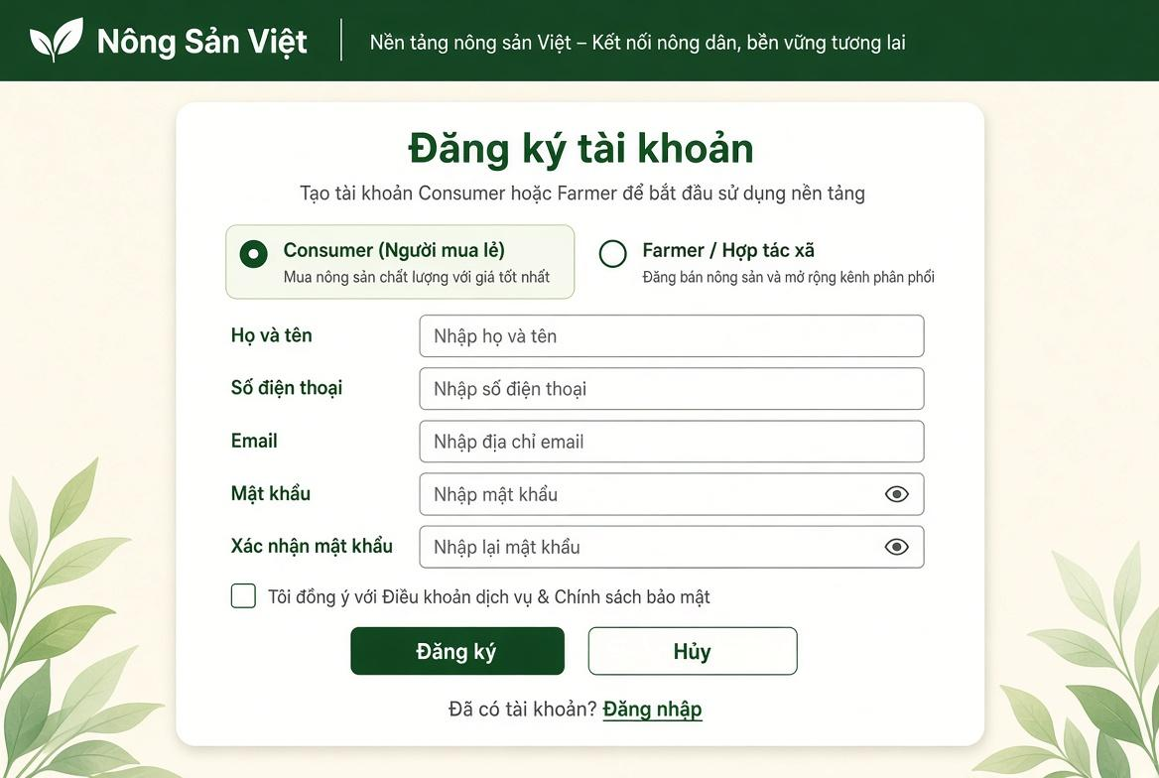

Field Name | Description
Vai trò tài khoản (Consumer / Farmer) | Radio button group allowing the user to select the account role: Consumer (Retail Buyer) or Farmer / Cooperative. Default: Consumer.
(2) Họ và tên | Textbox for entering the user's full name. Mandatory string, length: 2–50 characters.
(3) Số điện thoại | Textbox for entering the user's phone number. Mandatory numeric string, standard Vietnamese phone format (10 digits), globally unique.
(4) Email | Textbox for entering the email address. Mandatory, standard email format, globally unique across all accounts.
(5) Mật khẩu | Password input box with toggle visibility icon. Mandatory, minimum 8 characters, requiring at least one letter and one number.
(6) Xác nhận mật khẩu | Password input box with toggle visibility icon. Mandatory, must exactly match the value entered in Password.
(7) Điều khoản dịch vụ & Chính sách bảo mật | Checkbox confirming user acceptance of Terms of Service and Privacy Policy. Mandatory to check before proceeding.
(8) Đăng ký | Primary action button. Triggers form validation, sends verification OTP, and initiates account creation.
(9) Hủy | Secondary action button. Cancels the registration process and resets all entered fields.
(10) Đã có tài khoản? Đăng nhập | Navigation hyperlink. Redirects the user to the Sign In screen (SCR-06: User Login).

1.2 Sign In Screen

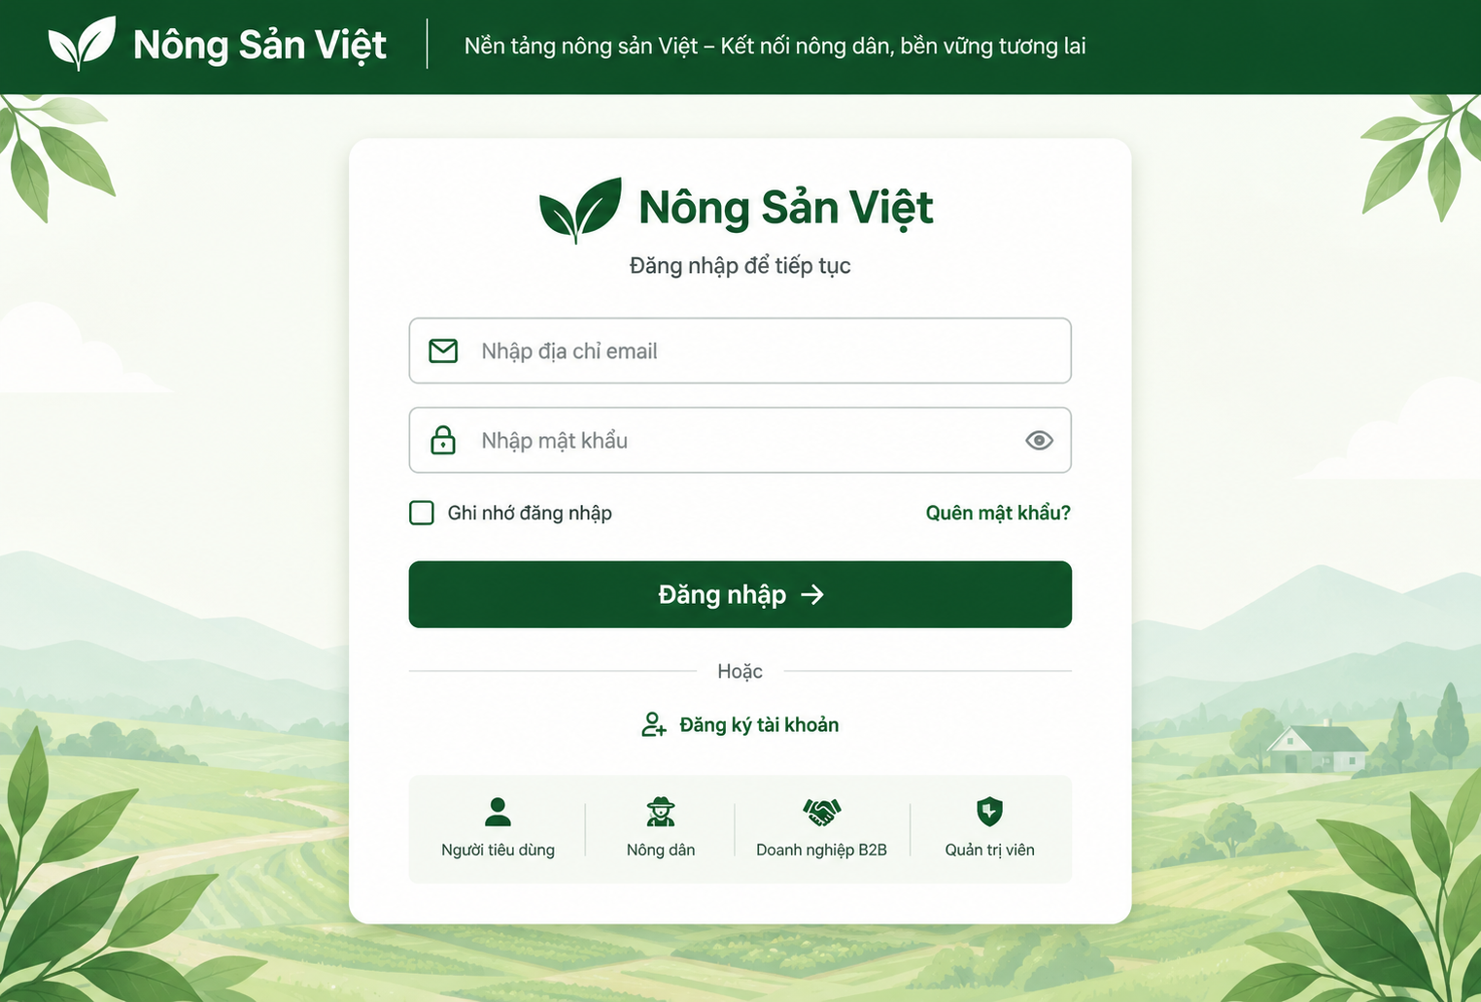

Field Name | Description
(1) Email | Textbox for entering the user's registered email address. Mandatory. Must follow a standard email format. The email is used to identify the user's account during authentication.
(2) Mật khẩu | Password input box for entering the user's account password. Mandatory. The entered password is securely verified against the stored password hash. The field provides a visibility toggle icon to show or hide the password.
(3) Ghi nhớ đăng nhập | Checkbox allowing the user to choose whether to keep the login session remembered on the current device. Optional.
(4) Quên mật khẩu? | Navigation hyperlink that redirects the user to the Password Recovery / Forgot Password screen to reset their password.
(5) Đăng nhập | Primary action button. Triggers validation of the Email and Password fields and submits the login request. If the credentials are valid and the account is active, the system authenticates the user, creates an authenticated session, identifies the user's role, and redirects the user to the appropriate page.
(6) Đăng ký tài khoản | Navigation hyperlink that redirects users who do not have an account to the Registration screen.

1.3 Change Password
1.3.1 Change Password

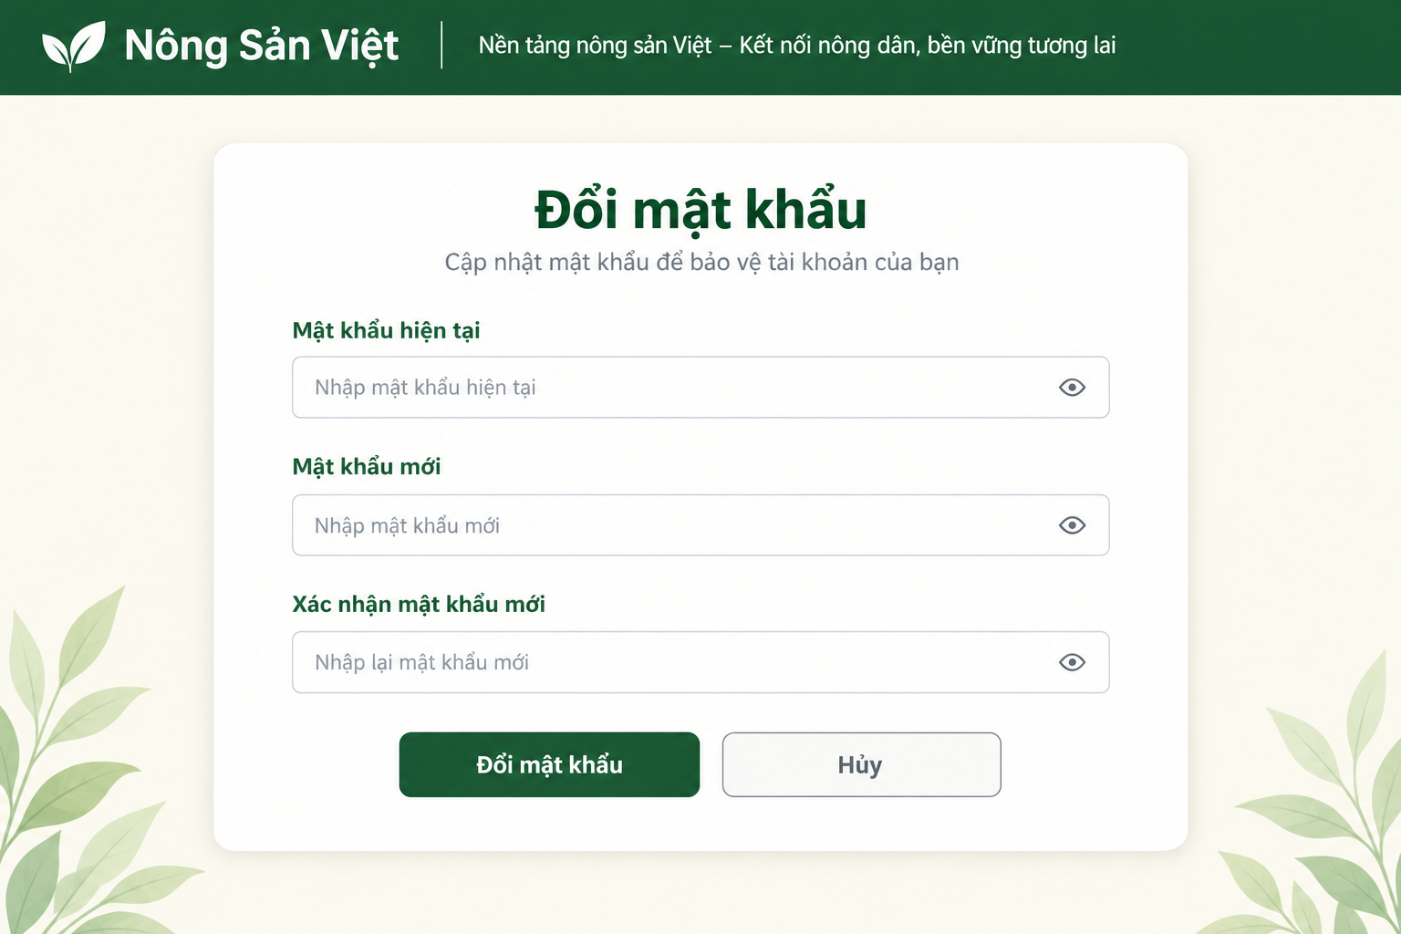

This screen allows an Authenticated User to change their account password. The user enters the current password, a new password, and confirms the new password. The system validates the current password and checks the new password against the password policy before updating the account.

Field Name | Description
Header | The system header displaying the Nông Sản Việt logo and platform slogan.
Page Title | Displays the title “Change Password”.
Subtitle | Displays the instruction “Update your password to protect your account”.
Current Password | The user's current account password. Data type: Password/String. The value is masked by default.
New Password | The new password entered by the user. Data type: Password/String. The value must satisfy the system password policy.
Confirm New Password | The new password entered again for confirmation. Data type: Password/String. The value must match the New Password field.
Password Visibility Icon | An eye icon that allows the user to show or hide the password value.
Change Password Button | The “Change Password” button. When selected, the system validates the current password and checks the new password against the password policy before updating it.
Cancel Button | The “Cancel” button. Cancels the password change operation and returns the user to the previous screen.
Validation Message | Displays validation errors when the current password is incorrect, the new password does not satisfy the password policy, or the confirmation password does not match.

1.4 Reset Password
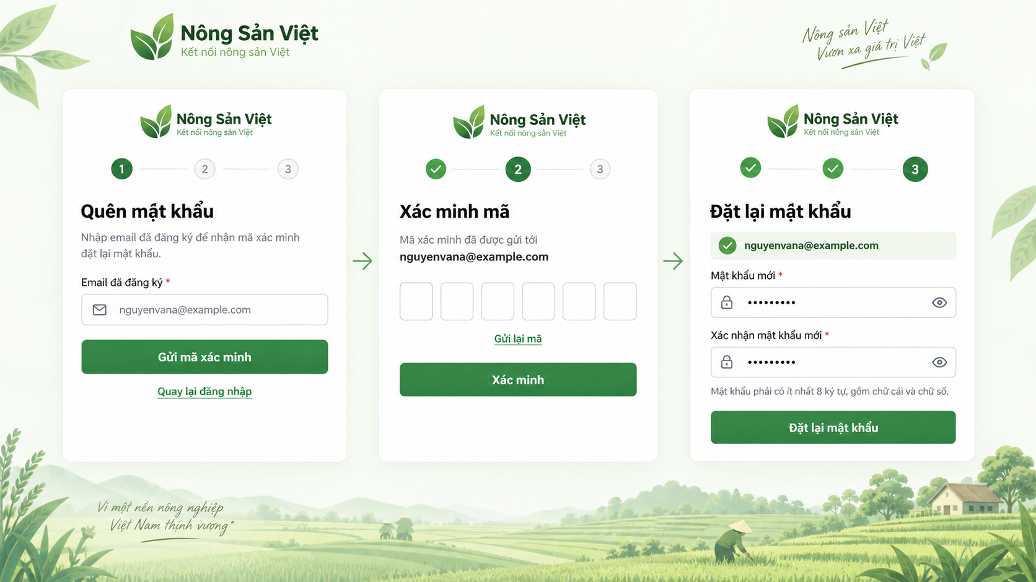

This screen allows Guest and registered users to recover access to their account when they forget their password. Users enter their registered email address, verify a one-time password (OTP) sent to that email, and create a new password. The system validates the OTP, checks that the new password satisfies the password policy, securely updates the password, and redirects the user to the Sign In screen after a successful reset.

Step | Fields / Controls
1. Forgot Password | Registered Email*, Send Verification Code, Back to Sign In
2. Verify Code | OTP Verification Code*, Verify Button, Resend Code, Back to Sign In
3. Reset Password | Verified Email (read-only), New Password*, Confirm New Password*, visibility icons, password-policy helper text, Reset Password Button

1.4 Logout

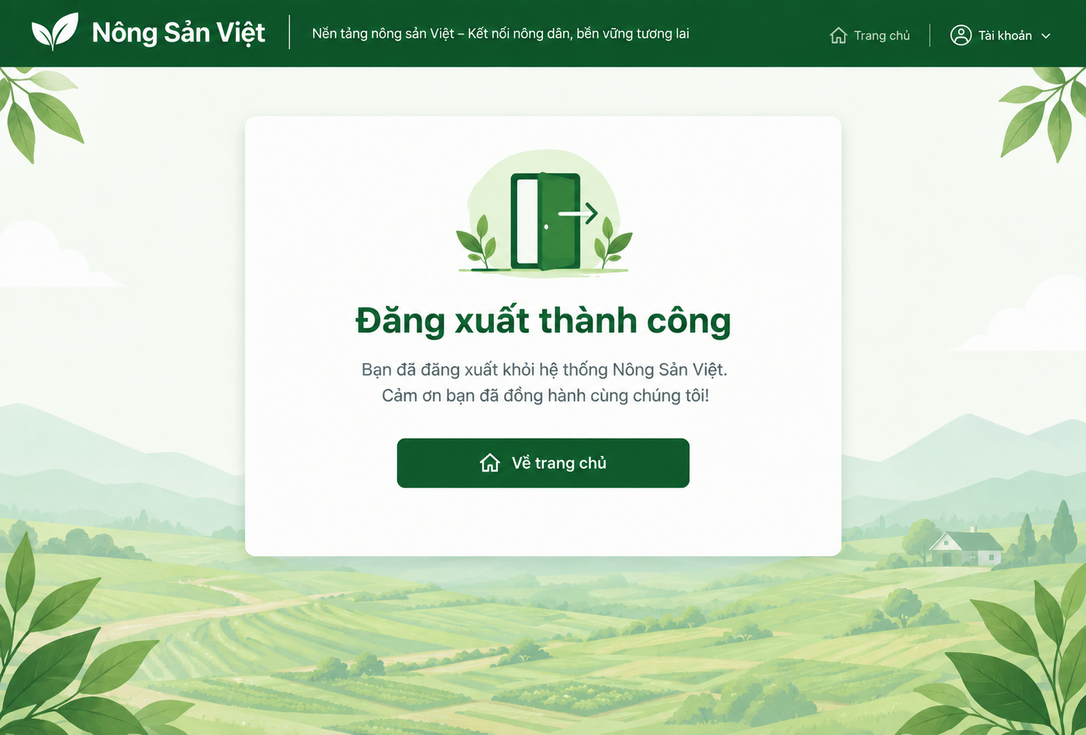

Field Name | Description
(1) Thông báo đăng xuất thành công | Displays the logout confirmation message: "Đăng xuất thành công". This informs the user that the logout process has been completed and the authenticated session has been terminated.
(2) Về trang chủ | Secondary navigation button allowing the user to return to the Home Page as a guest after logout.

2. MarketPlace

2.1 Browse Marketplace

2.1.1 Browse Marketplace
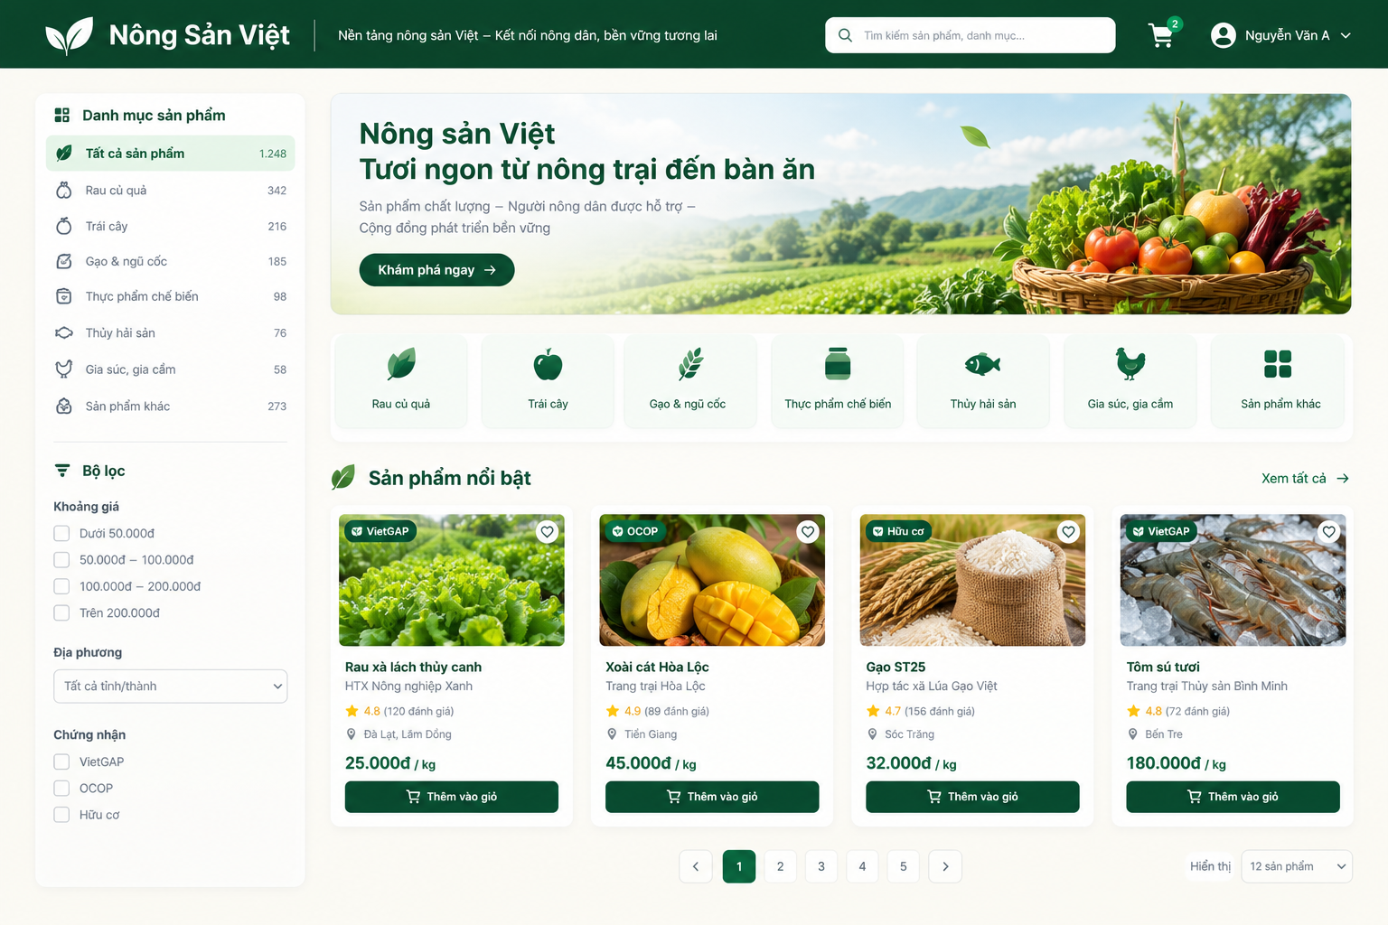

This screen allows Guest, Consumer, and Buyer B2B users to browse public agricultural products. Users can search for and filter products by name, category, supplier, region, season, or certification.

Field Name | Description
Header | The main system header containing the logo, slogan, search bar, shopping cart, and account information.
Search Product | A search field for entering a product name or category keyword.
All Products | Displays all publicly available products.
Product Category | Product categories such as Vegetables & Fruits, Fruits, Rice & Grains, Processed Food, Seafood, Livestock & Poultry, and Other Products.
Price Range | Filters products according to their price range.
Region | Filters products by province/city or production region.
Supplier | Filters products according to the Farmer/Supplier.
Season | Filters products according to the crop season.
Certification | Filters products by certification, such as VietGAP, GlobalGAP, Organic, or other supported certifications.
Product Image | The representative image of the product.
Product Name | The name of the publicly listed product.
Supplier/Farm Name | The name of the Farmer/Supplier providing the product.
Product Rating | The average rating and number of eligible reviews, if available.
Region | The production or supply region of the product.
Price | The current selling price and unit of the product.
Certification Badge | Displays verified certification badges when applicable.
View Product Detail | Allows the user to select a product and navigate to UC-MKT-02 – View Product Detail.
Add to Cart | Allows the user to add the product to the shopping cart when the function is available for the current actor/session.
Pagination | Allows the user to navigate between pages of product results.
Product Count | Displays the number of products or search results.

2.2 View Product Detail
2.1.1 View Product Detail

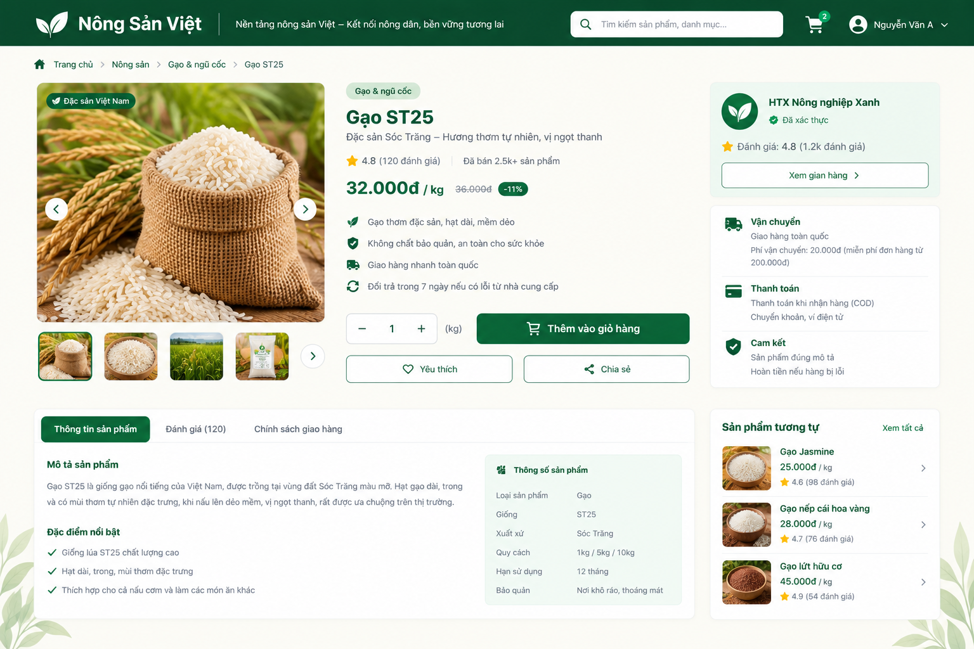
This screen allows Guest, Consumer, and Buyer B2B users to view detailed information about a publicly available product. The main information includes product description, price, available stock/batches, farm information, certificates, and eligible reviews.

Field Name | Description
Header | The Nông Sản Việt header containing the logo, slogan, search bar, shopping cart, and user account information.
Breadcrumb | Displays the navigation path from the Marketplace to the currently selected product.
Product Image Gallery | Displays the main product image and additional product images.
Product Name | The name of the selected product.
Category | The product category.
Short Description | A brief description of the product and its main characteristics.
Product Rating | The average product rating and number of eligible reviews.
Price | The current selling price and unit of the product.
Original Price | The original price when a promotional price is available.
Certification Badge | Displays verified product certification badges when available.
Available Stock | The quantity of the product currently available for purchase.
Available Batch | Information about available product batches when batch-level inventory is provided.
Unit | The product selling unit, such as kg, box, package, etc.
Quantity Selector | Allows the user to select the desired product quantity.
Farm Name | The name of the Farmer/Farm supplying the product.
Farm Verification | The verification status of the Farmer/Farm, when available.
Farm Rating | The Farm/Supplier rating or reputation information, when available.
View Farm | A link that allows the user to view the public Farm/Supplier profile.
Product Description | The full description of the product.
Origin | The origin or production region of the product.
Product Specifications | Product-related specifications such as variety, packaging, expiry period, or storage conditions when available.
Certificate Name | The name of the certification associated with the product, such as VietGAP, GlobalGAP, or Organic.
Verification Status | The verification status of the certificate.
Certificate Expiry | The expiration date of the certificate, when available.
Average Rating | The average rating of the product.
Review Count | The total number of eligible reviews displayed.
Review List | A list of eligible customer reviews.
Add to Cart | Allows a Consumer to add the product to the shopping cart when the product is available and the function is applicable to the current session.
Favorite | Allows the user to save the product as a favorite when the feature is supported.
Share | Allows the user to share the product link.
View Traceability | Navigates to the product traceability function when the product/batch supports traceability.

3. Farmer Sales

3.1 Process Order

3.1.1 Farmer Order Fulfillment Screen

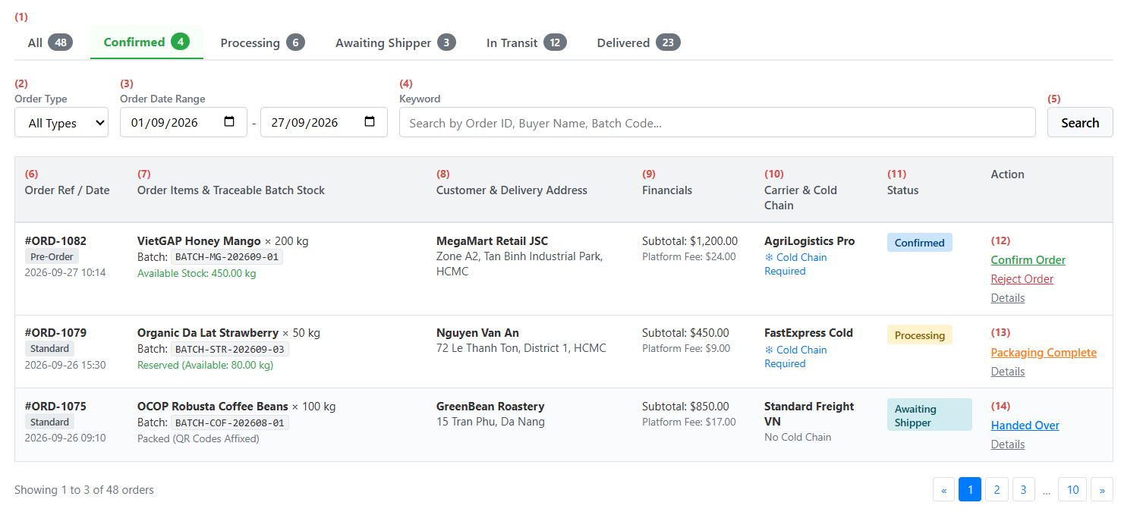
This screen allows the Farmer to:
- View Order List: View all incoming and ongoing orders with product details, batch codes, delivery addresses, and carrier information.
- Filter by Status: Filter orders by fulfillment stages (All, Confirmed, Processing, Awaiting Shipper, In Transit, Delivered) with real-time counter badges.
- Search Orders: Filter orders by order type (Standard, Pre-Order), date range, or keywords (Order ID, buyer name, batch code).
- Confirm Order: Verify batch inventory and accept confirmed orders to reserve stock and begin fulfillment.
- Reject Order: Decline an order with a mandatory explanation if produce fails quality checks or due to adverse weather.
- Confirm Packaging: Mark items as packed and labeled with batch QR codes, notifying the carrier for pickup.
- Hand Over Goods: Confirm handover of packages to the courier to initiate transit and delivery tracking.
Field Name | Description
(1) Status Filter Tabs | Status tabs to filter orders: All, Confirmed (default), Processing, Awaiting Shipper, In Transit, Delivered. Displays item count badge on each tab.
(2) Order Type Filter | Dropdown to filter by order classification: All Types (default), Standard, Pre-Order.
(3) Order Date Range | Date range selector to filter orders by creation date (From date – To date). Default is current month-to-date.
(4) Keyword Search Input | Text box to enter search keywords: Order ID, customer name, product name, or batch code.
(5) Search Button | Button to execute search and apply active filter criteria.
(6) Order Ref / Date | Displays Order ID (e.g., #ORD-1082), order type badge, and order creation date and time.
(7) Items & Traceable Batch Stock | Displays product name, ordered quantity with unit, linked traceable batch code, and available stock. Highlights in red if batch stock is insufficient.
(8) Customer & Delivery Address | Displays customer or company name and shipping destination address.
(9) Financial Breakdown | Displays order subtotal and platform transaction fee.
(10) Carrier & Cold Chain Info | Displays assigned shipping carrier name and a cold chain indicator if temperature control is required.
(11) Order Status Badge | Displays current order status: Confirmed, Processing, Awaiting Shipper, In Transit, or Delivered.
(12) Confirmed State Actions | Actions available only for orders in Confirmed status:  • Confirm Order: Checks batch stock, deducts inventory, and moves order to Processing.  • Reject Order: Opens a modal requiring a rejection reason, then cancels the order and starts the buyer refund.
(13) Packaging Action | Action available only for orders in Processing status:  • Packaging Complete: Confirms produce is packed with batch QR codes affixed, moves order to Awaiting Shipper, and notifies the courier.
(14) Logistics Handover Action | Action available only for orders in Awaiting Shipper status:  • Handed Over: Confirms handover to the courier and moves order status to In Transit.

3.2 Information Farmer
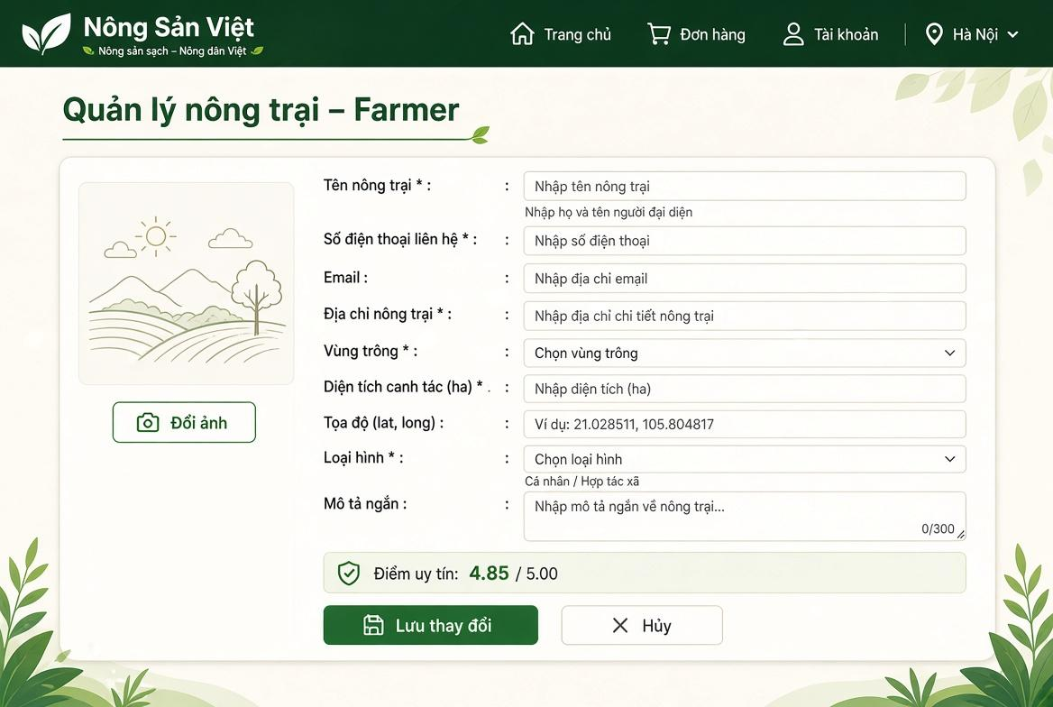

Field Name | Description
(1) Đổi ảnh | Button allowing the farmer to upload or replace the farm banner/avatar image. Max size: 5 MB.
(2) Tên nông trại * | Textbox for entering the official farm or agricultural cooperative brand name. Mandatory string, max length: 100 characters.
(3) Người đại diện * | Textbox for entering the legal representative's full name. Mandatory string, max length: 50 characters.
(4) Số điện thoại liên hệ * | Textbox displaying the primary contact telephone number of the production farm. Mandatory.
(5) Email | Textbox displaying the official operational email address. Standard email format.
(6) Địa chỉ nông trại * | Textbox for entering detailed physical address of the farm facility. Mandatory string, max length: 200 characters.
(7) Vùng trồng * | Dropdown selector for choosing the designated agricultural ecological zone (e.g., Da Lat, Mekong Delta, Red River Delta). Mandatory.
(8) Diện tích canh tác (ha) * | Numeric input field specifying the cultivated land size in hectares. Mandatory positive decimal number (>0).
(9) Tọa độ (lat, long) | Textbox for geographical GPS coordinates (latitude, longitude) for map identification. Format: xx.xxxxxx, yy.yyyyyy.
(10) Loại hình * | Dropdown selection for the legal production model: Cá nhân (Individual Farmer) or Hợp tác xã (Agricultural Cooperative).
(11) Mô tả ngắn | Multiline textarea for brief introduction of farming background and agricultural specialties, with a character counter (max: 300 characters).
(12) Điểm uy tín | Read-only rating badge showing the platform-calculated trust score (baseline: 5.00), dynamically updated based on order reviews and fulfillment compliance.
(13) Lưu thay đổi | Primary action button. Validates input values, uploads images, and saves updated farm records to the database.
(14) Hủy | Secondary action button. Discards current edits and reverts the form to its original values.

4. Administration

4.1 User Management

4.1.1 User List
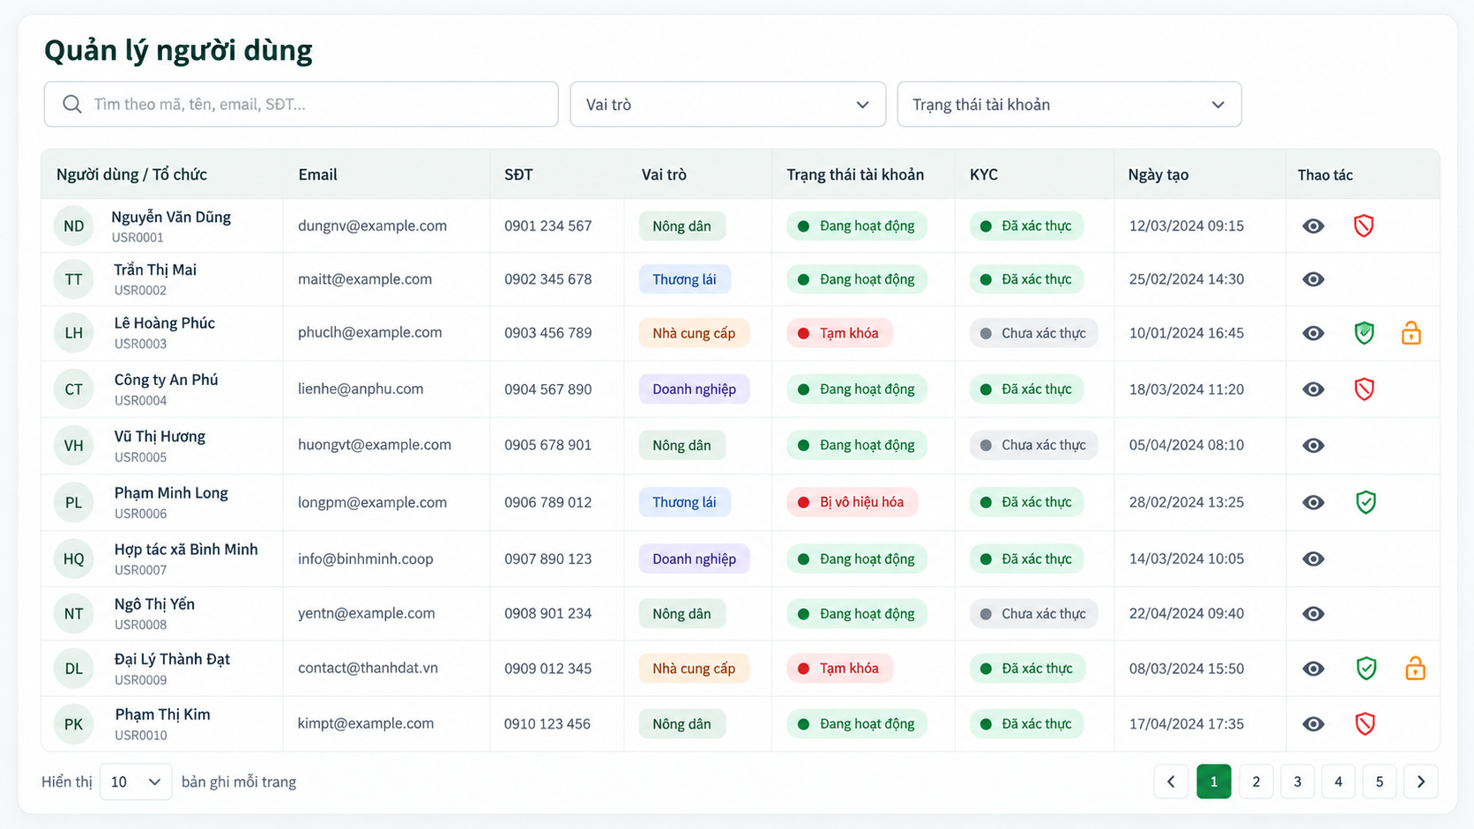
This screen allows the Administrator to:
- View User List: view registered user and organization accounts.
- Search Users: enter a keyword to search by Account ID, personal name, organization name, farm name, company name, email address, or phone number.
- Filter Users by Role: filter accounts by Consumer, Farmer, Buyer, Bank, Certifier, or Administrator role.
- Filter Users by Account Status: filter accounts by Active, Pending, Rejected, or Suspended status.
- View User Details: open the User Details screen of a selected account.
- Suspend / Activate Account: suspend an active account or reactivate a suspended account after confirmation.
- Unlock Account: clear the temporary security lock and reset the failed-login counter when applicable.
- Navigate User Records: move between pages of user records.

Field Name | Description
Search Keyword | Optional text input, maximum 100 characters. Searches by Account ID, personal or organization name, Farm Name, Company Name, email address, or phone number.
Role Filter | Dropdown: All, Consumer, Farmer, Buyer, Bank, Certifier, Administrator. Default: All.
Account Status Filter | Dropdown: All, Active (Approved), Pending, Rejected, Suspended. Default: All.
User / Entity Name | Read-only. Displays Full Name, Farm Name, Company Name, or organization name based on the account role.
Email | Read-only registered email address.
Phone Number | Read-only verified contact phone number.
Role | Read-only role badge.
Account Status | Read-only badge: Active, Pending, Rejected, or Suspended.
KYC Status | Read-only verification badge for roles that require legal verification.
Created Date | Read-only account creation date and time in dd/MM/yyyy HH:mm format.
View Details Action | Opens the User Details screen for the selected account.
Suspend / Activate Action | Suspends or reactivates an account after confirmation. An Administrator cannot suspend their own account.
Unlock Account Action | Clears the temporary security lock and resets the failed-login counter.
Pagination | Displays 10 records per page by default.

4.1.2 User Details
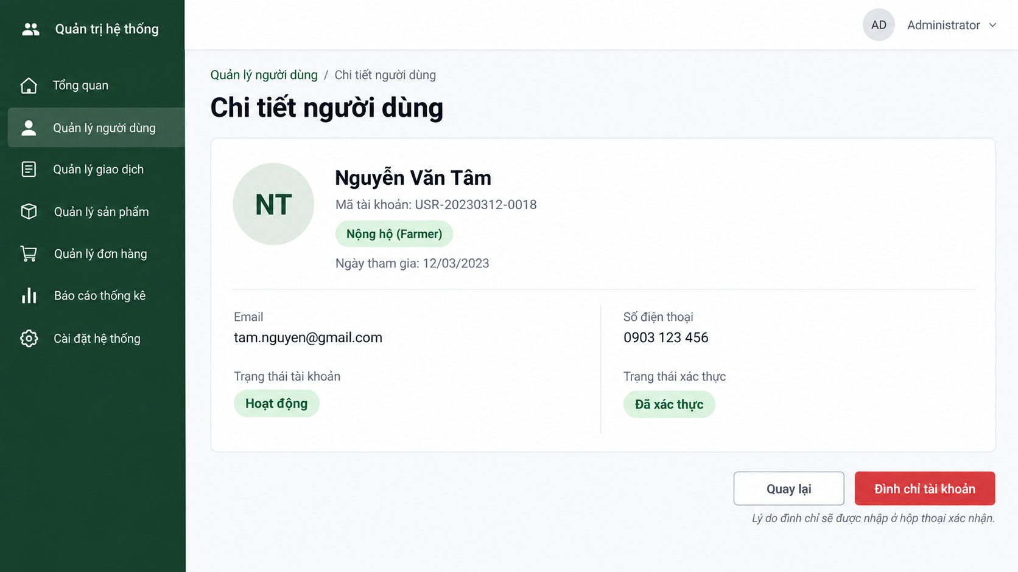
This screen allows the Administrator to:
- View User Details: view the selected account’s identity, contact information, role, account status, and verification status.
- Return to User List: return to the User List screen without changing data.
- Suspend / Activate Account: change the account status after confirmation and providing a reason.
- Unlock Account: unlock the account when it has been temporarily locked due to failed sign-in attempts.
Field Name | Description
User Avatar | Displays the user initials or profile image; read-only.
Full Name / Entity Name | The registered personal name or organization/farm name; read-only.
Account ID | System-generated unique account identifier; read-only.
Role | User role: Consumer, Farmer, Buyer, Bank, Certifier, or Administrator; read-only.
Joined Date | Account creation date in dd/MM/yyyy format; read-only.
Email | Registered email address; read-only.
Phone Number | Registered phone number; read-only.
Account Status | Displays Active, Pending, Rejected, or Suspended.
Verification Status | Displays the account/KYC verification result, such as Verified or Not Verified.
Suspend / Activate Account | Opens a confirmation dialog requiring an administrative reason before changing status. The displayed action depends on the current status.
Unlock Account | Displayed only when the account is locked due to failed sign-in attempts; unlocks the account after confirmation.
Back | Returns to the User List screen without changes.

4.2 Product Management

4.2.1 Product Category List
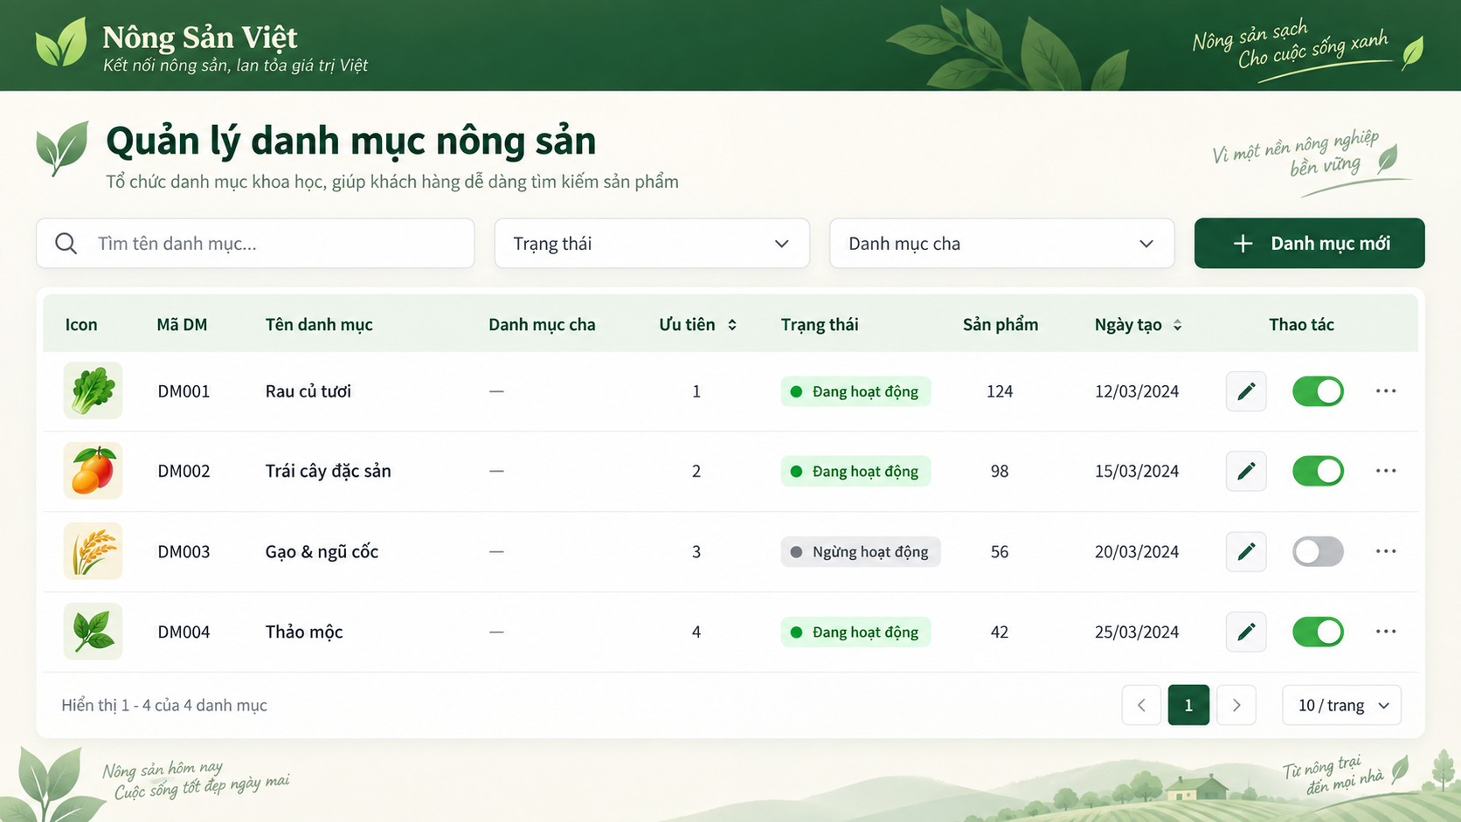
This screen allows the Administrator to:
- View Category List: view all product categories and their current information.
- Search Categories: enter a keyword to search categories by name.
- Filter Categories: filter categories by status or parent category.
- View Category Details: open the Category Details screen for a selected category.
- Create Category: navigate to the Category Details screen to create a new category.
- Update Category: navigate to the Category Details screen to update an existing category.
- Activate / Deactivate Category: change the availability status of a category.
- Delete Category: delete a category only when it does not contain active products.
- Navigate Category Records: move between pages of category records.
Field Name | Description
Search Keyword | Optional text input, maximum 100 characters. Searches by Category Name.
Status Filter | Dropdown: All, Active, Inactive. Default: All.
Parent Category Filter | Dropdown to filter by a parent category or show only Root Categories. Default: All.
Category Icon | Read-only thumbnail preview of the category image.
Category ID | Read-only system-generated category identifier.
Category Name | Read-only display name of the product category.
Parent Category | Read-only parent category name. Displays Root if the category has no parent.
Priority (Display Order) | Read-only non-negative integer used to determine the category order on the Marketplace.
Status | Read-only badge: Active or Inactive.
Product Count | Read-only number of products currently assigned to the category.
Created Date | Read-only category creation date and time.
New Category Button | Opens Product Category Details in create mode.
Edit Action | Opens Product Category Details for the selected category.
Activate / Deactivate Action | Changes category visibility on the Marketplace after confirmation.
Pagination | Displays 10 records per page by default.

4.2.2 Product Category Details
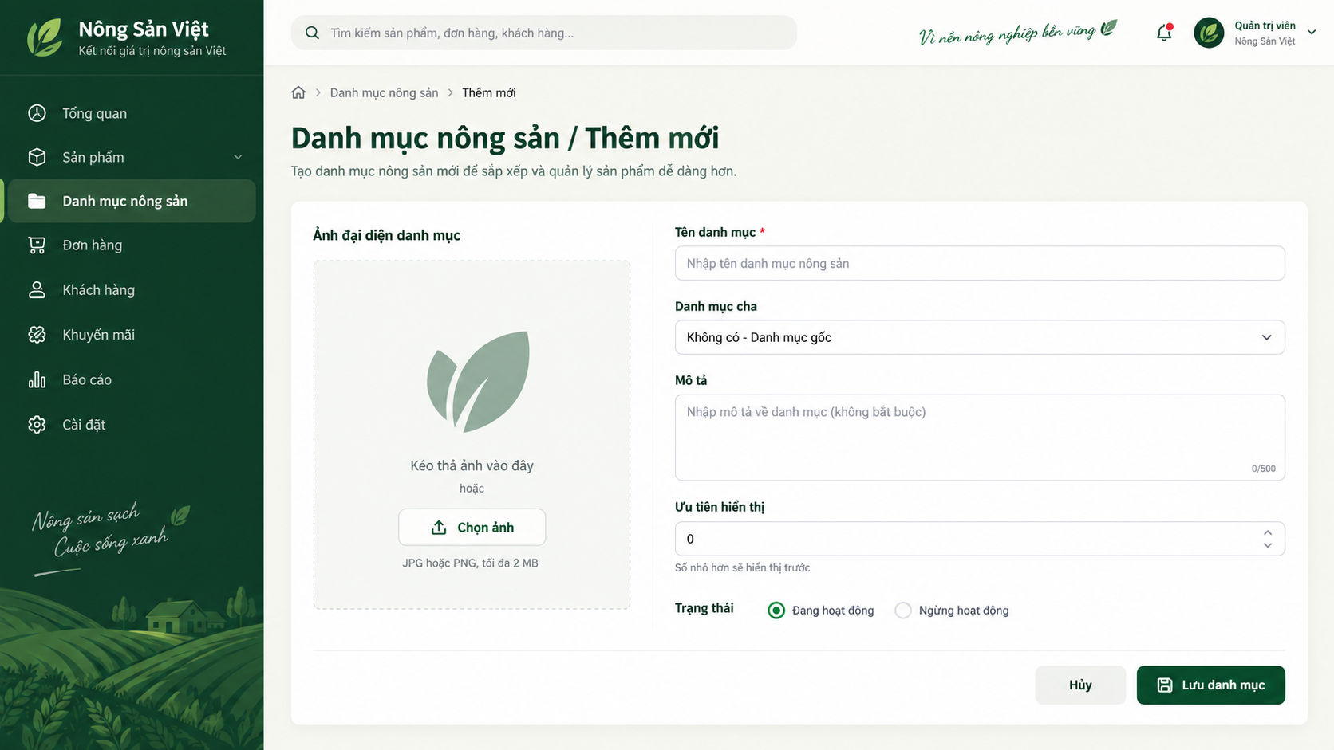
This screen allows the Administrator to:
- Create Category: create a new product category by entering valid category information.
- Update Category: update information of an existing product category.
- Select Parent Category: assign the category to a parent category where applicable.
- Upload Category Image: upload a supported image for the category.
- Set Category Priority: define the display order of the category.
- Activate / Deactivate Category: define whether the category is available for use.
- Cancel: return to the Category List screen without saving changes.

Field Name | Description
Category Name | Required text input, 2–100 characters. Must be unique, case-insensitively, within the same Parent Category.
Parent Category | Optional dropdown of active categories. Default: None (Root Category).
Description | Optional text area, maximum 500 characters.
Category Image | Optional image upload. Accepted formats: JPG, JPEG, PNG. Maximum file size: 2 MB.
Priority (Display Order) | Optional non-negative integer. Default value: 0. Lower values are displayed first.
Status | Required dropdown: Active or Inactive. Default for a new category: Active.
Save Button | Validates all inputs and creates or updates the category.
Cancel Button | Cancels changes and returns to Product Category List.

4.2.3 Product Listing Moderation Screen

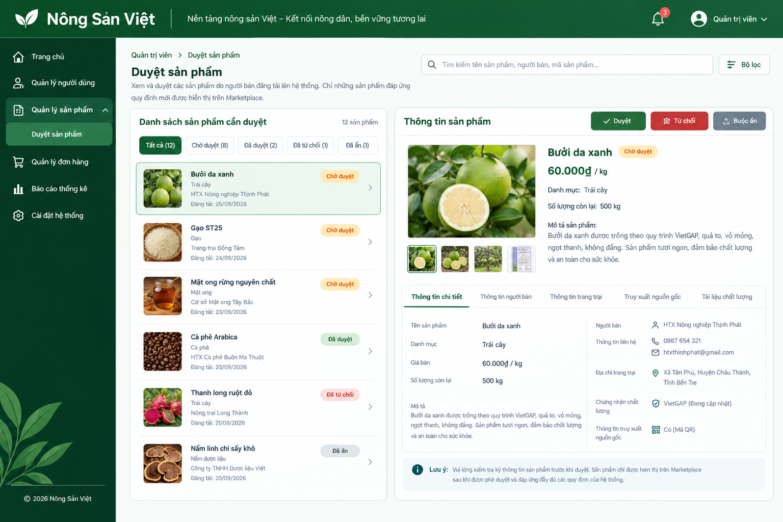

Field Name | Description
(1) Thanh điều hướng Admin | Navigation sidebar allowing the Administrator to access major administrative functions, including Trang chủ, Quản lý người dùng, Quản lý sản phẩm, Quản lý đơn hàng, Báo cáo thống kê, and Cài đặt hệ thống.
(2) Duyệt sản phẩm | Page title identifying the Product Listing Moderation function. Displays a brief description explaining that submitted products are reviewed before being displayed on the Marketplace.
(3) Tìm kiếm sản phẩm | Search textbox allowing the Administrator to search product listings by product name, seller name, or product code.
(4) Bộ lọc | Filter button allowing the Administrator to filter product listings according to available criteria such as product status, category, seller, or submission date.
(5) Danh sách sản phẩm cần duyệt | Main listing area displaying products submitted by Sellers. Each item contains product image, product name, category, seller/farm name, submission date, and current moderation status.
(6) Tất cả | Status filter/tab displaying all product listings available to the Administrator.
(7) Chờ duyệt | Status filter/tab displaying product listings that are waiting for Administrator review and moderation.
(8) Đã duyệt | Status filter/tab displaying product listings that have been approved.
(9) Đã từ chối | Status filter/tab displaying product listings that have been rejected by the Administrator.
(10) Đã ẩn | Status filter/tab displaying product listings that have been force-delisted or hidden from the Marketplace.
(11) Product Listing Item | Individual product entry in the moderation list. Displays product image, product name, category, seller/farm, submission date, and status. Clicking the item loads its detailed information in the review panel.
(12) Trạng thái sản phẩm | Status badge indicating the current moderation state of the product, such as Chờ duyệt, Đã duyệt, Đã từ chối, or Đã ẩn.
(13) Thông tin sản phẩm | Detail panel displaying the complete information of the selected product listing for Administrator review.
(14) Hình ảnh sản phẩm | Displays the main product image and additional product images submitted by the Seller.
(15) Tên sản phẩm | Displays the submitted product name.
(16) Giá bán | Displays the product selling price and applicable unit, for example 60.000đ/kg.
(17) Danh mục | Displays the product category, such as Trái cây, Gạo, Mật ong, Cà phê, etc.
(18) Số lượng còn lại | Displays the available quantity declared by the Seller.
(19) Mô tả sản phẩm | Displays the Seller's product description for the Administrator to verify completeness and compliance.
(20) Thông tin người bán | Displays Seller information, including seller/farmer/cooperative name and contact information.

5.Product Management

5.1 Manage Product Listing

5.1.1 Farmer Product Management Screen

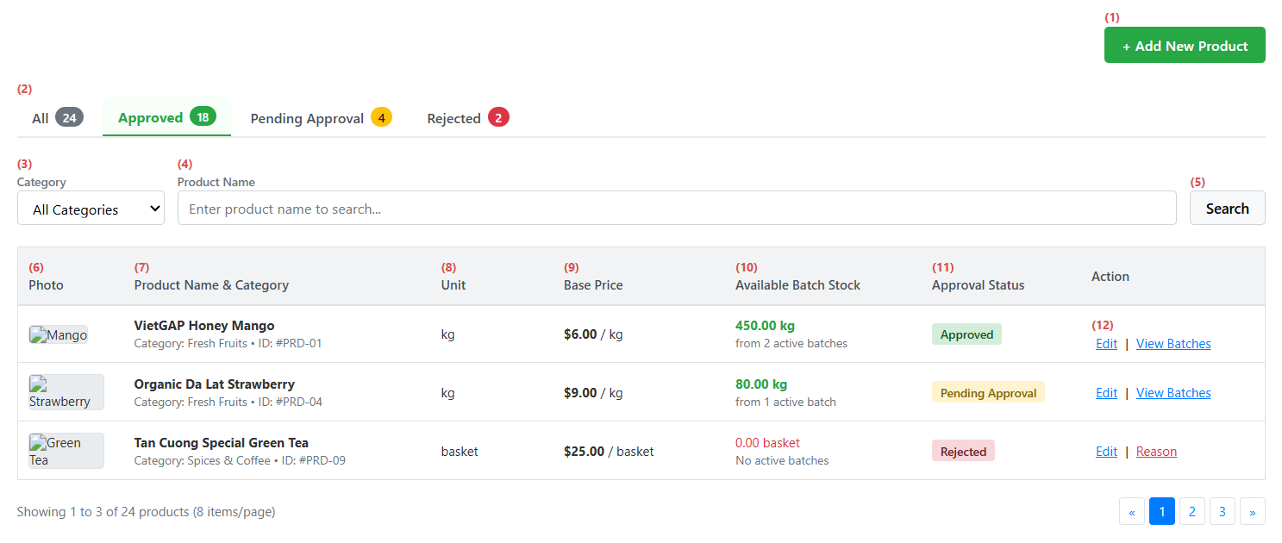
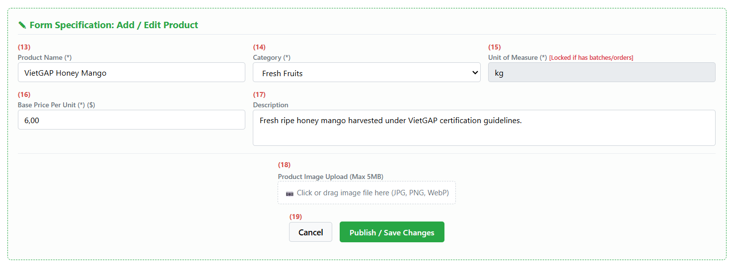
This screen allows the Farmer to:
- View Product Catalog: Browse farm products with real-time aggregated batch stock, listed prices, and current moderation statuses.
- Filter by Status: Filter products across approval stages (All, Approved, Pending Approval, Rejected).
- Filter and Search: Filter products by product category and search by product name.
- Create New Product: Open the product creation form to list a new agricultural item with pricing, packaging unit, description, and images.
- Update Product Details: Edit product name, base unit price, description, and images for owned items. Automatically locks the unit of measure if the product has associated batches or orders.
- View Batch Inventory: Inspect linked traceable batches and real-time available stock levels for any listed product.
Screen Components / Field Description Table
Field Name | Description
(1) Add New Product Button | Opens the product creation form to register a new agricultural listing.
(2) Status Filter Tabs | Navigation tabs filtering products by approval status: All, Approved, Pending Approval, Rejected. Displays item count badges.
(3) Category Filter | Dropdown to filter products by system categories (All Categories, Fresh Fruits, Vegetables, Grains, etc.).
(4) Product Name Search | Text input to search products by keyword matching product names.
(5) Search Button | Executes data query combining selected status tab, category filter, and keyword search.
(6) Product Photo Thumbnail | Displays image thumbnail preview uploaded for the product.
(7) Product Name & Category | Displays product title, category name, and unique system product code.
(8) Unit of Measure | Displays standard sales packaging unit (e.g., kg, ton, basket).
(9) Base Unit Price | Displays listed base selling price per unit.
(10) Available Batch Stock | Displays real-time total available inventory calculated from active traceable batches. Shows zero if no batches exist.
(11) Approval Status Badge | Displays current moderation state: Approved (Green), Pending Approval (Yellow), or Rejected (Red).
(12) Action Links | Action links for each row:  • Edit: Opens the form to update product details.  • View Batches: Navigates to traceable harvest batches and stock breakdown.  • Reason: Shows admin rejection comments if status is Rejected.
(13) Product Name Input | Text field to enter or modify product title. Required field.
(14) Category Dropdown | Dropdown selector to classify product under an active category. Required field.
(15) Unit of Measure Input | Text field to define packaging unit. Read-only and locked against changes if the product is already linked to batches or orders.
(16) Base Price Input | Numeric input for listed unit price. Must be greater than 0.
(17) Description Textarea | Multi-line text field to provide cultivation notes, storage tips, or product specifications.
(18) Product Image Upload | File upload box supporting JPG, PNG, or WebP formats up to 5MB.
(19) Form Action Buttons | Form submission buttons:  • Publish / Save Changes: Validates inputs, uploads images, sets status to Pending Approval, and saves product.  • Cancel: Discards unsaved changes and closes the form.

6.Consumer Ordering

6.1Checkout and Place Retail Order

6.1.1 Retail Checkout Screen
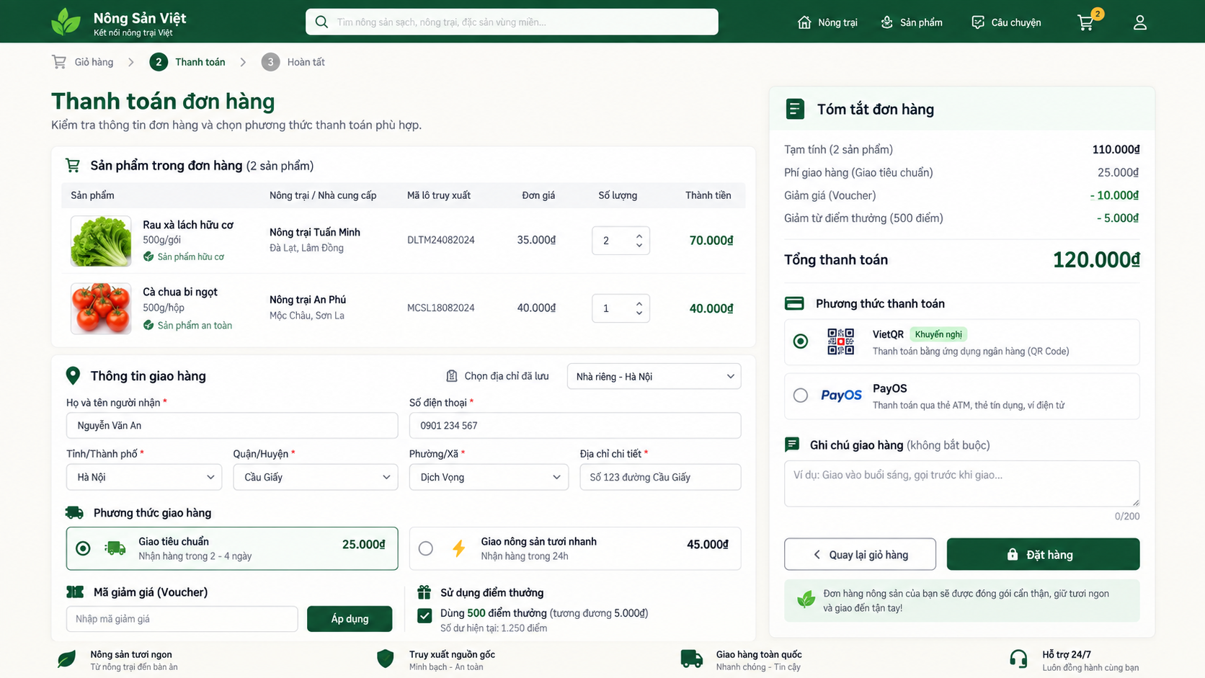
This screen allows the Consumer to:
- Review Order Items: view selected products, quantities, prices, farmers, and subtotals.
- Select or Enter Delivery Address: choose a saved delivery address or enter a new address.
- Select Delivery Method: choose an available delivery service.
- Apply Voucher: enter or select a valid voucher for the order.
- Redeem Reward Points: use available reward points where applicable.
- Select Payment Method: choose VietQR / PayOS or another supported payment method.
- Add Order Notes: provide optional instructions for the order.
- Review Payment Summary: view subtotal, delivery fee, voucher discount, point discount, and final amount.
- Place Order: confirm the order; the system validates information, reserves stock, creates the order, and redirects the Consumer to the payment process.

Field Name | Description
Order Item List | Read-only list of selected cart items, including product image, product name, unit of measure, farmer name, Batch Code, unit price, quantity, and item subtotal.
Saved Address Selector | Allows the Consumer to select a saved delivery address or enter a new address.
Recipient Name | Required text input, 2–100 characters.
Recipient Phone Number | Required text input. Must match the configured Vietnamese phone-number format.
Province / City | Required dropdown used for delivery-area selection and delivery-fee calculation.
District | Required dropdown based on the selected Province / City.
Ward | Required dropdown based on the selected District.
Address Detail | Required text area for house number, street, or delivery instructions. Maximum 255 characters.
Delivery Method | Required selection: Standard Delivery or Fresh Produce Express Delivery. Displays estimated delivery time and fee.
Voucher Code | Optional text input or voucher selector. The system validates voucher eligibility before applying a discount.
Reward Points Redemption | Optional input or checkbox. Displays available Reward Points Balance and applies an eligible points discount.
Payment Method | Required selection: VietQR or PayOS.
Order Notes | Optional text area for special delivery instructions. Maximum 300 characters.
Subtotal | Read-only total price of all selected order items before discounts and delivery fees.
Delivery Fee | Read-only fee calculated from the delivery address and selected delivery method.
Voucher Discount | Read-only discount amount from an eligible voucher. Default value: 0 VND.
Reward Points Discount | Read-only discount amount converted from redeemed reward points. Default value: 0 VND.
Total Amount | Read-only final amount: Subtotal + Delivery Fee − Voucher Discount − Reward Points Discount.
Return to Cart Button | Returns to Shopping Cart without creating an order.
Place Order Button | Revalidates stock, creates an order with PendingPayment status, reserves Product Batch inventory, removes successfully ordered items from the cart, and redirects to UC-CON-03 – Pay Retail Order by VietQR or PayOS.

6.2 Information Consumer

6.2.1 Information Consumer

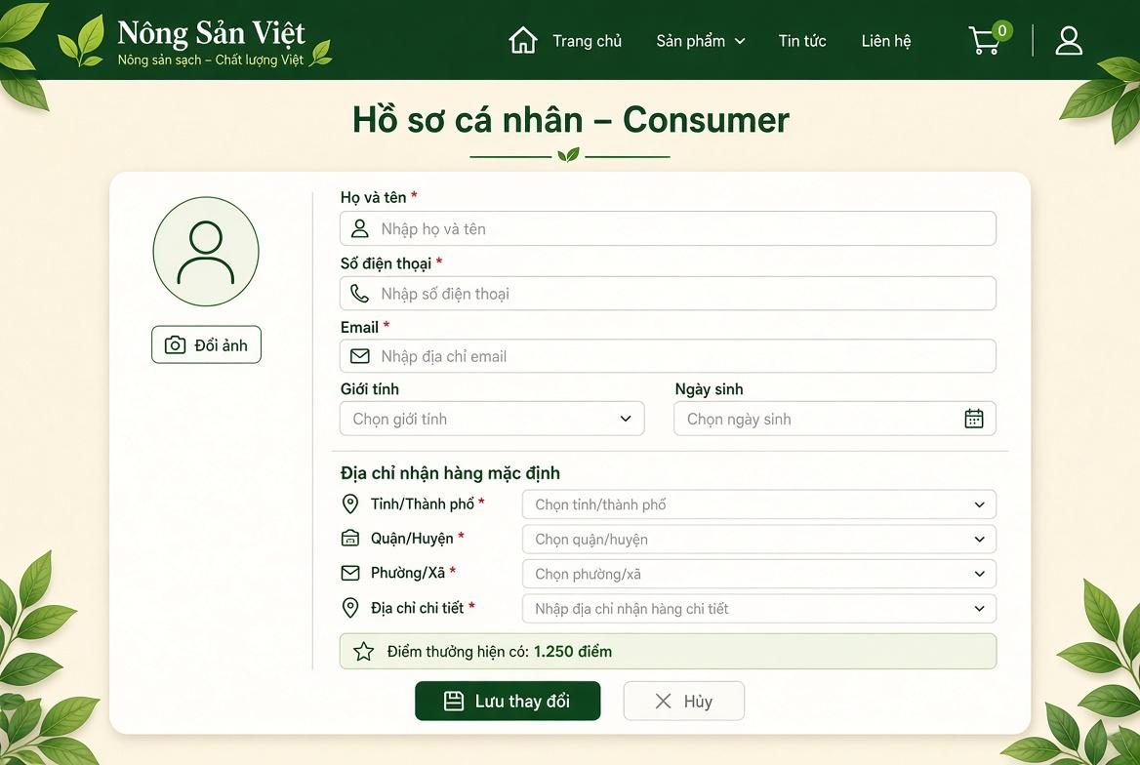

Field Name | Description
(1) Đổi ảnh | Button allowing the consumer to upload or update their personal profile avatar. Accepts .png, .jpg, .jpeg up to 5 MB.
(2) Họ và tên | Textbox displaying and updating the consumer's full name. Mandatory field, max length: 50 characters.
(3) Số điện thoại | Textbox displaying the registered phone number. Mandatory field, requires verification when changed.
(4) Email | Textbox displaying the primary email address. Mandatory, unique across the platform.
(5) Giới tính | Dropdown list for selecting gender (Male, Female, Other). Optional.
(6) Ngày sinh | Datepicker control for picking the user's date of birth in DD/MM/YYYY format. Optional.
(7) Tỉnh/Thành phố * | Dropdown selection for province or municipality. Mandatory for calculating regional delivery routes.
(8) Quận/Huyện * | Dropdown selection dynamically populated based on the chosen Province/City. Mandatory.
(9) Phường/Xã * | Dropdown selection dynamically populated based on the chosen District. Mandatory.
(10) Địa chỉ chi tiết * | Textbox for entering specific house number and street address. Mandatory string, max length: 150 characters.
(11) Điểm thưởng hiện có | Read-only badge/text displaying the current accumulated reward point balance available for order checkout discounts.
(12) Lưu thay đổi | Primary action button. Submits the form, validates all fields, and updates profile data in the database.
(13) Hủy | Secondary action button. Discards all unsaved edits and restores original profile values.

6.3Track Retail Order

6.3.1 History Order
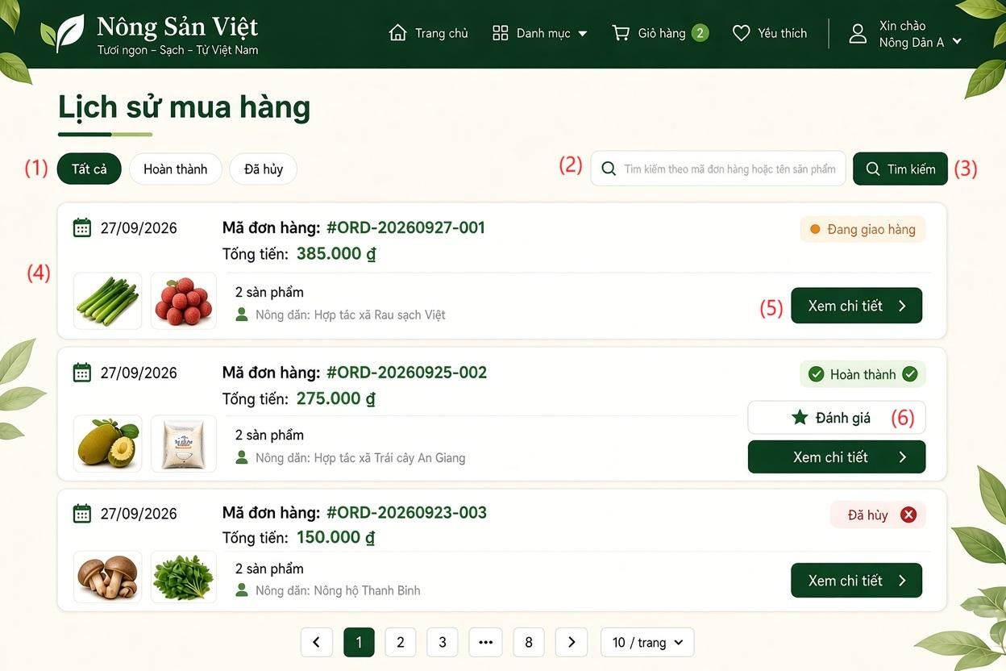

Field Name | Description
(1) Bộ lọc trạng thái đơn hàng (Tabs) | Status filter tab group allowing the user to filter orders by: All (Tất cả), Completed (Hoàn thành), and Cancelled (Đã hủy). Clicking a tab reloads the matching order list.
(2) Ô tìm kiếm | Search input text field allowing consumers to look up orders by Order ID (e.g., #ORD-xxxxxx-xxx) or by Product Name keywords.
(3) Nút tìm kiếm | Action button executing the filter query based on the entered keyword and refreshing the order cards display.
(4) Thẻ danh sách đơn hàng | Summary card displaying key information of each order: Order Date, Order Code & Total Amount,Item Summary,Status Badge
(5) Xem chi tiết | Primary row action button. Navigates the consumer to the Order Detail & Fulfillment Tracking Screen (SCR-16).
(6) Đánh giá | Contextual action button visible only for orders in "Completed" status. Clicking it opens the Product Review modal to submit star ratings and feedback comments.
(7) Thanh phân trang (Pagination) | Navigation control with Next/Previous arrows and explicit page numbers to navigate across order records. Dropdown selector allowing the user to choose the number of records displayed per page (e.g., 10 / trang)

6.3.1 Order Detail
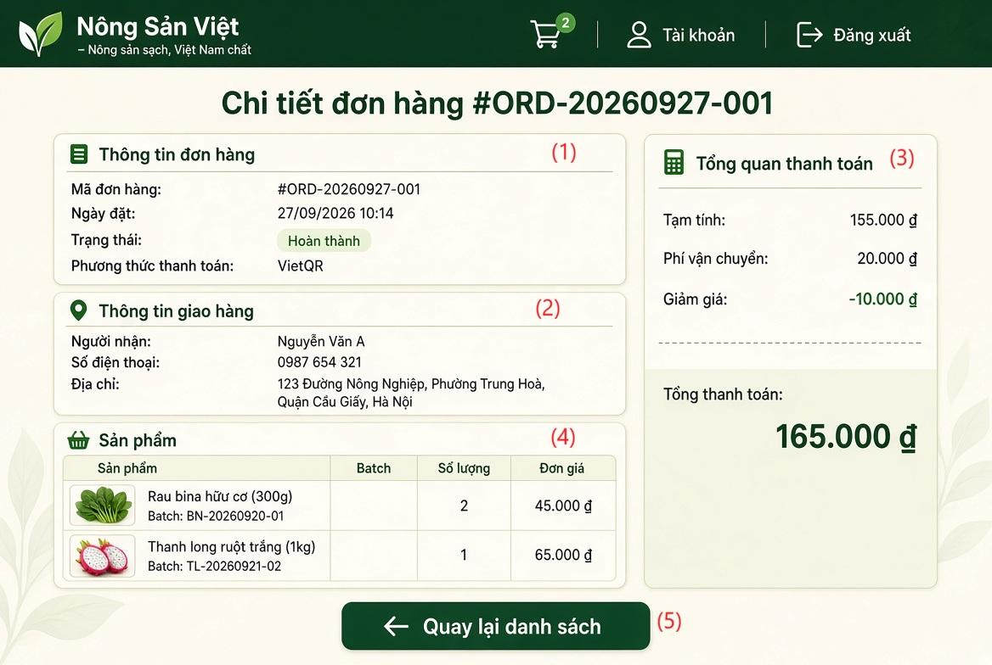

Field Name | Description
(1) Thông tin đơn hàng (Order Information) | Information panel displaying basic order identifiers and statuses
(2) Thông tin giao hàng | Panel displaying recipient contact and delivery location details
(3) Tổng quan thanh toán | Financial ledger breakdown for the order transaction
(4) Sản phẩm | Tabular list of agricultural goods purchased in the order
(5)"Quay lại danh sách" | Primary navigation action button that returns the consumer to the Order History & Overview Screen (SCR-12 / SCR-16) without altering data.

6.4 Shopping Cart

6.4.1 Shopping Cart Screen
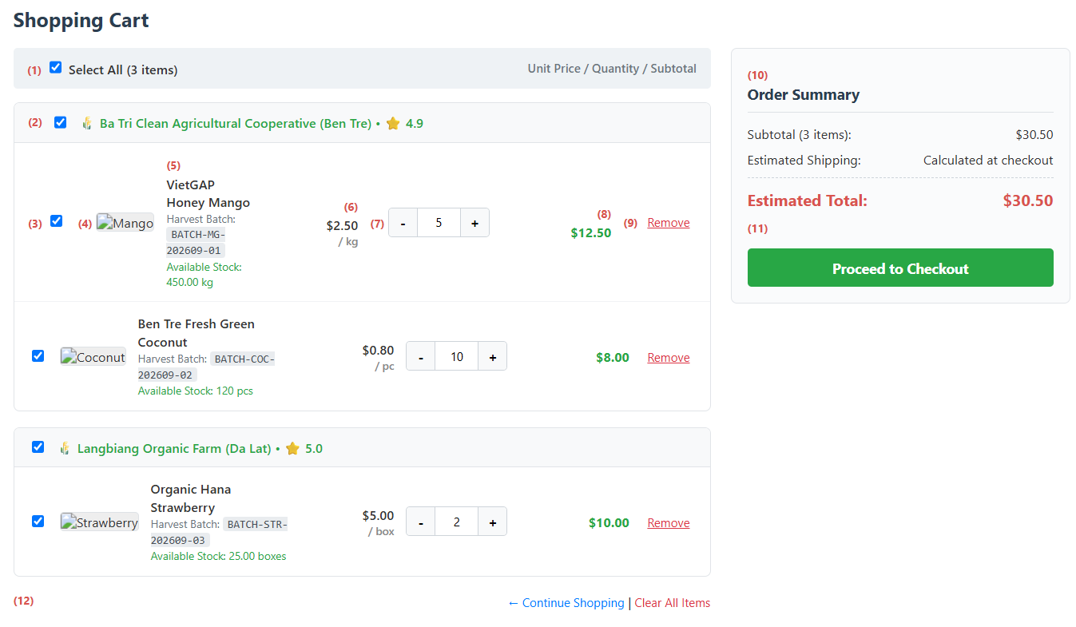
This screen allows the Consumer to:
- View Cart Items: View all items added to the cart, organized and grouped by Farm/Cooperative.
- Select Items for Checkout: Select or deselect individual items, all items from a specific farm, or all items in the cart.
- Adjust Item Quantities: Increase, decrease, or manually input quantities with real-time validation against available batch inventory.
- Remove Items: Delete individual unwanted items or clear the entire shopping cart.
- Review Summary & Checkout: Monitor order subtotals and estimated total cost in real time, then proceed to the Retail Checkout screen.
Field Name | Description
(1) Select All Checkbox | Toggles selection for all items across all farms in the cart simultaneously.
(2) Farm Header & Group Selection | Displays farm/cooperative name, reputation score, and a checkbox to select or deselect all items from that specific farm.
(3) Item Selection Checkbox | Checkbox to include or exclude a specific item from the order subtotal and checkout.
(4) Product Thumbnail | Displays thumbnail image of the agricultural product.
(5) Product Details & Batch Info | Displays product name, unit of measure, linked harvest batch code, and current available batch stock. Warns if stock is insufficient.
(6) Unit Price | Listed retail selling price per unit at the time of adding to the cart.
(7) Quantity Controls | Decrement (-), increment (+), and numeric input to adjust order quantity. Minimum is 1; maximum cannot exceed available batch stock.
(8) Item Subtotal | Line item subtotal, automatically calculated as unit price multiplied by selected quantity.
(9) Remove Item Action | Removes the specific item from the cart after user confirmation.
(10) Order Cost Summary | Displays item subtotal, estimated shipping notice, and estimated total payable amount.
(11) Proceed to Checkout Button | Validates stock availability for selected items and navigates to the Retail Order Placement screen (UC-CON-02).
(12) Secondary Action Links | Quick navigation links to return to the Marketplace for shopping or clear all items from the cart.
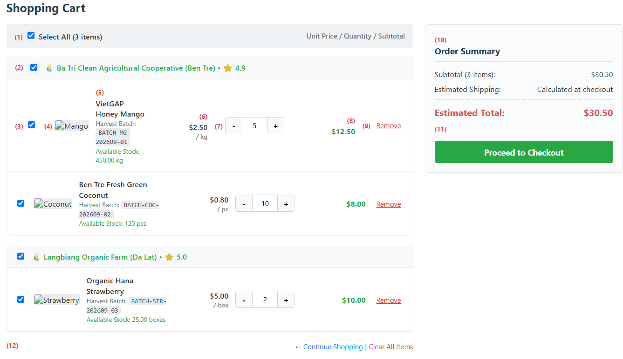

7. Background Job Inventory

7.1 Expire Password Reset Tokens (JOB-01)
Trigger: Scheduled — Runs every 15 minutes.
Purpose: Invalidate expired password-reset OTPs and security tokens across the platform to mitigate brute-force and token replay vulnerabilities.
Processing steps:
- Query active token records / OTP verification caches where expiration timestamp < CurrentTimestamp().
- Transition matching tokens/OTPs to Expired or remove unconsumed transient session tokens.
- Log the total number of invalidated tokens per execution cycle.

Failure behavior:
Scenario | System behavior
Database / Cache timeout | Write an error log and retry upon the next 15-minute scheduled run.
No expired tokens found | Complete execution cleanly with zero modifications.

7.2 Auto-Cancel Unpaid Retail Orders (JOB-02)
Trigger: Scheduled — Runs every 30 minutes.
Purpose: Automatically cancel retail orders that remain unpaid beyond the configured payment time limit (e.g., 15–30 minutes) and restore reserved batch inventory to ensure active stock availability.
Processing steps:
- Scan the Orders table for records where OrderType = 'Retail', OrderStatus = 'PendingPayment', and elapsed time exceeds the allowed checkout window.
- For each identified order within an atomic transaction:
  - Update OrderStatus to 'Cancelled'.
  - Read ordered items from OrderItems and restore QuantityAvailable back into the respective ProductBatches.
  - Log transaction detail in FinancialTransactions or audit history.
  - Enqueue a notification to Notifications informing the Consumer of order expiration.
- Commit the transaction and log the count of cancelled orders and restocked quantities.
Failure behavior:
Scenario | System behavior
Stock rollback or database transaction error | Roll back the affected order transaction, write an error log with contextual IDs (OrderID), and proceed to the next record. Failed orders are evaluated on the next run.
No unpaid expired orders found | Terminate successfully without action.

7.3 Reconcile Payment Status (JOB-03)
Trigger: Scheduled — Runs every 15 minutes.
Purpose: Re-check and reconcile pending VietQR / PayOS payment transactions when inbound payment webhooks are delayed, dropped, or network-interrupted.

Processing steps:
- Query Orders and FinancialTransactions where PaymentMethod IN ('VietQR', 'PayOS'), OrderStatus = 'PendingPayment', and creation time is between 5 and 60 minutes ago.
- Call the VietQR/PayOS query transaction status API using GatewayTransactionRef or Order Code.
- If payment gateway returns PAID:
  - Update transaction status to Success.
  - Update Orders.OrderStatus to 'Paid'.
  - Dispatch an order payment confirmation alert to the Consumer and Farmer.
- If payment gateway returns FAILED or EXPIRED:
  - Mark transaction as Failed.
  - Trigger cancellation and inventory release logic.

Failure behavior:
Scenario | System behavior
Payment Gateway API unreachable | Log gateway communication failure and retry during the next 15-minute window.
Order already reconciled via Webhook | Skip processing gracefully to prevent duplicate updates.

7.4 Pre-Order Campaign Status Update (JOB-04)
Trigger: Scheduled — Runs every hour.
Purpose: Automatically activate, close, or mark agricultural pre-order campaigns as completed based on configured start times, end times, target capacity limits, and campaign rules.
Processing steps:
- Query pre-order campaign entities and associated CropSeasons:
  - Activate campaigns scheduled to start (StartTime <= CurrentTimestamp()) whose status is Scheduled.
  - Close campaigns where EndTime <= CurrentTimestamp() or reserved volume reaches maximum campaign capacity.
  - Mark campaigns as completed once harvest fulfillment commences or status updates to Harvested.
- Update campaign status flags and restrict public pre-order cart submissions for closed/completed campaigns.
- Notify relevant Farmers regarding campaign status changes and final committed quantities.
Failure behavior:
Scenario | System behavior
Database write lock | Retry query up to 3 times before raising an alert to the platform monitoring system.
No campaign transitions required | Complete the cycle immediately.

7.5 Contract Milestone Reminder (JOB-05)
Trigger: Scheduled — Runs daily at 8:00 AM.
Purpose: Notify B2B Buyers and Farmers about upcoming, due, or overdue B2B offtake contract milestones (e.g., scheduled harvest inspections, consignment dispatch dates, payment tranches).
Processing steps:
- Query OfftakeContracts with status 'Active' and retrieve milestone schedules matching notification thresholds (e.g., 3 days before milestone, day of milestone, or overdue).
- Compose contextual alerts outlining milestone title, contract code, due date, and expected obligations.
- Insert dispatched records into Notifications for both Buyer and Farmer accounts, and trigger external email notifications where configured.

Failure behavior:
Scenario | System behavior
Notification service failure | Record failed alert entries for resolution by the notification retry worker.

7.6 Clean Up Old Notifications and Activity Logs (JOB-06)
Trigger: Scheduled — Runs daily at 8:00 AM.
Purpose: Alert B2B Buyers prior to membership subscription expiration (e.g., 7 days and 1 day prior) and automatically update expired subscription statuses upon term completion.
Processing steps:
- Identify records in BuyerSubscriptions where Status = 'Active' and EndDate <= CurrentDate() + 7 days.
- For subscriptions nearing expiry: Dispatch renewal reminder alerts to the Buyer's account and email.
- For subscriptions where EndDate < CurrentDate():
  - If AutoRenew = false: Update Status to 'Expired' and downgrade account tier entitlements (e.g., restricting access to MarketReports).
  - If AutoRenew = true: Enqueue recurring payment processing; if recurring charge fails, flag status as Expired.

Failure behavior:
Scenario | System behavior
Query Concurrency update conflicts | Reload subscription state, log exception, and retry for remaining buyer accounts.

7.7 Certificate Expiry Monitoring (JOB-07)
Trigger: Scheduled — Runs daily at 8:00 AM.
Purpose: Identify quality and safety certificates (VietGAP, GlobalGAP, Organic) nearing expiry (30 days prior) or already expired, and notify Farmers and Administrators while demoting unverified product badges.
Processing steps:
- Scan Certifications where VerificationStatus = 'Verified'.
- For certificates where ExpiryDate <= CurrentDate() + 30 days and ExpiryDate >= CurrentDate(): Dispatch upcoming expiration reminders to the Farmer.
- For certificates where ExpiryDate < CurrentDate():
  - Transition certificate VerificationStatus to 'Expired'.
  - Identify products linked to the owner's FarmerID and unpublish/suppress verified certification badges on the Marketplace.
  - Notify the Farmer and platform Administrator regarding certification deactivation.

Failure behavior:
Scenario | System behavior
Batch update error | Reload subscription state, log Roll back active record batch, log failure metadata, and retry during the subsequent cycle. , and retry for remaining buyer accounts.

7.8 Pending KYC Review Reminder (JOB-08)
Trigger: Scheduled — Runs daily at 8:00 AM.
Purpose: Consolidate and notify platform Administrators of all Consumer, Farmer, or Buyer accounts currently pending legal/KYC document approval.
Processing steps:
- Query Accounts joined with Buyers and Farmers where Status = 'Pending' and KYC verification documents have been submitted.
- Count pending items by role and duration in queue (> 24 hours, > 48 hours).
- Dispatch high-priority summary notifications and internal emails to platform Administrators with a direct navigation link to the KYC Application Review workspace.
Failure behavior:
Scenario | System behavior
Zero pending KYC applications | Exit execution without sending notifications.

7.9 Notification Delivery Retry (JOB-09)
Trigger: Scheduled — Runs every 15 minutes.
Purpose: Resend failed in-app, system, or email notifications (e.g., Google Gmail API outages or network glitches) to guarantee message delivery.
Processing steps:
- Query Notifications and email dispatch queues where DeliveryStatus = 'Failed' and RetryCount < 3.
- Attempt re-dispatching messages via the respective delivery channel (e.g., Google Gmail API for external alerts).
- On success: Update status to 'Sent', record dispatch timestamp, and reset error code.
- On failure: Increment RetryCount by 1. If RetryCount >= 3, mark status as 'PermanentFailure' and write to system error logs.
Failure behavior:
Scenario | System behavior
Notification provider continues to fail | Abort active loop after sequential rate limit errors; retain messages in queue for next interval.

7.10 Archive Old Audit and Activity Logs (JOB-10)
Trigger: Scheduled — Runs monthly on the 1st at 2:00 AM.
Purpose: Archive or clean up historical system audit records, activity logs, and read notifications according to the platform’s data-retention policy (e.g., records older than 180 days) to optimize operational database indexing and query performance.
Processing steps:
- Load configured retention cutoff threshold (e.g., CurrentDate() - 180 days).
- Export historical activity logs and read Notifications (IsRead = true) older than the cutoff threshold to compressed cold storage or dedicated archival tables.
- Delete archived records in controlled batches (e.g., 5,000 rows per batch) to prevent table locks and minimize CPU load.
- Record the final count of archived entries in system maintenance telemetry.
Failure behavior:
Scenario | System behavior
Long-running query timeout | Abort current batch safely, log progress checkpoint, and allow remaining items to be processed in the next scheduled execution.

8. External API Inventory

8.1 PayOS / VietQR Webhook (API-01)
URL | POST: /api/v1/payments/webhook/payos
Purpose | Ingest Instant Payment Notifications (IPN) from the PayOS/VietQR payment gateway upon successful QR transfer; transition order state to Paid and record transactional history.
Caller | PayOS Gateway System.
Auth | HMAC-SHA256 signature verification via the x-payos-signature request header.

8.2 Gmail Notification Service API (API-02)
URL | POST: [https://gmail.googleapis.com/gmail/v1/users/me/messages/send](https://gmail.googleapis.com/gmail/v1/users/me/messages/send)
Purpose | Dispatches account verification OTP codes, order confirmations, password reset requests, and bilateral offtake contract signing notifications via Google Gmail
Caller | AgriSustain backend system
Auth | Google OAuth 2.0 (Service Account / Access Token with [https://www.googleapis.com/auth/gmail.send](https://www.googleapis.com/auth/gmail.send) scope)

IV. Non-Functional Requirements

1. External Interfaces

No. | External Interface | Description | Users / External System | Communication / Format
1 | Web User Interface | Provides a web interface for users to interact with the system, including registration, login, product browsing, ordering, product management, and administration. | Guest, Buyer, Seller, Admin | Web Browser, HTTPS
2 | RESTful API Interface | Receives requests from the frontend, processes requests through the backend, and returns results to the client. | Web Client ↔ Backend | REST API, HTTPS, JSON
3 | Database Interface | Stores and retrieves system data such as users, products, orders, farm information, traceability records, reviews, and complaints. | Backend ↔ Database | Database connection
4 | Payment Gateway Interface | Communicates with an external payment service to process online payments and receive payment results. | Buyer ↔ Payment Gateway | HTTPS, JSON
5 | QR Code Interface | Allows the system to generate QR codes for traceability and allows users to access product origin information by scanning the QR code. | Seller, Guest, Buyer | QR Code, URL, HTTPS
6 | Transportation Interface | Represents the interaction with a third-party transportation service for updating delivery status. The project uses a simulated transportation process rather than real-time transportation tracking. | Seller ↔ Carrier Service | System status update
7 | File Upload Interface | Allows users to upload supporting documents such as farm certificates and product quality or biochemical test results. | Seller, Admin | File Upload
8 | Authentication Interface | Provides communication between the client and backend for user authentication, authorization, login, logout, and password management. | Buyer, Seller, Admin | HTTPS, REST API, JSON

2. Quality Attributes

2.1 Usability
This section specifies the usability requirements of the AgriSustain system. The system shall provide a simple, consistent, and user-friendly interface so that Consumer, Farmer, Buyer B2B, and Administrator can perform their tasks efficiently with minimal training.

ID | Usability Requirement | Description / Measurement
USA-01 | Simple and Consistent Interface | The system shall provide a consistent layout, navigation structure, terminology, buttons, icons, and interaction behavior across all screens.
USA-02 | Role-based Interface | The system shall display functions and menus according to the user's role. Consumer, Farmer, Buyer B2B, and Administrator shall only see functions relevant to their permissions.
USA-03 | Easy Navigation | Users shall be able to navigate from the Home Page to major functions such as Marketplace, Product Details, Cart, Orders, Profile
USA-04 | Clear Input Forms | Input forms shall provide clear field labels, placeholders, required-field indicators, and appropriate validation messages. Users shall be informed about the expected input format before submitting a form.
USA-05 | Error Prevention and Feedback | The system shall validate user input before processing and display clear, understandable error messages when invalid information is entered. Error messages shall identify the problem and, where possible, explain how to correct it.
USA-06 | Operation Confirmation | The system shall provide a confirmation message after important successful operations such as registration, login, product submission, order placement, payment, and password change.
USA-07 | Destructive Action Confirmation | Before performing potentially destructive actions such as deleting a product, cancelling an order, rejecting a product, or delisting a product, the system shall request user confirmation.
USA-08 | Responsive Design | The web interface shall be responsive and usable on desktop, tablet, and mobile browser screen sizes without requiring horizontal scrolling for normal operations.
USA-09 | Traceability Accessibility | Guest and Buyer shall be able to access product traceability information by scanning the product QR code and viewing the corresponding information through a simple interface.
USA-10 | Search and Filtering | Users shall be able to search and filter agricultural products using clearly identified search fields and filtering options. Search results shall be presented in an easy-to-understand format.
USA-11 | Readable Content | Text, labels, buttons, and notifications shall use clear and understandable language. Important information such as product price, quantity, order status, and traceability information shall be visually distinguishable.
USA-12 | Help and Guidance | The system shall provide contextual guidance, placeholders, validation messages, or instructions when users need additional information to complete a task.

2.2 Performance
The performance requirements of the AgriSustain system are specified below. The system shall provide responsive interactions and maintain stable performance when multiple users access the system.
Requirement | Target | Condition
Page Load Time | Any standard page shall load within 2 seconds | Up to 100 concurrent active users
Form Submission Response | The system shall acknowledge a valid form submission within 2 seconds | Up to 100 concurrent active users
Search Response Time | Product search and filtering results shall be returned within 2 seconds | Up to 100 concurrent active users
Product Details Response | Product details shall be displayed within 2 seconds after the request | Up to 100 concurrent active users
QR Traceability Response | Traceability information shall be displayed within 3 seconds after a valid QR request | Normal network conditions and up to 100 concurrent active users
Maximum Simultaneous Users | The system shall remain functional for up to 100 concurrent users | Single-server deployment
System Availability | The system shall be available during the project's defined operating period with minimal unexpected downtime | Normal operating conditions

2.3 Security
The security requirements of the AgriSustain system are specified below. The system shall protect user accounts, personal information, product data, order information, and administrative functions from unauthorized access or modification.
Requirement | Description
Authentication Required | All protected pages and actions shall require the user to be signed in. Public functions such as the Marketplace, product details, and publicly available traceability information may be accessed without authentication where permitted.
Role-based Access Control | The system shall restrict functions according to the user's role. Consumer, Farmer, Buyer B2B, and Administrator shall only access functions permitted for their respective roles.
Password Protection | User passwords must never be stored in a form that can be directly read by a person or program.
Session Security | Authenticated sessions shall be protected from unauthorized use. After logout or session expiration, the user shall no longer be able to access protected functions using the previous session.
Account Status Control | Inactive or blocked accounts shall not be allowed to access authenticated system functions.
Authorization Check | The system shall verify that the authenticated user has permission to perform a requested action before allowing access to protected resources or functions.
Personal Information Protection | Personal information such as name, phone number, email address, and address shall only be accessible to users with appropriate permission.
Product Data Protection | Only authorized Farmers and Administrators shall be allowed to create, modify, approve, reject, or remove product information according to their permissions.
Payment Information Protection | Payment-related information shall only be accessible to authorized users and systems involved in the payment process.
Input Validation | User-provided data shall be validated before being accepted by the system to prevent invalid or unauthorized data from being processed.

V. Requirement Appendix
[Provide business rules, common requirements, or other extra requirements information here]

1. Business Rules

GBR-ID | Rule Statement | Applies To | Rationale | Enforced By
GBR-01 | Each account shall have exactly one assigned system role. A user cannot access functions outside their assigned role permissions. | All accounts and protected functions | Ensures role-based access control. | The system on every authorization request
GBR-02 | Only accounts with Active (Approved) status may sign in and use protected system functions. | Sign-in and authenticated functions | Prevents unapproved, rejected, or suspended accounts from accessing the system. | The system on every sign-in and authorization request
GBR-03 | A suspended account cannot sign in, even when its credentials are correct. | Sign-in | Enables immediate restriction of accounts violating platform policies. | The system on every sign-in attempt
GBR-04 | The system shall not reveal whether an email address exists or whether an incorrect password was entered during a failed sign-in attempt. | Sign-in | Prevents account-enumeration attacks. | The system on every failed sign-in attempt
GBR-05 | When consecutive failed sign-in attempts reach the configured limit, the system temporarily locks the account and resets the failed-attempt counter only after a successful unlock. | Account security | Protects accounts against password-guessing attacks. | The system automatically; Administrator through Unlock Account Action
GBR-06 | An Administrator cannot suspend, reactivate, or unlock their own account. | User Management | Prevents administrators from accidentally removing their own administrative access. | The system when executing account actions
GBR-07 | Every account-status change must require a reason and must be recorded with the acting Administrator, date/time, previous status, and new status. | User Management | Maintains accountability and supports audit investigation. | The system when an Administrator changes account status
GBR-08 | Legal verification information shall only be visible to authorized Administrators and verification-related roles. | KYC and account verification | Protects personal and organizational information. | The system on every data-access request
GBR-09 | A product category name must be unique within its parent category. | Product Category Management | Avoids duplicate and confusing product classifications. | The system when creating or updating a category
GBR-10 | A category containing active products cannot be deleted. It must first be made inactive or its products must be reassigned. | Product Category Management | Prevents orphaned products and preserves catalogue consistency. | The system when deleting a category
GBR-11 | Only Farmers with an active and approved account may create, publish, update, or manage their product listings. | Farmer Product Management | Ensures products originate from eligible sellers. | The system on every listing-management request
GBR-12 | Product price, available quantity, unit of measure, and origin information must be provided before a product can be published. | Product Listing | Ensures consumers receive sufficient and reliable product information. | The system when publishing a product
GBR-13 | A Consumer may only add available products to the shopping cart. The system shall revalidate product availability and current prices before an order is placed. | Shopping Cart and Retail Checkout | Prevents orders for unavailable products or outdated prices. | The system when adding items and placing an order
GBR-14 | An order shall be created only after the Consumer confirms the checkout information, including delivery address, delivery method, and payment method. | Retail Checkout | Ensures the order contains sufficient fulfilment information. | The system when placing an order
GBR-15 | When a retail order is successfully created, the system shall reserve the ordered quantities and remove the ordered items from the Consumer’s shopping cart. | Retail Checkout and Order Processing | Prevents overselling and duplicate ordering. | The system when creating an order
GBR-16 | If payment is not completed before the payment-reservation expiry time, the system shall cancel the pending-payment order and release the reserved quantities. | Payment and Order Processing | Returns inventory to sale when payment is abandoned. | The system through scheduled background processing
GBR-17 | A voucher may be applied only when it is active, within its valid period, has remaining usage quota, and satisfies its minimum-order conditions. | Retail Checkout | Prevents invalid or excessive voucher use. | The system when applying a voucher and placing an order
GBR-18 | A traceability QR code must refer to one identifiable product batch and must not be reassigned to another batch. | QR Traceability | Maintains the integrity of product-origin information. | The system when generating or updating batch traceability data
GBR-19 | Only a Consumer with a completed order may submit a review for products included in that order. A Consumer may submit only one review per order line. | Product Reviews | Ensures reviews are based on actual purchases and limits spam. | The system when submitting a review
GBR-20 | Administrators may suspend content, products, or accounts that violate platform policies; the suspension reason must be recorded. | Administration and Moderation | Supports policy enforcement and auditability. | Authorized Administrator through moderation functions

2. System Messages

# | Message code | Message Type | Context | Content
System-Wide & Authentication Messages
1 | MSG01 | In line | There is not any search result | No search results.
2 | MSG02 | In red, under the text box | Input-required fields are empty | The * field is required.
3 | MSG08 | In red, under the text box | Input value length > max length | Exceed max length of {max_length}.
4 | MSG09 | In line | Username or password is not correct when clicking sign-in | Incorrect user name or password. Please check again.
5 | MSG10 | In line | Account is inactive or suspended | Your account is inactive or blocked. Please contact the administrator.
6 | MSG11 | Toast message | Password updated successfully | Password updated successfully. Please use your new password for future sign-ins.
7 | MSG12 | In red, under text box | New password matches current password | New password cannot be the same as your current password.
8 | MSG13 | Toast message | Profile updated successfully | Profile updated successfully!
9 | MSG14 | Toast message | OTP verification email sent | A confirmation email has been sent to {email_address}.
Marketplace & Product Management Messages
10 | MSG15 | Toast message | Product created / published | Product '{Product Name}' published successfully! Awaiting Administrator approval.
11 | MSG16 | In line | Product unavailable / deleted | Product is no longer available.
12 | MSG17 | In red, under text box | Requested quantity exceeds batch stock | The requested quantity exceeds current available stock ({QuantityAvailable} {Unit} available).
13 | MSG18 | In line / Alert | Attempt to modify Unit of Measure on active product | Cannot modify the Unit of Measure because this product already has associated batches or orders.
Farmer Sales & Order Fulfillment Messages
14 | MSG19 | Alert dialog | Item unassigned to traceable batch | Product [{Product Name}] has not been assigned a traceable batch code.
15 | MSG20 | Alert dialog | Insufficient batch stock for order confirmation | Approval failed! Batch [{Batch Code}] only has {Stock Qty} in stock, which is insufficient for the ordered quantity ({Order Qty}).
16 | MSG21 | Alert dialog | Invalid order status workflow transition | Invalid operation or order is not in ready-for-handover status.
17 | MSG22 | In red, under modal input | Rejection reason missing when cancelling order | A rejection reason is required to notify the buyer.
Consumer Ordering & Checkout Messages
18 | MSG23 | In line | Order history empty | You have no orders yet.
19 | MSG24 | Toast / In line | Order reference not found | Order not found. Please verify the order reference code.
20 | MSG25 | In line | Unauthorized access to order detail | You do not have permission to view this order.
21 | MSG26 | Toast message | OTP delivery failure | Failed to send verification code. Please try again later.
Administrator & Moderation Messages
22 | MSG27 | Toast message | KYC / Account approved by Admin | Account {Account_ID} has been successfully approved and activated.
23 | MSG28 | Toast message | KYC / Account rejected by Admin | Account {Account_ID} verification rejected. Notification sent to user.
24 | MSG29 | Toast message | Product listing approved | Product listing '{Product_Name}' approved and published to Marketplace.
25 | MSG30 | In red, under modal text box | Rejection or delisting reason missing | Please provide a valid reason for rejecting or delisting this item.
26 | MSG31 | Toast message | Product force delisted | Product '{Product_Name}' has been delisted and removed from public view.
27 | MSG32 | Toast message | Complaint resolved by Admin | Complaint #{Complaint_ID} resolved. Outcome notification sent to both parties.
28 | MSG33 | Alert dialog | Self-suspension prevention | You cannot suspend your own Administrator account.
B2B Buyer Messages
29 | MSG34 | Toast message | Offtake contract proposal submitted | Offtake contract proposal sent successfully to {Farmer_Name}.
30 | MSG35 | In red, under text box | Wholesale minimum order quantity not met | Order quantity does not meet the minimum wholesale threshold ({Min_Qty} {Unit}).
31 | MSG36 | Toast message | Subscription upgrade / renewal success | Subscription plan '{Plan_Name}' activated successfully until {End_Date}.
32 | MSG37 | In line / Banner | Subscription expired notice | Your B2B subscription has expired. Please renew to access premium market analytics.

3. Other Requirements

OR-ID | Requirement Statement | Applies To | Purpose / Note
OR-01 | The system user interface shall be provided in Vietnamese. English may be used for technical terms, product standards, or system-generated identifiers where necessary. | All screens | Ensures usability for the primary target users.
OR-02 | All dates and times displayed to users shall use the dd/MM/yyyy HH:mm format and Vietnam time zone (UTC+07:00). | All screens, reports, audit records | Maintains a consistent local format.
OR-03 | Required fields shall be clearly indicated, and the system shall display a specific validation message when submitted data is missing or invalid. | All input forms | Helps users correct data before submission.
OR-04 | The system shall preserve user-entered form data when validation fails, except for sensitive fields such as passwords and payment credentials. | All input forms | Prevents unnecessary re-entry while protecting sensitive data.
OR-05 | Sensitive information, including passwords, payment data, personal identification data, and verification documents, shall not be exposed in URLs, client-side logs, or unauthorized screens. | Authentication, payment, KYC, administration | Protects confidential data.
OR-06 | Passwords shall be stored only in hashed form and shall never be displayed or recoverable by users or Administrators. | Authentication and account management | Protects account credentials.
OR-07 | The system shall record audit logs for significant actions, including account-status changes, category changes, product moderation, order-status changes, and payment-status updates. | Administration, orders, payment, catalogue | Supports traceability and issue investigation.
OR-08 | System-generated identifiers, such as Account ID, Order ID, Product Batch ID, and Traceability QR Code ID, shall be unique and immutable after creation. | All core business records | Prevents duplicate references and maintains data integrity.
OR-09 | The system shall display user-friendly error messages and shall not expose database connection strings, stack traces, internal server paths, or technical exception details to end users. | All screens and APIs | Prevents information disclosure and improves user experience.
OR-10 | File uploads shall be validated by permitted file type and maximum file size before storage. | Product images, verification documents, certificates | Reduces security risks and invalid uploads.
OR-11 | The system shall support the latest stable versions of Google Chrome, Microsoft Edge, and Mozilla Firefox on desktop devices. | Web application | Defines minimum browser compatibility.
OR-12 | Tables containing long lists shall provide pagination, search, and filtering where applicable. The default page size shall be 10 records. | User List, Category List, Product List, Order List | Improves readability and performance.
OR-13 | A user shall receive a clear confirmation message after successfully creating, updating, suspending, activating, or deleting an allowed record. | All management functions | Gives users feedback about completed actions.
OR-14 | Destructive or high-impact actions, such as suspending an account, deleting a category, cancelling an order, or changing order status, shall require a confirmation step. | Administration and order management | Prevents accidental actions.
OR-15 | The system shall maintain backups of production data according to the project deployment policy. | Database and file storage | Supports data recovery in case of failure.

